Name Date Period
Lesson 5-8 · Session 1 · Guided Notes
Surface Area of Pyramids
Learning target — I can find the surface area of a pyramid by adding the base area and the areas of its triangular faces. · 6.G.A.4
WORDS TO KNOW fill in the missing words
WORD | WHAT IT MEANS | EXAMPLE
slant height  altura inclinada | The height of a side triangle, measured its face. | ½ × base × slant height
lateral face  cara lateral | A side of a pyramid. | 4 on a square pyramid
apex  ápice | The point where the side faces meet. | tip of the pyramid
KEY IDEA complete each sentence
• SA of a pyramid = base area + area of all the faces.
• A square pyramid has matching triangles.
• Use the height, not the straight-up height, for the triangles.
WORKED EXAMPLE fill in the blanks as we solve
A square pyramid has a base 10 cm on each side and a slant height of 7 cm. Find its surface area.
Step 1 Base: 10 × 10 = cm².
Step 2 One triangle: ½ × 10 × 7 = cm².
Step 3 Four triangles: 4 × 35 = cm².
Answer SA = 100 + 140 = cm²
YOU TRY use the example as a model

1. Find the surface area of the square pyramid.  Answer m² | 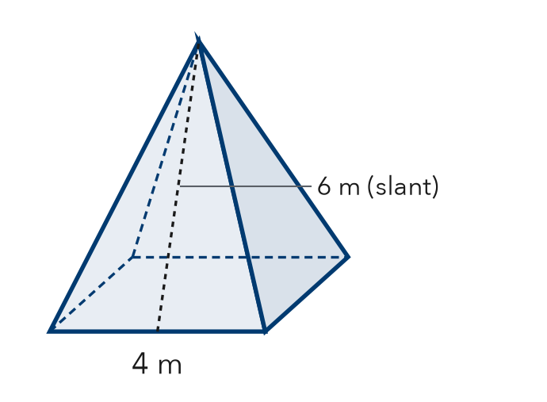
  Show your work.

2. Find each area.
a. one triangle, base 6 in, slant 5 in in² | b. square base, side 6 in in²

SUM IT UP in your own words
To find the surface area of a pyramid, I add and .
Name Date Period
Lesson 5-8 · Session 2 · Guided Notes
Lateral Area of Pyramids
Learning target — I can find the lateral area of a pyramid, which covers only its slanted faces. · 6.G.A.4
WORDS TO KNOW fill in the missing words
WORD | WHAT IT MEANS | EXAMPLE
lateral area  área lateral | The area of the slanted faces . | the base is left out
surface area  área superficial | The area of face, base included. | lateral area + base
lateral face  cara lateral | A side triangle of a pyramid. | 3 on a triangle-base pyramid
KEY IDEA complete each sentence
• Lateral area = the area of all the faces.
• Surface area = lateral area + area.
• Read the problem to decide whether the base is .
WORKED EXAMPLE fill in the blanks as we solve
A square pyramid roof has a base 4 m on each side and a slant height of 6 m. Shingles cover only the slanted sides.
Step 1 Cover the 4 slanted triangles. Leave out the .
Step 2 One triangle: ½ × 4 × 6 = m².
Step 3 Four triangles: 4 × 12 = m².
Answer lateral area = m²
YOU TRY use the example as a model

1. Find the lateral area of the square pyramid.  Answer ft² | 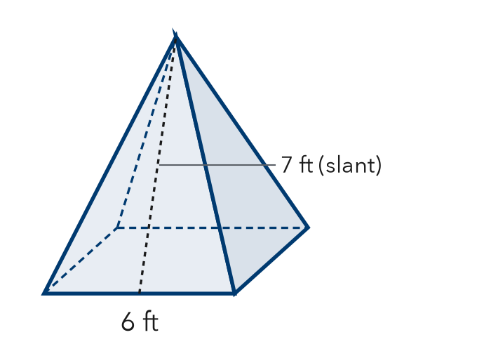
  Show your work.

2. Find each lateral area.
a. SA = 90 m², base = 25 m² m² | b. 3 faces, each 12 in² in²

SUM IT UP in your own words
I leave the base out when because .

