Name Date Period
Lesson 6-2 · Session 1 · Practice · Form A
Dividing a Fraction by a Fraction
Learning target — I can divide a fraction by another fraction using the reciprocal. · 6.NS.A.1

REMEMBER  • To divide by a fraction, multiply by its reciprocal: a/b ÷ c/d = a/b × d/c.  • Keep the first fraction, change ÷ to ×, flip only the second fraction.  • Check: quotient × divisor = the amount you started with. | WORKED EXAMPLE  A pitcher has 2/3 liter of juice. Each cup holds 1/6 liter. How many cups can be filled?  Step 1 Write the division: 2/3 ÷ 1/6.  Step 2 Flip the divisor and multiply: 2/3 × 6/1 = 12/3.  Step 3 Simplify: 12/3 = 4. Check: 4 × 1/6 = 4/6 = 2/3.  Answer 4 cups
WORDS reciprocal (recíproco) · dividend (dividendo) · divisor (divisor) · quotient (cociente)
PRACTICE show your work · label units

1. Divide. Write each quotient in simplest form.
a. 5/6 ÷ 1/3 = | b. 2/3 ÷ 4/9 = | c. 8/9 ÷ 2/9 =
d. 3/5 ÷ 1/10 = | e. 1/3 ÷ 5/6 = | f. 5/8 ÷ 3/4 =

2. Soup and Nuts. A shop has 3/4 gallon of soup and 4/5 pound of nuts. The bar is 1 gallon; the shaded part is the soup.
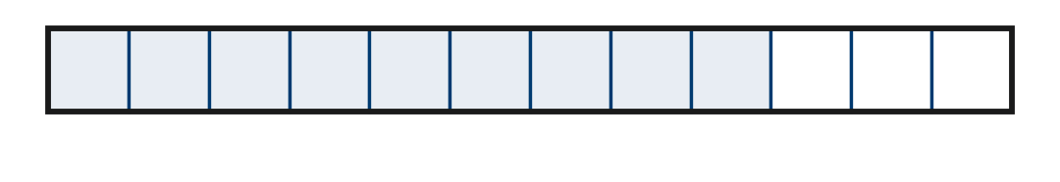
a. Each bowl holds 1/12 gallon. How many bowls can the shop fill? bowls
b. Each bag holds 2/5 pound. How many bags of nuts? bags

3. Sanding Strips. Lia has 11/12 meter of sandpaper. She tears it into strips that are each 1/12 meter wide. How many strips?  Hint Count the twelfths in 11/12.  Answer strips | 4. Honey Jars. A tub holds 7/8 pound of honey. Each gift jar holds 1/16 pound. How many jars can be filled?  Hint 1/8 pound holds two 1/16 pounds.  Answer jars
  Show your work.
  Show your work.

5. Wire Pieces. A 5/12-meter wire is cut into pieces that are each 5/12 meter long. Nadia says there are 25/144 pieces. Justify or correct her answer.
Hint Did Nadia flip the divisor? How many 5/12s fit in 5/12?

Show your work.
Answer piece

6. Wood Stain. A can holds 15/16 liter of stain. Grant uses 3/16 liter on a chair. He pours the rest into jars that each hold 1/16 liter.
Hint Subtract first, then divide by 1/16.
a. How much stain is left? L
b. How many jars does it fill? jars

Show your work.

7. Craft Supplies. A roll holds 9/10 meter of tape. A large project uses 3/10 meter. A small project uses 1/10 meter.
a. How many large projects can one roll supply? projects
b. How many small projects? projects
c. Explain why the second answer is 3 times the first.

8. Name Tags. A roll holds 5/6 yard of trim. Each name tag uses 1/18 yard of trim.
Hint A tiny divisor means many groups fit inside.
a. How many name tags can the roll cover? tags
b. Explain why the quotient is so large.

Show your work.

FIND THE ERROR explain the mistake, then fix it

9. Jamal’s Work. Jamal solved 3/5 ÷ 1/2. He flipped both fractions and wrote 5/3 × 2/1 = 10/3. Explain his mistake. Then find the correct quotient.

TEST PRACTICE choose the best answer

10. Find 3/4 ÷ 1/4.
A 3/16 | B 3 | C 1/3 | D 4/3

11. To divide by a fraction, you multiply by its —
A numerator | B denominator | C reciprocal | D opposite

SELF-CHECK CODE find your answer · copy its letter into that problem’s box · spell a math word
7/128  Z | 9  O | 25/144  Q | 15  R | 1  V | 3/4  I | 12  S | 5/108  X | 14  I | 11  D

#3 | #4 | #5 | #6a | #6b | #7b | #8a

CHECK YOURSELF | □ I can do this on my own | □ I need a little help | □ I have a question about #

