Name Date Period
Lesson 6-2 · Session 1 · Practice · Form B
Dividing a Fraction by a Fraction
Learning target — I can divide a fraction by another fraction using the reciprocal. · 6.NS.A.1

REMEMBER  • To divide by a fraction, multiply by its reciprocal: a/b ÷ c/d = a/b × d/c.  • Keep the first fraction, change ÷ to ×, flip only the second fraction.  • Check: quotient × divisor = the amount you started with. | WORKED EXAMPLE  A pitcher has 2/3 liter of juice. Each cup holds 1/6 liter. How many cups can be filled?  Step 1 Write the division: 2/3 ÷ 1/6.  Step 2 Flip the divisor and multiply: 2/3 × 6/1 = 12/3.  Step 3 Simplify: 12/3 = 4. Check: 4 × 1/6 = 4/6 = 2/3.  Answer 4 cups
WORDS reciprocal (recíproco) · dividend (dividendo) · divisor (divisor) · quotient (cociente)
PRACTICE show your work · label units

1. Divide. Write each quotient in simplest form.
a. 7/8 ÷ 1/4 = | b. 3/4 ÷ 5/8 = | c. 10/11 ÷ 2/11 =
d. 4/5 ÷ 1/10 = | e. 1/4 ÷ 2/3 = | f. 5/9 ÷ 1/3 =

2. Ink and Clay. An art club has 5/6 liter of ink and 6/7 pound of clay. The bar is 1 liter; the shaded part is the ink.
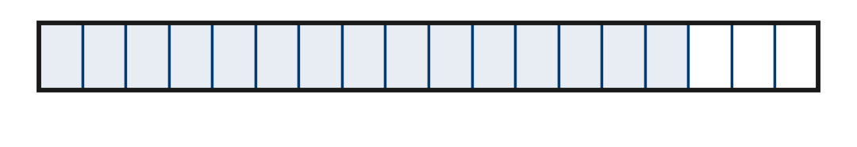
a. Each bottle holds 1/18 liter. How many bottles can the club fill? bottles
b. Each clay portion is 2/7 pound. How many portions? portions

3. Sanding Strips. Theo has 9/10 meter of sandpaper. He tears it into strips that are each 1/10 meter wide. How many strips?  Hint Count the tenths in 9/10.  Answer strips | 4. Honey Jars. A tub holds 3/4 pound of honey. Each gift jar holds 1/16 pound. How many jars can be filled?  Hint 1/4 pound holds four 1/16 pounds.  Answer jars
  Show your work.
  Show your work.

5. Wire Pieces. A 3/8-meter wire is cut into pieces that are each 3/8 meter long. Kofi says there are 9/64 pieces. Justify or correct his answer.
Hint Did Kofi flip the divisor? How many 3/8s fit in 3/8?

Show your work.
Answer piece

6. Wood Stain. A can holds 11/12 liter of stain. Rosa uses 3/12 liter on a shelf. She pours the rest into jars that each hold 1/24 liter.
Hint Subtract first, then divide by 1/24.
a. How much stain is left? L
b. How many jars does it fill? jars

Show your work.

7. Banner Ribbon. A spool holds 4/5 meter of ribbon. A large banner uses 2/5 meter. A small banner uses 1/10 meter.
a. How many large banners can one spool supply? banners
b. How many small banners? banners
c. Explain why the second answer is 4 times the first.

8. Name Tags. A roll holds 2/3 yard of trim. Each name tag uses 1/15 yard of trim.
Hint A tiny divisor means many groups fit inside.
a. How many name tags can the roll cover? tags
b. Explain why the quotient is so large.

Show your work.

FIND THE ERROR explain the mistake, then fix it

9. Priya’s Work. Priya solved 4/7 ÷ 2/3. She flipped both fractions and wrote 7/4 × 3/2 = 21/8. Explain her mistake. Then find the correct quotient.

TEST PRACTICE choose the best answer

10. Find 2/5 ÷ 1/10.
A 1/25 | B 4 | C 1/4 | D 20

11. The reciprocal of 3/7 is —
A −3/7 | B 3/7 | C 7/3 | D 1/7

SELF-CHECK CODE find your answer · copy its letter into that problem’s box · spell a math word
2/3  E | 8  S | 9  I | 2/45  X | 3/64  Z | 16  R | 12  N | 9/64  Q | 1  V | 10  E

#3 | #4 | #5 | #6a | #6b | #7b | #8a

CHECK YOURSELF | □ I can do this on my own | □ I need a little help | □ I have a question about #

