Name Date Period
Lesson 6-2 · Session 1 · Guided Notes
Dividing a Fraction by a Fraction
Learning target — I can divide a fraction by another fraction using the reciprocal. · 6.NS.A.1
WORDS TO KNOW fill in the missing words
WORD | WHAT IT MEANS | EXAMPLE
reciprocal  recíproco | A fraction flipped upside down; the two numbers multiply to make . | 2/9 and 9/2
dividend  dividendo | The amount you with and split into groups. | In 8/9 ÷ 2/9, 8/9 is the dividend
divisor  divisor | The size of each group; the number you divide . | In 8/9 ÷ 2/9, 2/9 is the divisor
KEY IDEA complete each sentence
• To divide by a fraction, multiply by its .
• Keep the first fraction, change ÷ to ×, and flip only the fraction.
• Check: quotient × divisor = .
WORKED EXAMPLE fill in the blanks as we solve
How many 1/8-meter strips can be cut from 3/4 meter of tape?
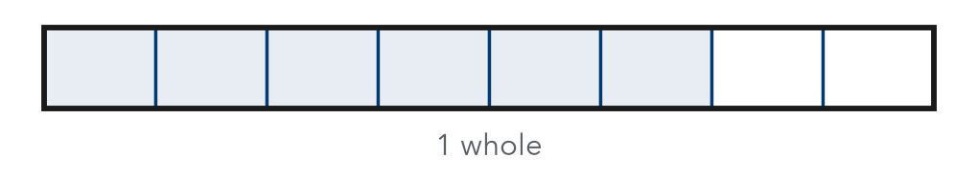
Step 1 Write the division: 3/4 ÷ .
Step 2 Multiply by the reciprocal: 3/4 × = 24/4.
Step 3 Simplify: 24/4 = .
Answer strips. Check: 6 × 1/8 = 6/8 = 3/4.
YOU TRY use the example as a model

1. Divide.
a. 3/5 ÷ 1/5 = | b. 3/8 ÷ 3/4 =

2. Ben has 9/10 pound of nuts. Each bag holds 3/10 pound. How many bags can he fill?

Show your work.
Answer bags

SUM IT UP in your own words
To divide 2/3 ÷ 1/6, I multiply by because .
Name Date Period
Lesson 6-2 · Session 2 · Guided Notes
Dividing with Mixed Numbers
Learning target — I can divide mixed numbers by writing them as improper fractions first. · 6.NS.A.1
WORDS TO KNOW fill in the missing words
WORD | WHAT IT MEANS | EXAMPLE
mixed number  número mixto | A number and a fraction written together. | 2 1/2
improper fraction  fracción impropia | A fraction whose numerator is than or equal to its denominator. | 5/2
simplify  simplificar | Write the same amount using numbers. | 28/14 = 2
KEY IDEA complete each sentence
• Before dividing, write each mixed number as an fraction.
• Then multiply by the of the divisor and simplify.
• You cannot flip a mixed number until it is fraction.
WORKED EXAMPLE fill in the blanks as we solve
A baker has 3 1/2 cups of flour. Each loaf uses 1 3/4 cups. How many loaves can she make?
Step 1 Convert: 3 1/2 = and 1 3/4 = .
Step 2 Multiply by the reciprocal: 7/2 × = 28/14.
Step 3 Simplify: 28/14 = .
Answer She can make loaves.
YOU TRY use the example as a model

1. Fill in each blank.
a. 2 1/2 as an improper fraction: | b. 3 1/3 ÷ 2/3 =

2. Kofi has 3 3/4 cups of rice. Each serving is 3/4 cup. How many servings can he make?

Show your work.
Answer servings

SUM IT UP in your own words
Before I divide mixed numbers, I because .

