Name Date Period
Lesson 6-3 · Session 2 · Practice · Form A
Finding the Value of a Power
Learning target — I can find the value of a power by multiplying the base the number of times the exponent shows. · 6.EE.A.1

REMEMBER  • Write the expanded form, then multiply one factor at a time.  • 4³ = 4 × 4 × 4 = 64, not 4 × 3 = 12.  • Decimals and fractions work the same way: 0.3² = 0.3 × 0.3 = 0.09. | WORKED EXAMPLE  Find the value of 3⁴.  Step 1 Expand: 3⁴ = 3 × 3 × 3 × 3.  Step 2 Multiply: 3 × 3 = 9, 9 × 3 = 27, 27 × 3 = 81.  Step 3 Check: I used 3 as a factor 4 times.  Answer 3⁴ = 81
WORDS evaluate (evaluar) · squared (al cuadrado) · cubed (al cubo) · expanded form (forma desarrollada)
PRACTICE show your work · label units

1. Find the value of each power.
a. 12² = | b. 3³ = | c. 2⁴ =
d. 11² = | e. 1.2² = | f. (1/3)² =

2. Power Table. A science club makes a table of powers of 2. Complete it. Then tell what each value is multiplied by to get the next one.
Power | Expanded form | Value
2¹
2²
2³
2⁴
Multiply by

3. Storage Cube. A storage cube has edges of 4 units, so its volume is 4³ cubic units. Find the volume.  Hint Use 4 as a factor three times.  Answer cubic units | 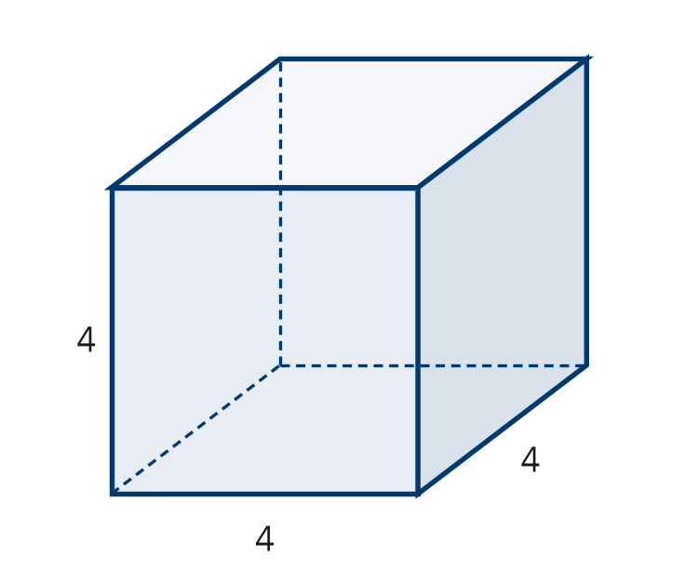
  Show your work.

4. Plant Cuttings. A count of plant cuttings is multiplied by 5 each week for 4 weeks, so it is 5⁴. Evaluate it.  Hint 5 × 5 = 25, then keep multiplying by 5.  Value | 5. Poster Claim. A classroom poster says 7² = 14. Justify or correct the poster.  Hint Expand the power into factors first.  Value
  Show your work.
  Show your work.

6. Which Is Biggest? Evaluate 2⁵, 5² and 3³. Order them from least to greatest.  Hint Evaluate each power before comparing.  Order | 7. Decimal Powers. Evaluate each power.  Hint Count decimal places: 0.6 × 0.6 has two.  a. 0.6² =  b. 1.5² =
  Show your work.

8. Growing Cells. A culture of cells triples every hour. It starts with 1 cell.
a. Write the number of cells after 4 hours as a power of 3, then evaluate. cells
b. How many cells after 5 hours? cells
c. How many more cells after 5 hours than after 4 hours? cells

FIND THE ERROR explain the mistake, then fix it

9. Teo’s Work. Teo evaluated 10³. He wrote 10 × 3 = 30 and said the value is 30. Explain his mistake. Then find the correct value.

TEST PRACTICE choose the best answer

10. 2⁵ equals —
A 10 | B 25 | C 32 | D 7

11. A number to the 2nd power is said to be —
A squared | B cubed | C doubled | D halved

SELF-CHECK CODE find your answer · copy its letter into that problem’s box · spell a math word
2.25  R | 64  S | 81  E | 0.36  A | 162  D | 20  X | 49  U | 12  Z | 14  J | 625  Q

#3 | #4 | #5 | #7a | #7b | #8a | #8c

CHECK YOURSELF | □ I can do this on my own | □ I need a little help | □ I have a question about #

