Name Date Period
Lesson 7-1 · Session 1 · Practice · Form A
Integers and Opposites
Learning target — I can write an integer for a real situation and name its opposite. · 6.NS.C.5

REMEMBER  • Positive and negative numbers show opposite directions from 0. First decide what 0 means.  • Above, gain, and deposit are positive. Below, loss, and debt are negative.  • Opposites are the same distance from 0 on different sides. Zero is its own opposite. | WORKED EXAMPLE  A game score starts at 0. You earn 8 points, then you lose 8 points. Write each as an integer.  Step 1 0 means the starting score.  Step 2 Earn 8 points: 8. Lose 8 points: −8.  Step 3 Both are 8 units from 0, on opposite sides.  Answer 8 and −8 are opposites
WORDS integer (entero) · opposite (opuesto) · negative number (número negativo)
PRACTICE show your work · label units

1. Write an integer for each situation.
a. a gain of 12 yards | b. a debt of 25 dollars
c. 8 degrees below zero | d. 3 floors below the street

2. Write the opposite of each number.
a. −19 | b. 6 | c. 0

3. Hiking Trail. A trail map lists four spots: Ridge Point 35 m above sea level, Salt Flat 20 m below, Camp 15 m above, and Cave Floor 35 m below.
Hint Sea level is 0. Below sea level is negative.
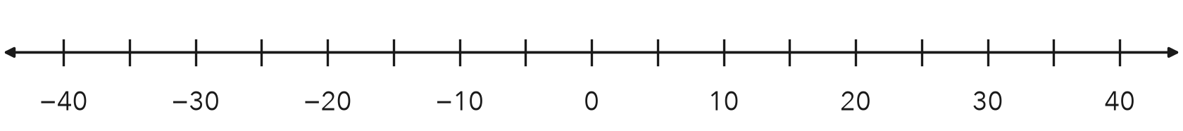
a. Write the integers: Ridge Salt Flat Camp Cave
b. Plot and label all four. Which two spots are opposites?

4. Sunrise Temperature. At sunrise it was 12 degrees below zero. Write the integer. Then write its opposite.  Hint Below zero means negative.  Integer, opposite | 5. Marco’s Claim. Marco says the opposite of −18 is −18, because it already has a negative sign. Is he right?  Hint Opposites sit on different sides of 0.  Opposite
  Show your work.
  Show your work.

6. Golf Scores. Three golfers finished at 7 under par, 7 over par, and even par. Write an integer for each. Plot them. Name the opposite pair.
Hint Even par is 0. Under par is negative.
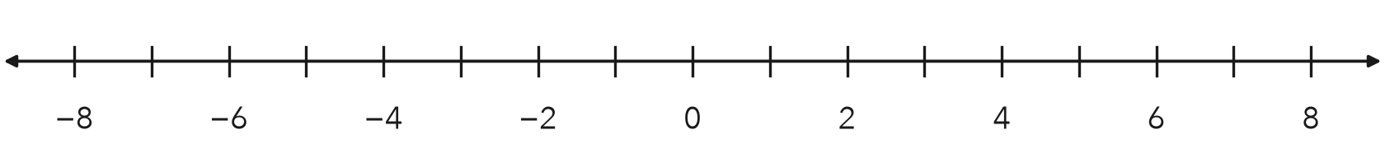
Opposite pair

7. Windmill and Well. A windmill blade tops out 31 feet above the ground. A well bottom sits at the opposite elevation.
a. Integer for the well bottom: ft
b. What does 0 represent here?

8. Elevator Trip. An elevator starts at the lobby, marked 0. It goes down 3 floors, then up 7 floors.
a. Write an integer for each move.
b. Integer for the floor where it ends:
c. What would the opposite of that floor mean?

Show your work.

FIND THE ERROR explain the mistake, then fix it

9. Tessa’s Work. A canyon floor sits 24 meters below sea level. Tessa wrote the elevation as 24 and said its opposite is also 24. Explain her two mistakes. Then give the correct elevation and its opposite.

TEST PRACTICE choose the best answer

10. A debt of 30 dollars is written as —
A 30 | B −30 | C 0 | D −(−30)

11. The opposite of 0 is —
A 1 | B −1 | C 0 | D There is none.

SELF-CHECK CODE find your answer · copy its letter into that problem’s box · spell a math word
10  X | 19  T | −8  N | −31  E | −18  Q | 4  R | 18  G | −19  Z | −12  E | −25  I

#1b | #1c | #2a | #4 | #5 | #7a | #8b

CHECK YOURSELF | □ I can do this on my own | □ I need a little help | □ I have a question about #

