EXIT TICKET · LESSON 7-1 · SESSION 1 Name
Integers and Opposites

1. Write an integer for each situation.
a. a withdrawal of 20 dollars | b. 11 degrees above zero

2. Plot −5 and its opposite. How far is each from 0?
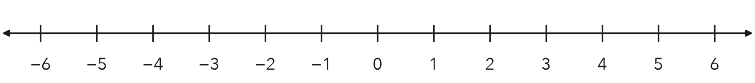
Answer units

3. Which pair of numbers are opposites?
A −4 and 4 | B −4 and 0 | C 4 and 1/4 | D −4 and −1/4

HOW DID IT GO? □ I got it □ Almost □ I need help
cut here
EXIT TICKET · LESSON 7-1 · SESSION 1 Name
Integers and Opposites

1. Write an integer for each situation.
a. a withdrawal of 20 dollars | b. 11 degrees above zero

2. Plot −5 and its opposite. How far is each from 0?
Answer units

3. Which pair of numbers are opposites?
A −4 and 4 | B −4 and 0 | C 4 and 1/4 | D −4 and −1/4

HOW DID IT GO? □ I got it □ Almost □ I need help
EXIT TICKET · LESSON 7-1 · SESSION 2 Name
Integers in Real Situations

1. Write an integer or find the value.
a. a 20-dollar charge | b. −(−13) =

2. It is 7 degrees below zero. Write the integer and its opposite. What would the opposite mean?

Show your work.
Answer

3. Which is equal to −(−9)?
A −9 | B 9 | C 0 | D 1/9

HOW DID IT GO? □ I got it □ Almost □ I need help
cut here
EXIT TICKET · LESSON 7-1 · SESSION 2 Name
Integers in Real Situations

1. Write an integer or find the value.
a. a 20-dollar charge | b. −(−13) =

2. It is 7 degrees below zero. Write the integer and its opposite. What would the opposite mean?

Show your work.
Answer

3. Which is equal to −(−9)?
A −9 | B 9 | C 0 | D 1/9

HOW DID IT GO? □ I got it □ Almost □ I need help

