Name Date Period
Lesson 7-1 · Session 1 · Prerequisite Practice A · Skill 1 of 2
Read Number Line Scales
Builds on Grade 2 · 2.MD.B.6
TODAY’S LESSON | You will plot spots like 35 m above and 20 m below sea level on one number line.
YOU NEED TO | Find how much each jump is worth, like 0 to 40 in 8 jumps: each jump is 5. You will use it in Practice Form A, problems 3 and 6.
STEPS TO FOLLOW use these same steps on every problem
1 | Subtract the two labels to find the gap.
2 | Count the equal jumps between the labels.
3 | Divide: gap ÷ jumps = size of each jump.
WATCH ME the steps in action
A line goes from 0 to 40 in 8 equal jumps. How much is each jump?  Step 1 40 − 0 = 40  Step 2 There are 8 jumps.  Step 3 40 ÷ 8 = 5. Each jump is 5.  Answer 5 | 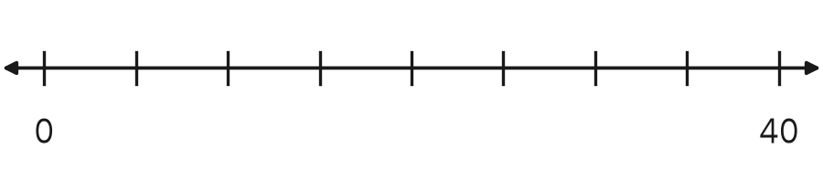

TRY IT WITH HELP fill in each step
1. A line goes from 0 to 100 in 10 equal jumps. How much is each jump?
Step 1 100 − 0 =
Step 2 There are jumps.
Step 3 100 ÷ 10 =

2. A line goes from 0 to 60 in 3 equal jumps. How much is each jump?
Step 1 60 − 0 =
Step 2 There are jumps.
Step 3 60 ÷ 3 =

YOUR TURN use the steps on your own

3. Find the size of each jump.
a. 0 to 20 in 4 jumps | b. 0 to 50 in 5 jumps
c. 0 to 30 in 6 jumps | d. 0 to 200 in 4 jumps
e. 10 to 30 in 4 jumps | f. 0 to 12 in 6 jumps

Lesson 7-1 · Session 1 · Prerequisite Practice A · Skill 2 of 2
Compare Using a Number Line
Builds on Grade 4 · 4.NBT.A.2
TODAY’S LESSON | You will plot 7 under par and 7 over par. One sits left of 0, one sits right.
YOU NEED TO | Know that the number farther right on a number line is greater. You will use it in Practice Form A, problems 3 and 6.
STEPS TO FOLLOW use these same steps on every problem
1 | Find both numbers on the number line.
2 | The number farther right is greater.
3 | Write < or >. The open side faces the greater number.
WATCH ME the steps in action
Compare 35 and 53.  Step 1 Find 35 and 53 on the line.  Step 2 53 is farther right, so 53 is greater.  Step 3 35 < 53  Answer 35 < 53 | 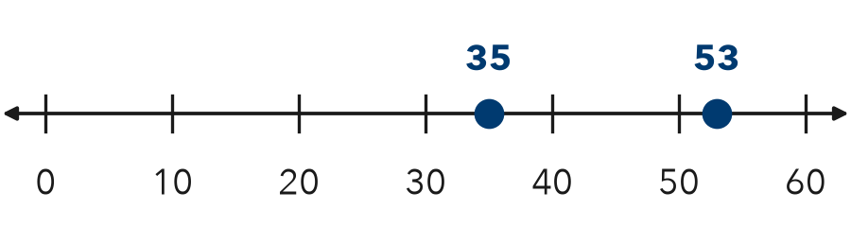

TRY IT WITH HELP fill in each step
4. Compare 120 and 102.
Step 1 Find and on the line.
Step 2 Farther right:
Step 3 120 102

5. Compare 19 and 91.
Step 1 Find and on the line.
Step 2 Farther right:
Step 3 19 91

YOUR TURN use the steps on your own

6. Write < or >.
a. 8 3 | b. 240 204 | c. 47 74
d. 150 105 | e. 86 68 | f. 15 51

READY CHECK a problem like the one in today’s lesson

7. Camp is at 15 m. Ridge Point is at 35 m. Which is farther right on a number line?
A 15 | B 35 | C the same place | D 0

CHECK YOURSELF | □ I can do this on my own | □ I need a little help | □ I have a question about #

