EXIT TICKET · LESSON 7-2 · SESSION 1 Name
Rational Numbers on a Number Line

1. Name the two integers each number is between.
a. −4.3 | b. 11/4

2. Plot and label −0.75 and 1.5 on the number line.
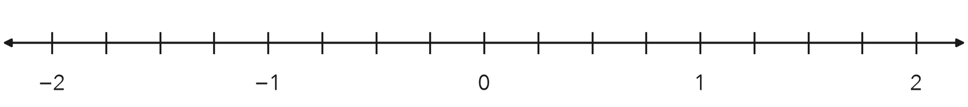

3. Which number is farthest left on a number line?
A −0.5 | B −2.25 | C −2 | D 0.75

HOW DID IT GO? □ I got it □ Almost □ I need help
cut here
EXIT TICKET · LESSON 7-2 · SESSION 1 Name
Rational Numbers on a Number Line

1. Name the two integers each number is between.
a. −4.3 | b. 11/4

2. Plot and label −0.75 and 1.5 on the number line.

3. Which number is farthest left on a number line?
A −0.5 | B −2.25 | C −2 | D 0.75

HOW DID IT GO? □ I got it □ Almost □ I need help
EXIT TICKET · LESSON 7-2 · SESSION 2 Name
Opposites of Rational Numbers

1. Find each value.
a. opposite of −3.2 | b. −(−7/9) = | c. −(1.4) =

2. A number’s opposite is 6.5. What is the number?

Show your work.
Answer

3. Is the opposite of a number always negative? Give an example.

HOW DID IT GO? □ I got it □ Almost □ I need help
cut here
EXIT TICKET · LESSON 7-2 · SESSION 2 Name
Opposites of Rational Numbers

1. Find each value.
a. opposite of −3.2 | b. −(−7/9) = | c. −(1.4) =

2. A number’s opposite is 6.5. What is the number?

Show your work.
Answer

3. Is the opposite of a number always negative? Give an example.

HOW DID IT GO? □ I got it □ Almost □ I need help

