Name Date Period
Lesson 7-2 · Session 1 · Guided Notes
Rational Numbers on a Number Line
Learning target — I can plot a rational number and its opposite on a number line. · 6.NS.C.6c
WORDS TO KNOW fill in the missing words
WORD | WHAT IT MEANS | EXAMPLE
rational number  número racional | A number that can be written as a of two integers. | −3/4, 0.5, 7 = 7/1
integer  número entero | A whole number or its . | −3, 0, 5
number line  recta numérica | A line where numbers from left to right. | −2 is left of 1, so −2 < 1
KEY IDEA complete each sentence
• To plot 7/4, split each whole into equal parts and count parts from 0.
• Negative numbers sit to the of 0 on a horizontal line and 0 on a vertical line.
WORKED EXAMPLE fill in the blanks as we solve
Plot −2.75 on the number line.
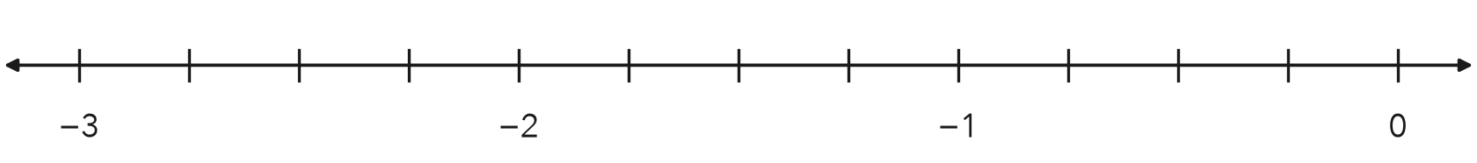
Step 1 −2.75 is between the integers and .
Step 2 Split the gap between −3 and −2 into equal parts (fourths).
Step 3 Start at −2 and count fourths to the left.
Answer −2.75 is one fourth to the of −3.
YOU TRY use the example as a model

1. Plot and label −1.5 and 2.25 on the number line.
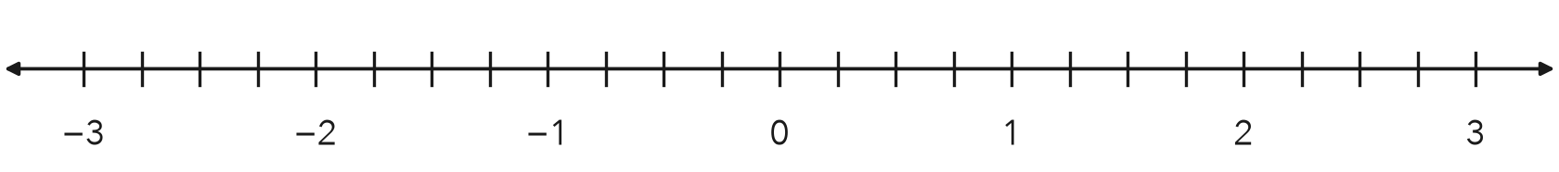

2. Name the two integers each number is between.
a. −3.6 | b. 5/2

SUM IT UP in your own words
To plot a rational number on a number line, I first because .
Name Date Period
Lesson 7-2 · Session 2 · Guided Notes
Opposites of Rational Numbers
Learning target — I can find the opposite of a rational number and explain what taking the opposite twice does. · 6.NS.C.6a
WORDS TO KNOW fill in the missing words
WORD | WHAT IT MEANS | EXAMPLE
opposites  opuestos | Two numbers the same from 0, on different sides of 0. | −2.5 and 2.5
opposite of the opposite  opuesto del opuesto | Taking the opposite gives back the number you started with. | −(−3) = 3
zero  cero | The only number that is its opposite. | the opposite of 0 is 0
KEY IDEA complete each sentence
• The symbol −(4.5) means the of 4.5, which is −4.5.
• The opposite of a negative number is .
WORKED EXAMPLE fill in the blanks as we solve
Find −(−5.3).
Step 1 −5.3 is units to the left of 0.
Step 2 Its opposite is the same distance on the side of 0.
Step 3 So −(−5.3) = .
Answer −(−5.3) =
YOU TRY use the example as a model

1. Find each value.
a. opposite of 2/9 | b. −(−0.6) = | c. opposite of 0

2. Point A is at −1.25. Plot its opposite and label it B.
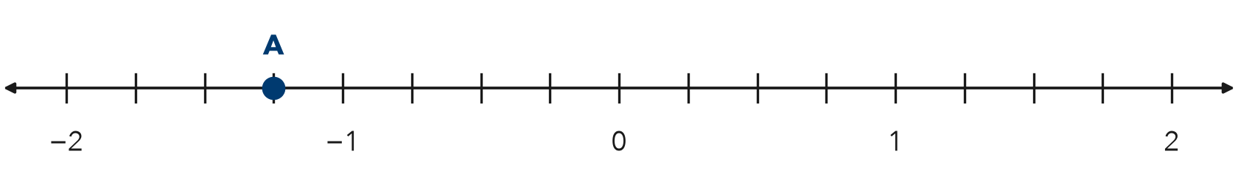
B =

SUM IT UP in your own words
Taking the opposite twice gives because .

