Name Date Period
Lesson 7-2 · Homework Packet · Level 1 · Sheet 1 of 2
Rational Numbers on a Number Line
Maryland Standard 6.NS.C.6c · Learning target — I can plot a rational number and its opposite on a number line.

REMEMBER  • A rational number can be written as a fraction a/b of two integers (b ≠ 0). Examples: 3/4, −2.5, 7, −1 1/2.  • Between two integers, split the gap into equal parts (halves, fourths, tenths).  • Negative numbers sit left of 0. −2.5 is halfway between −3 and −2. | WORKED EXAMPLE  Plot −1.75 and its opposite on a number line.  Step 1 −1.75 is between −2 and −1. Split each unit into fourths; count 3 fourths left of −1.  Step 2 The opposite, 1.75, is 3 fourths right of 1.  Answer points at −1.75 and 1.75

WORD BANK  rational number — a number you can write as a fraction  integer — …, −2, −1, 0, 1, 2, … | negative — less than 0; to the left of 0  between — in the middle of two numbers
PRACTICE show your work · label units

1. Write the number for each point as a decimal or a fraction.
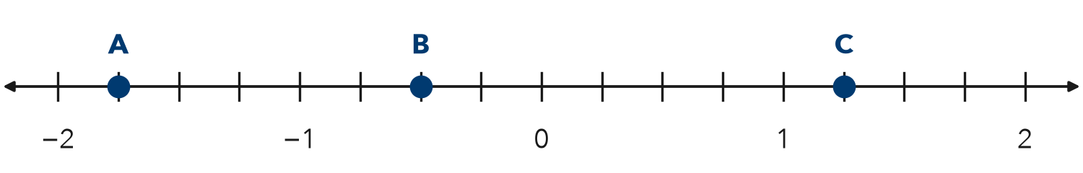
a. A = | b. B = | c. C =

2. Plot and label each number on the number line: −2.5, 1/2, −0.75, 1 1/4
Step 1 Find the two integers on each side of the number.
Step 2 Split the gap into equal parts.
Step 3 Count the parts and mark the point.
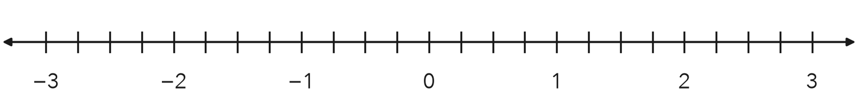

3. Name the two integers each number is between.
a. −4.6 is between | b. 7/2 is between
c. −0.3 is between | d. −9/4 is between

4. Write a rational number for each situation.
a. a loss of $3.50 | b. a gain of 2 1/2 ft | c. 4.5 degrees below 0

5. Pond. A frog is 1.5 feet above the pond. A fish is 2.25 feet below the top of the pond. The top of the pond is 0.
Frame The is closer to 0 because .
a. Write a number for the frog and for the fish.
b. Which one is closer to the surface?

6. Find the Error. Tyrell plotted −1.5 between −1 and 0. Explain his mistake.
Frame Tyrell’s mistake is . −1.5 is between and .

CHECK YOURSELF | □ I can do this on my own | □ I need a little help | □ I have a question about #
AT HOME Find a ruler or measuring cup at home. Show someone where 1/2, 1/4, and 3/4 are.
Name Date Period
Lesson 7-2 · Homework Packet · Level 1 · Sheet 2 of 2
Opposites of Rational Numbers
Maryland Standard 6.NS.C.6a · Learning target — I can find the opposite of a rational number and explain what taking the opposite twice does.

REMEMBER  • Opposites are the same distance from 0: 2.5 and −2.5.  • The opposite of a negative number is positive.  • Taking the opposite twice gives back the number you started with. | WORKED EXAMPLE  Start at 3/5. Find its opposite. Then find the opposite of that.  Step 1 Opposite of 3/5 is −3/5.  Step 2 Opposite of −3/5 is 3/5.  Answer −3/5, then 3/5

WORD BANK  opposite — same distance from 0, other side  −(−3) — the opposite of −3, which is 3 | distance from 0 — how far a number is from 0
PRACTICE show your work · label units

1. Write the opposite of each number, or find the value.
a. 4.8 | b. −2/3 | c. −0.05
d. 0 | e. −(−1.6) = | f. −(−5/8) =

2. Point P is shown. Plot its opposite and label it Q.
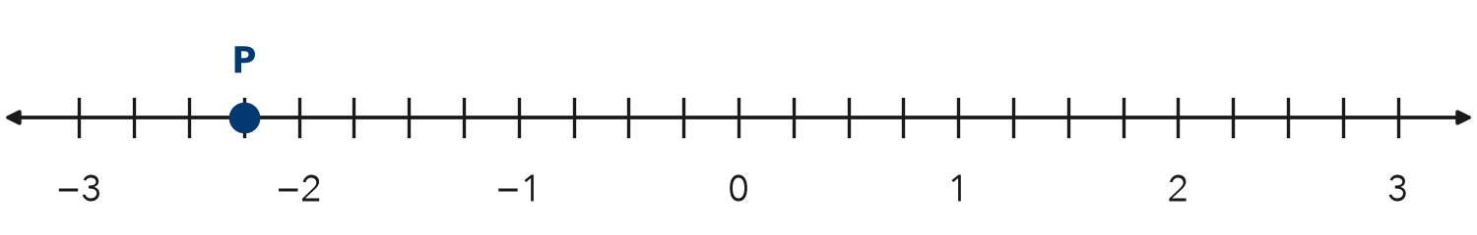
Q =

3. Game Score. Lena has −12.5 points. A bonus card changes her score to the opposite number.
What is her new score? How far from 0 is it?

4. Stretch. Point M is 3.75 units from 0, to the left of 0. Point N is the opposite of M.
Step 1 M is to the left of 0, so M is negative.
Step 2 N is the opposite of M, so N is positive.
a. M =
b. N =

5. Find the Error. Kofi says −(−2/5) = −2/5. Explain his mistake. Give the correct value.
Frame Kofi is wrong because the opposite of a negative number is .

TEST PRACTICE choose the best answer

6. What is the opposite of −7/8?
A −7/8 | B 7/8 | C 8/7 | D −8/7

7. Point R is at 3.4. Where is the opposite of the opposite of R?
A −3.4 | B 0 | C 3.4 | D 4.3

CHECK YOURSELF | □ I can do this on my own | □ I need a little help | □ I have a question about #
AT HOME Explain to someone at home why −(−1.5) is a positive number.

