Name Date Period
Lesson 7-2 · Session 2 · Prerequisite Practice A · Skill 1 of 2
Rename Fractions Greater Than 1
Builds on Grade 4 · 4.NF.B.3b
TODAY’S LESSON | You will place and flip numbers like −9/2 and 5/4 on a number line.
YOU NEED TO | Rename a fraction greater than 1, like 9/2 = 4 1/2, to see which wholes it is between. You will use it in Practice Form A, problems 1 and 4 (Session 1).
STEPS TO FOLLOW use these same steps on every problem
1 | Divide the top number by the bottom number.
2 | The quotient is the whole number.
3 | The remainder goes over the same bottom number.
WATCH ME the steps in action
Write 17/4 as a mixed number.
Step 1 17 ÷ 4 = 4 R1.
Step 2 The whole number is 4.
Step 3 The remainder 1 goes over 4: 1/4.
Answer 17/4 = 4 1/4
TRY IT WITH HELP fill in each step
1. Write 9/2 as a mixed number.
Step 1 9 ÷ 2 = R .
Step 2 The whole number is .
Step 3 The remainder over 2 is . So 9/2 = .

2. Write 11/4 as a mixed number.
Step 1 11 ÷ 4 = R .
Step 2 The whole number is .
Step 3 The remainder over 4 is . So 11/4 = .

YOUR TURN use the steps on your own

3. Write each fraction as a mixed number.
a. 7/2 | b. 9/4 | c. 13/4
d. 10/3 | e. 8/5 | f. 15/4

Lesson 7-2 · Session 2 · Prerequisite Practice A · Skill 2 of 2
Hundredths on a Number Line
Builds on Grade 4 · 4.NF.C.6
TODAY’S LESSON | You will find opposites of depths like −7.25 m and −6.35.
YOU NEED TO | Place a decimal like 7.25 between two whole numbers and see which it is closer to. You will use it in Practice Form A, problems 2, 6, and 7.
STEPS TO FOLLOW use these same steps on every problem
1 | Find the whole number before the point. The next whole is one more.
2 | Compare the decimal part to .5 (halfway).
3 | Less than .5: closer to the lower whole. More: the higher one.
WATCH ME the steps in action
Where is 8.75 on a number line?  Step 1 The whole number is 8. It is between 8 and 9.  Step 2 .75 is more than .5.  Step 3 It is past halfway, closer to 9.  Answer 8.75 is between 8 and 9, closer to 9. | 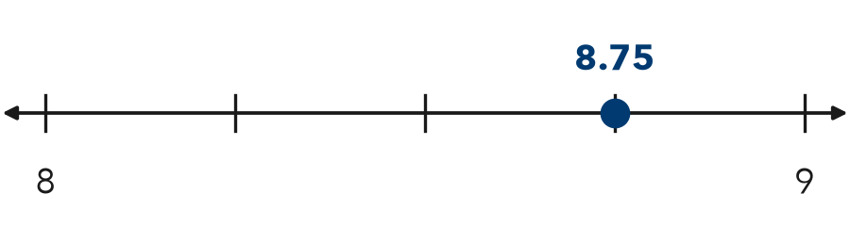

TRY IT WITH HELP fill in each step
4. Where is 7.25 on a number line?
Step 1 7.25 is between and .
Step 2 .25 is than .5.
Step 3 7.25 is closer to .

5. Where is 6.35 on a number line?
Step 1 6.35 is between and .
Step 2 .35 is than .5.
Step 3 6.35 is closer to .

YOUR TURN use the steps on your own

6. Write the whole number each decimal is closer to.
a. 4.75 | b. 2.25 | c. 6.8
d. 1.35 | e. 9.6 | f. 3.45

READY CHECK a problem like the one in today’s lesson

7. A ladder top reaches 6.75 feet. Which whole number is 6.75 closest to?
A 6 | B 7 | C 8 | D 75

CHECK YOURSELF | □ I can do this on my own | □ I need a little help | □ I have a question about #

