Name Date Period
Lesson 7-2 · Session 2 · Prerequisite Practice B · Skill 1 of 2
Plot Rational Numbers
Builds on Lesson 7-2 Session 1 · 6.NS.C.6c
TODAY’S LESSON | You will find opposites of depths like −4.5 m and plot them.
YOU NEED TO | Plot a negative decimal, like −2.5: halfway between −2 and −3. You will use it in Practice Form A, problems 2 and 8.
STEPS TO FOLLOW use these same steps on every problem
1 | Find the two integers the number sits between.
2 | Split that gap into equal parts.
3 | Count the parts away from 0. Mark the point.
WATCH ME the steps in action
Plot −1.75.  Step 1 −1.75 is between −1 and −2.  Step 2 Split −1 to −2 into 4 equal parts.  Step 3 Count 3 parts left of −1. Mark the point.  Answer 3 parts left of −1, close to −2 | 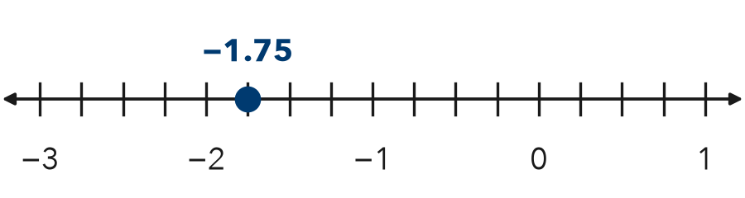

TRY IT WITH HELP fill in each step
1. Plot −2.5.
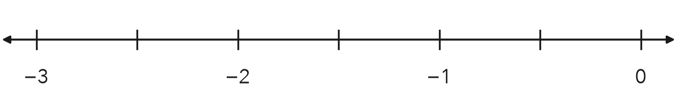
Step 1 −2.5 is between and .
Step 2 Split the gap into equal parts.
Step 3 Count part left of −2. Mark it.

2. Plot −0.4.
Step 1 −0.4 is between and .
Step 2 Split the gap into equal parts.
Step 3 Count parts left of 0. Mark it.

YOUR TURN use the steps on your own

3. Write the two integers each number is between.
a. −2.7 | b. −4.5 | c. −0.8
d. 3.6 | e. −7.25 | f. −11.5

Lesson 7-2 · Session 2 · Prerequisite Practice B · Skill 2 of 2
Find Opposites of Integers
Builds on Lesson 7-1 Session 2 · 6.NS.C.6a
TODAY’S LESSON | You will find values like −(−4.5) and the opposite of −7/8.
YOU NEED TO | Find the opposite of an integer, like −(−5) = 5. You will use it in Practice Form A, problems 1, 3, and 7.
STEPS TO FOLLOW use these same steps on every problem
1 | Find the number’s distance from 0.
2 | Switch sides of 0: left becomes right, right becomes left.
3 | Write the number on the new side. −( ) means the opposite of.
WATCH ME the steps in action
Find −(−12).
Step 1 −12 is 12 units from 0.
Step 2 −12 is left of 0. Switch to the right.
Step 3 −(−12) = 12.
Answer 12
TRY IT WITH HELP fill in each step
4. Find the opposite of 9.
Step 1 9 is units from 0.
Step 2 9 is right of 0. Switch to the .
Step 3 The opposite of 9 is .

5. Find −(−20).
Step 1 −20 is units from 0.
Step 2 −20 is left of 0. Switch to the .
Step 3 −(−20) = .

YOUR TURN use the steps on your own

6. Find each value. −(n) means the opposite of n.
a. −(−7) = | b. −(0) = | c. −(−1) =
d. −(15) = | e. −(−30) = | f. −(6) =

READY CHECK a problem like the one in today’s lesson

7. What is −(−4.5)?
A −4.5 | B 4.5 | C 0 | D −9

CHECK YOURSELF | □ I can do this on my own | □ I need a little help | □ I have a question about #

