Name Date Period
Lesson 7-3 · Session 1 · Practice · Form A
Absolute Value as Distance
Learning target — I can use absolute value to describe how far a number is from zero. · 6.NS.C.7c

REMEMBER  • Absolute value is how far a number is from 0. Write it with bars: |−4| = 4 and |4| = 4.  • Distance is never negative, so absolute value is never negative.  • Greater means farther right. Farther from 0 means a bigger absolute value. −9 is farther from 0 than 4, but 4 is greater. | WORKED EXAMPLE  Find |−13| and |6|. Which number is farther from 0?  Step 1 −13 is 13 units left of 0, so |−13| = 13.  Step 2 6 is 6 units right of 0, so |6| = 6.  Step 3 Compare the distances: 13 > 6.  Answer −13 is farther from 0
WORDS absolute value (valor absoluto) · distance (distancia) · magnitude (magnitud)
PRACTICE show your work · label units

1. Find each absolute value.
a. |−16| = | b. |9| =
c. |0| = | d. |−2.75| =

2. Beaker Readings. Four beakers read: A −6 degrees, B 2.5 degrees, C −0.5 degrees, D 8 degrees.
Hint Count the units from 0 to each point.
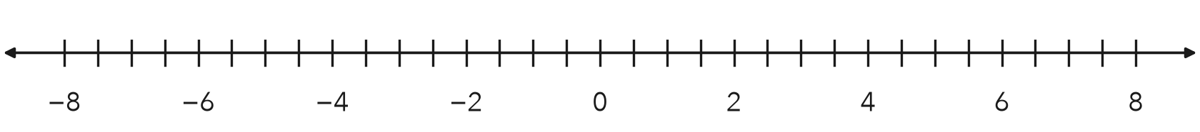
a. Absolute values: A B C D
b. Plot all four. Which beaker is closest to 0? Farthest?

3. Two Accounts. One account has a balance of −45 dollars. Another has a balance of 12 dollars.
a. Absolute value of each balance:
b. Which account is closer to a zero balance?

Show your work.

4. Survey Cards. One card reads −7.5 m and another reads 7.5 m. Find each absolute value. Do they mark the same place?  Hint Same distance does not mean same side.  Answer | 5. Cold Storage. A cooler logged −14 degrees at midnight. Find the absolute value. What does it tell you?  Answer
  Show your work.
  Show your work.

6. Greater Magnitude. Which number has the greater absolute value, −36 or 22? Justify your choice.
Hint Compare 36 and 22.

Show your work.
Number

7. Omar’s Claim. Omar says |−5.2| = −5.2 because the number inside the bars is negative. Is he right? Give the correct value.
Hint Can a distance be negative?

Show your work.
|−5.2|

8. Bank Balances. Three accounts read −85, 40, and −120 dollars.
a. Find the absolute value of each balance.
b. Which balance is farthest from 0?
c. Which balance is greatest? Why is this a different question?

Show your work.

FIND THE ERROR explain the mistake, then fix it

9. Bianca’s Work. Bianca said −19 is closer to 0 than 6: “The negative number is smaller, so it must be closer to zero.” Explain her mistake. Then say which number is closer to 0.

TEST PRACTICE choose the best answer

10. |−17| equals —
A −17 | B 17 | C 0 | D 1/17

11. Which number is closest to 0?
A −9 | B 7 | C −3 | D 5

SELF-CHECK CODE find your answer · copy its letter into that problem’s box · spell a math word
−120  R | −36  U | 22  Q | 12  E | 40  E | −85  Z | 14  S | 7.5  A | −14  X | 16  M

#1a | #3b | #4 | #5 | #6 | #8b | #8c

CHECK YOURSELF | □ I can do this on my own | □ I need a little help | □ I have a question about #

