Name Date Period
Lesson 7-3 · Session 1 · Prerequisite Practice A · Skill 1 of 2
Compare Decimals
Builds on Grade 5 · 5.NBT.A.3b
TODAY’S LESSON | You will find which beaker reading is closest to 0, like 0.5 or 2.5.
YOU NEED TO | Compare two decimals, like 3.5 and 4.25. You will use it in Practice Form A, problem 2.
STEPS TO FOLLOW use these same steps on every problem
1 | Line up the decimal points. Add zeros so the digits match.
2 | Compare the whole numbers first.
3 | If they match, compare tenths, then hundredths.
WATCH ME the steps in action
Compare 7.5 and 7.25.
Step 1 Line up: 7.50 and 7.25.
Step 2 Wholes: 7 = 7. They match.
Step 3 Tenths: 5 > 2. So 7.5 > 7.25.
Answer 7.5 > 7.25
TRY IT WITH HELP fill in each step
1. Compare 3.5 and 4.25.
Step 1 Line up: 3.50 and .
Step 2 Wholes: 3 4.
Step 3 So 3.5 4.25.

2. Compare 0.5 and 0.45.
Step 1 Line up: 0.50 and .
Step 2 Wholes match. Tenths: 5 4.
Step 3 So 0.5 0.45.

YOUR TURN use the steps on your own

3. Write <, >, or =.
a. 9.6 11 | b. 12.5 12.50 | c. 2.75 2.8
d. 5.2 5.02 | e. 8.5 8.49 | f. 2.5 0.5

Lesson 7-3 · Session 1 · Prerequisite Practice A · Skill 2 of 2
Decimals on a Number Line
Builds on Grade 4 · 4.NF.C.6
TODAY’S LESSON | You will plot −6, 2.5, −0.5, and 8 and mark each distance to 0.
YOU NEED TO | Read a number line scale to name a point like 3.5. You will use it in Practice Form A, problem 2.
STEPS TO FOLLOW use these same steps on every problem
1 | Find the jump size between tick marks.
2 | Start at the labeled number just before the point.
3 | Add one jump for each tick you pass.
WATCH ME the steps in action
What number is at point A?  Step 1 Each whole has 2 jumps, so each jump is 0.5.  Step 2 Start at 3.  Step 3 1 jump: 3 + 0.5 = 3.5.  Answer A = 3.5. It is 3.5 units from 0. | 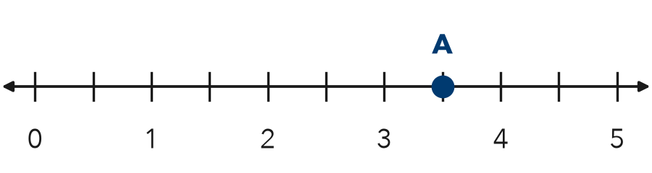

TRY IT WITH HELP fill in each step
4. Each whole has 2 jumps. Point B is 1 jump past 2. What number is B?
Step 1 Each jump is .
Step 2 Start at .
Step 3 1 jump: B = .

5. Each whole is split into 4 jumps. Point C is 3 jumps past 1. What number is C?
Step 1 Each jump is .
Step 2 Start at .
Step 3 3 jumps: C = .

YOUR TURN use the steps on your own

6. Each jump is 0.5. Start at the number. Make the jumps. Where do you land?
a. 2, 1 jump | b. 7, 1 jump | c. 0, 3 jumps
d. 4, 2 jumps | e. 5, 3 jumps | f. 8, 1 jump

READY CHECK a problem like the one in today’s lesson

7. Beakers read 2.5, 0.5, 6, and 8 degrees. Which reading is closest to 0?
A 2.5 | B 0.5 | C 6 | D 8

CHECK YOURSELF | □ I can do this on my own | □ I need a little help | □ I have a question about #

