Name Date Period
Lesson 7-4 · Session 1 · Practice · Form B
Comparing Numbers on a Number Line
Learning target — I can compare two rational numbers using their positions on a number line. · 6.NS.C.7a

REMEMBER  • On a number line, the number farther right is greater. Any positive number is greater than any negative number.  • For negatives, the one closer to 0 is greater. Bigger digits do not mean a bigger negative number: −13 > −40.  • For decimals, use the same number of digits: −0.06 > −0.60. | WORKED EXAMPLE  Compare −14 degrees and −5 degrees.  Step 1 Plot −14 and −5 on a number line.  Step 2 −5 is to the right of −14.  Step 3 Write the comparison: −14 < −5.  Answer −5 is greater; −14 is colder
WORDS greater than (mayor que) · less than (menor que) · inequality (desigualdad)
PRACTICE show your work · label units

1. Write < or > in each blank.
a. −6 −11 | b. −3.75 2.25
c. −9 −1 | d. 0 −7

2. Trivia Scores. Scores: Maya −8, Eli 4, Nora −3, Caleb 0.
Hint The score farthest right is greatest.
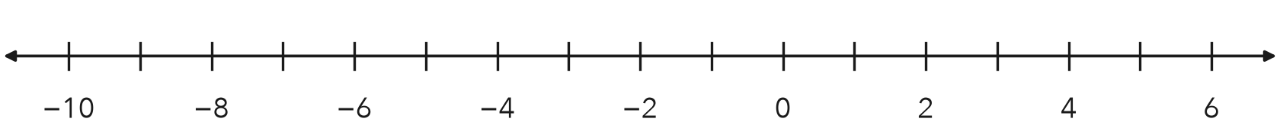
a. Plot and label all four scores.
b. Compare Nora and Maya using >.
c. Greatest score Least score

3. Two Accounts. One account ended at −28 dollars. Another ended at −53 dollars. Which balance is greater?  Hint Which is closer to 0?  Greater | 4. Freezer Check. One freezer holds at −21 degrees. Another holds at 3 degrees. Which reading is colder?  Colder
  Show your work.
  Show your work.

5. Two Cave Floors. Cave A has a floor at −13 m. Cave B has a floor at −31 m. Write a comparison using < or >. Which cave is deeper?
Hint The deeper floor is farther left.
Deeper

6. Eighths. Plot −5/8 and −3/8. Which number is greater?
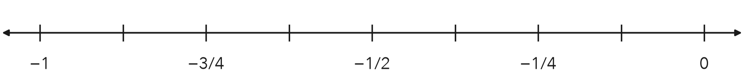
Greater

7. Kofi’s Claim. Kofi says −0.7 > −0.07 because seven tenths is more than seven hundredths. Is he right? Which number is greater?
Hint Write −0.7 as −0.70.

Show your work.
Greater

8. Three Accounts. Three accounts hold −60, 15, and −9 dollars.
a. Order the balances from least to greatest.
b. Which balance has the largest absolute value?
c. Why is that balance not the greatest?

Show your work.

FIND THE ERROR explain the mistake, then fix it

9. Owen’s Work. Owen wrote −22 > −7. He said 22 comes after 7 when you count, so −22 must be greater. Explain his mistake. Then write the correct comparison.

TEST PRACTICE choose the best answer

10. Which symbol makes 0 −4 true?
A < | B > | C = | D none of these

11. Which number is greatest?
A −12 | B −2 | C −20 | D −5

SELF-CHECK CODE find your answer · copy its letter into that problem’s box · spell a math word
−5/8  Z | −28  U | −3/8  E | −60  S | −3 > −8  N | −21  M | −53  Q | Cave B  B | −0.7  X | −0.07  R

#2b | #3 | #4 | #5 | #6 | #7 | #8b

CHECK YOURSELF | □ I can do this on my own | □ I need a little help | □ I have a question about #

