Name Date Period
Lesson 7-4 · Session 1 · Guided Notes
Comparing Numbers on a Number Line
Learning target — I can compare two rational numbers using their positions on a number line. · 6.NS.C.7a
WORDS TO KNOW fill in the missing words
WORD | WHAT IT MEANS | EXAMPLE
greater than (>)  mayor que | Farther to the on the number line. | 3 > −6
less than (<)  menor que | Farther to the on the number line. | −6 < −2
inequality  desigualdad | A math sentence that numbers using < or >. | −8 < −5
KEY IDEA complete each sentence
• On a number line, the number farther is greater.
• For two negative numbers, the one closer to is greater.
WORKED EXAMPLE fill in the blanks as we solve
Compare the temperatures −14 degrees and −5 degrees.
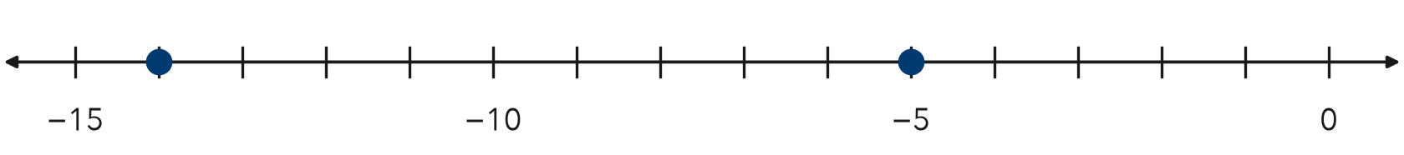
Step 1 −5 is to the of −14.
Step 2 So −14 −5.
Answer −5 is ; −14 is colder.
YOU TRY use the example as a model

1. Write < or > in each blank.
a. −7 −3 | b. −1.5 −2.5

2. Plot −3/4 and −1/4. Write a true comparison using <.
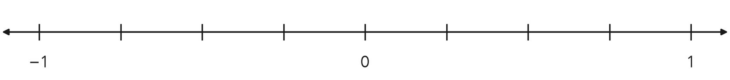
Comparison

SUM IT UP in your own words
To compare two negative numbers, I because .
Name Date Period
Lesson 7-4 · Session 2 · Guided Notes
Ordering Integers and Rational Numbers
Learning target — I can order integers and rational numbers from least to greatest. · 6.NS.C.7b
WORDS TO KNOW fill in the missing words
WORD | WHAT IT MEANS | EXAMPLE
order  orden | To list numbers from to greatest (or greatest to least). | −9, −2, 0, 6
least  mínimo | The smallest number; it is farthest to the . | −9 is the least
greatest  máximo | The biggest number; it is farthest to the . | 6 is the greatest
KEY IDEA complete each sentence
• Least to greatest means to right on a number line.
• Write every number in the same (such as decimals) before you order.
WORKED EXAMPLE fill in the blanks as we solve
Order −6, 1.5, −0.5, and 3/4 from least to greatest.
Step 1 Write 3/4 as a decimal: .
Step 2 Negatives first: −6 < .
Step 3 Then positives: 0.75 < 1.5.
Answer −6, −0.5, 3/4,
YOU TRY use the example as a model

1. Order from least to greatest.
a. −3, −8, 1 | b. −0.2, −2, −0.02

2. Three divers are at −12 m, −4.5 m, and −20.25 m. Which diver is deepest?

Show your work.
Deepest

SUM IT UP in your own words
To order rational numbers, I , then I .

