Name Date Period
Lesson 7-4 · Homework Packet · Sheet 1 of 2
Comparing Numbers on a Number Line
Maryland Standard 6.NS.C.7a · Learning target — I can compare two rational numbers using their positions on a number line.

REMEMBER  • Numbers get greater to the right and less to the left.  • Any positive number is greater than any negative number.  • −2 > −8 because −2 is farther right. < means is less than; > means is greater than. | WORKED EXAMPLE  Compare −3.5 and −1.5. Use < or >.  Step 1 −1.5 is to the right of −3.5 on the number line.  Step 2 Right means greater.  Answer −1.5 > −3.5
PRACTICE show your work · label units
1. Use the number line. Write < or > in each blank.
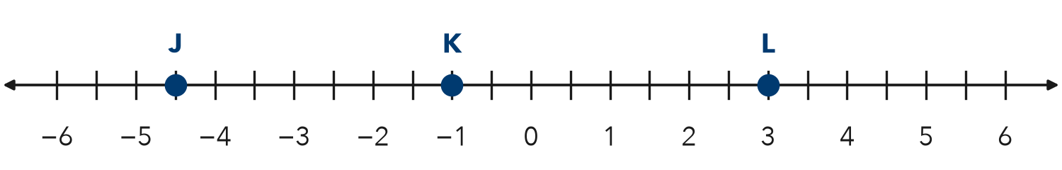
a. J K | b. L K | c. J L

2. Write < or > in each blank.
a. −8 −3 | b. 0 −6 | c. −2.5 −2.05
d. 4 −10 | e. −1/2 −3/4 | f. −7 −7.1

3. Plot −3.5 and −0.5 on the number line. Then write a true comparison using <.
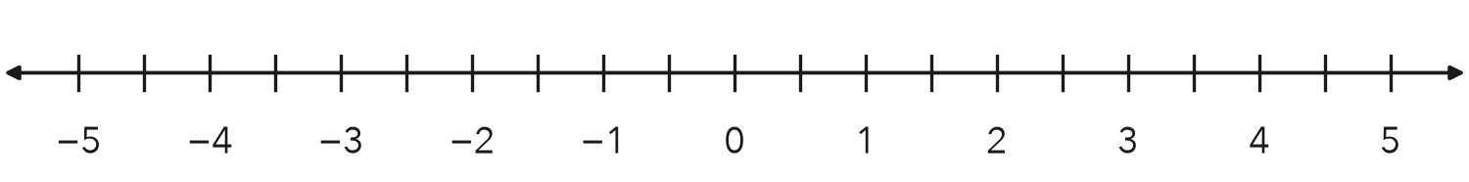

4. Golf. In golf, the lower score wins. Tanya scored −3. Malik scored −5.
a. Compare the scores using < or >.
b. Who won?

5. Cold Days. Monday’s low was −7 degrees. Tuesday’s low was −2 degrees. Which day was colder? Write a comparison using < or >.
Answer

6. Reasoning. Is −6 < |−6| true? Explain how you know.
Sentence Frame: "I know this because..."

CHECK YOURSELF | □ I can do this on my own | □ I need a little help | □ I have a question about #
AT HOME Ask someone at home: which is colder, −4 degrees or −9 degrees? Why?
Name Date Period
Lesson 7-4 · Homework Packet · Sheet 2 of 2
Ordering Integers and Rational Numbers
Maryland Standard 6.NS.C.7b · Learning target — I can order integers and rational numbers from least to greatest.

REMEMBER  • Place the numbers on a number line. Least is farthest left; greatest is farthest right.  • Change fractions to decimals to compare: −3/4 = −0.75.  • For negative numbers, the one farther from 0 is less. | WORKED EXAMPLE  Order −1.2, 0.5, −2, and −1/2 from least to greatest.  Step 1 Write −1/2 as −0.5.  Step 2 Read the number line from left to right.  Answer −2, −1.2, −1/2, 0.5
PRACTICE show your work · label units
1. Plot each number. Then write them in order from least to greatest: 1.5, −2.5, −3/4, 2 1/4, −3.25
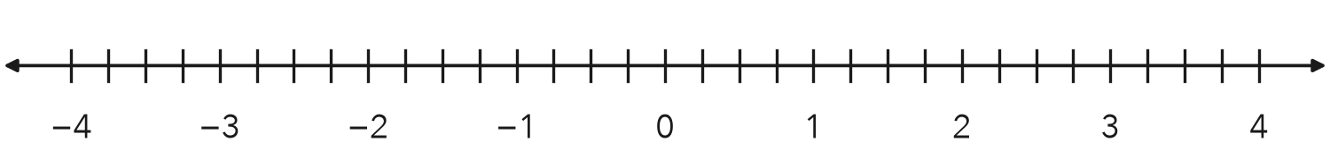
Order

2. Order each set from least to greatest.
a. −6, 4, −9, 0
b. −0.3, −3, −0.03

3. Circle the greatest number in each set.
a. −5, −2, −8 | b. −1.4, −1.04, −1.44
c. −2/3, −1/2, −3/4 | d. 0, −0.1, −10

4. Ocean Animals. A shark swims at −45.5 m, a turtle at −12 m, a dolphin at −30.25 m, and a jellyfish at −8.75 m. List the animals from deepest to closest to the surface.
Answer

5. Find the Error. Leo ordered −1/2, −0.4, and −0.6 from least to greatest as −0.4, −1/2, −0.6. Explain his mistake and write the correct order.

TEST PRACTICE choose the best answer
6. Which list is ordered from least to greatest?
A −5, −8, 0, 3 | B −8, −5, 0, 3 | C 0, −5, −8, 3 | D 3, 0, −5, −8

7. Which number is greatest?
A −2.7 | B −2.07 | C −2.77 | D −2.2

CHECK YOURSELF | □ I can do this on my own | □ I need a little help | □ I have a question about #
AT HOME List the low temperatures for three cold days with someone at home. Order them from coldest to warmest.

