Name Date Period
Lesson 7-4 · Session 1 · Prerequisite Practice B · Skill 1 of 2
Locate Rational Numbers
Builds on Lesson 7-2 Session 1 · 6.NS.C.6c
TODAY’S LESSON | You will plot −7/8 and −1/8 and decide which is greater.
YOU NEED TO | Plot a negative fraction, like −3/4: 3 fourths left of 0. You will use it in Practice Form A, problems 2 and 6.
STEPS TO FOLLOW use these same steps on every problem
1 | Negative means left of 0.
2 | Split 0 to −1 into equal parts. Use the bottom number.
3 | Count the top number of parts left from 0. Mark it.
WATCH ME the steps in action
Plot −3/4.  Step 1 −3/4 is left of 0.  Step 2 The bottom number is 4. Split 0 to −1 into 4 parts.  Step 3 Count 3 parts left from 0. Mark it.  Answer 3 parts left of 0 | 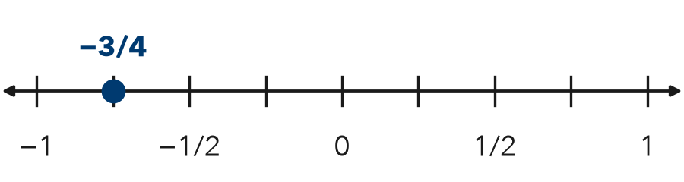

TRY IT WITH HELP fill in each step
1. Plot −1/2.
Step 1 −1/2 is of 0.
Step 2 Split 0 to −1 into parts.
Step 3 Count part left from 0.

2. Plot −5/8.
Step 1 −5/8 is of 0.
Step 2 Split 0 to −1 into parts.
Step 3 Count parts left from 0.

YOUR TURN use the steps on your own

3. For each number, write how many parts to split 0 to −1 into, then how many to count left.
a. −1/4 | b. −2/3 | c. −3/8
d. −4/5 | e. −1/3 | f. −5/6

Lesson 7-4 · Session 1 · Prerequisite Practice B · Skill 2 of 2
Write Integers for Situations
Builds on Lesson 7-1 Session 1 · 6.NS.C.5
TODAY’S LESSON | You will compare cave floors at −24 m and −9 m.
YOU NEED TO | Write an integer for a situation, like 24 m below sea level = −24. You will use it in Practice Form A, problems 3, 4, and 5.
STEPS TO FOLLOW use these same steps on every problem
1 | Find the zero point: the ground, sea level, or $0.
2 | Choose the sign: above or gain is +. Below or loss is −.
3 | Write the number with its sign.
WATCH ME the steps in action
A submarine is 35 m below sea level. Write an integer.
Step 1 Zero is sea level.
Step 2 Below sea level, so the sign is −.
Step 3 Write −35.
Answer −35
TRY IT WITH HELP fill in each step
4. A player loses 12 points. Write an integer.
Step 1 Zero is points.
Step 2 A loss, so the sign is .
Step 3 The integer is .

5. It is 6 degrees above 0. Write an integer.
Step 1 Zero is degrees.
Step 2 Above 0, so the sign is .
Step 3 The integer is .

YOUR TURN use the steps on your own

6. Write an integer for each situation.
a. owe $40 | b. 18 m below sea level
c. gain 7 yards | d. a $25 deposit
e. a drop of 3 degrees | f. 9 m below sea level

READY CHECK a problem like the one in today’s lesson

7. Cave A’s floor is 24 m below sea level. Which integer shows it?
A 24 | B −24 | C −2.4 | D 0

CHECK YOURSELF | □ I can do this on my own | □ I need a little help | □ I have a question about #

