Name Date Period
Lesson 7-4 · Session 2 · Prerequisite Practice B · Skill 1 of 2
Compare Rational Numbers
Builds on Lesson 7-4 Session 1 · 6.NS.C.7a
TODAY’S LESSON | You will order temperatures like −11, 4, −19, 0, and −2.
YOU NEED TO | Compare two numbers: the one farther left on the number line is less. You will use it in Practice Form A, problems 1 and 5.
STEPS TO FOLLOW use these same steps on every problem
1 | Picture both numbers on a number line.
2 | The number farther left is less.
3 | Write < with the lesser number first.
WATCH ME the steps in action
Compare −3.5 and −1.5.  Step 1 Plot −3.5 and −1.5.  Step 2 −3.5 is farther left.  Step 3 −3.5 < −1.5  Answer −3.5 < −1.5 | 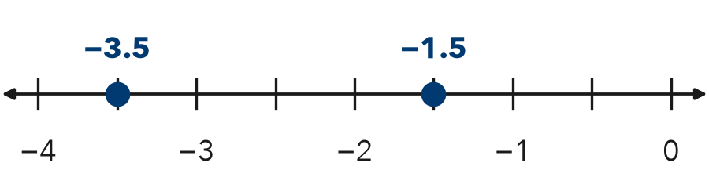

TRY IT WITH HELP fill in each step
1. Compare −6 and −2.
Step 1 Picture and on the line.
Step 2 Farther left:
Step 3 <

2. Compare −9 and 4.
Step 1 Picture and on the line.
Step 2 Farther left:
Step 3 <

YOUR TURN use the steps on your own

3. Write a true statement with < for each pair.
a. −7, 2 | b. −1, −8 | c. 0, −0.5
d. −4.2, −4.3 | e. −12, −21 | f. −3/4, −1/4

Lesson 7-4 · Session 2 · Prerequisite Practice B · Skill 2 of 2
Absolute Value as Distance
Builds on Lesson 7-3 Session 1 · 6.NS.C.7c
TODAY’S LESSON | You will decide which golf score is farther from 0, −7 or 5.
YOU NEED TO | Use absolute value to find distance from 0, like |−7| = 7. You will use it in Practice Form A, problems 2 and 6.
STEPS TO FOLLOW use these same steps on every problem
1 | Find the absolute value of each number.
2 | Compare the absolute values.
3 | The greater absolute value is farther from 0.
WATCH ME the steps in action
Which is farther from 0, −6 or −2?
Step 1 |−6| = 6 and |−2| = 2
Step 2 6 > 2
Step 3 −6 is farther from 0.
Answer −6
TRY IT WITH HELP fill in each step
4. Which is farther from 0, −7 or 5?
Step 1 |−7| = and |5| =
Step 2 7 5
Step 3 is farther from 0.

5. Which is farther from 0, −3 or 4?
Step 1 |−3| = and |4| =
Step 2 3 4
Step 3 is farther from 0.

YOUR TURN use the steps on your own

6. Which is farther from 0?
a. −5 or 3 | b. −8 or 8 | c. −2 or −9
d. −4.5 or 4 | e. 0 or −1 | f. −10 or 6

READY CHECK a problem like the one in today’s lesson

7. Readings: −1.5, 2, −3, and 0.5. Which is farthest from 0?
A −1.5 | B 2 | C −3 | D 0.5

CHECK YOURSELF | □ I can do this on my own | □ I need a little help | □ I have a question about #

