Name Date Period
Lesson 7-5 · Session 2 · Practice · Form B
Reflecting Points Across Axes
Learning target — I can reflect a point across the x-axis or the y-axis and name the new coordinates. · 6.NS.C.6b

REMEMBER  • A reflection flips a point like a mirror image. Only one coordinate changes sign.  • Across the x-axis, y changes sign: (4, 1) becomes (4, −1). Across the y-axis, x changes sign: (4, 1) becomes (−4, 1).  • A point and its image are the same distance from the mirror: (−5, 2) and (5, 2) are 5 + 5 = 10 units apart. | WORKED EXAMPLE  Reflect (7, −2) across the x-axis, then across the y-axis.  Step 1 Across the x-axis: keep x = 7, change −2 to 2. Image: (7, 2).  Step 2 Across the y-axis: keep y = −2, change 7 to −7. Image: (−7, −2).  Answer (7, 2) and (−7, −2)
WORDS reflection (reflexión) · x-axis (eje x) · y-axis (eje y)
PRACTICE show your work · label units

1. Write the image after each reflection.
a. (6, 2) across the x-axis | b. (−5, 7) across the y-axis
c. (8, −3) across the x-axis | d. (−10, −5) across the y-axis

2. Mirror Room. Ms. Rivera’s floor plan puts lamp L at (−5, 6). One mirror lies along each axis.  Hint Plot each image to check your answer.  a. Across the x-axis: ( , ) Quadrant  b. Across the y-axis: ( , ) Quadrant | 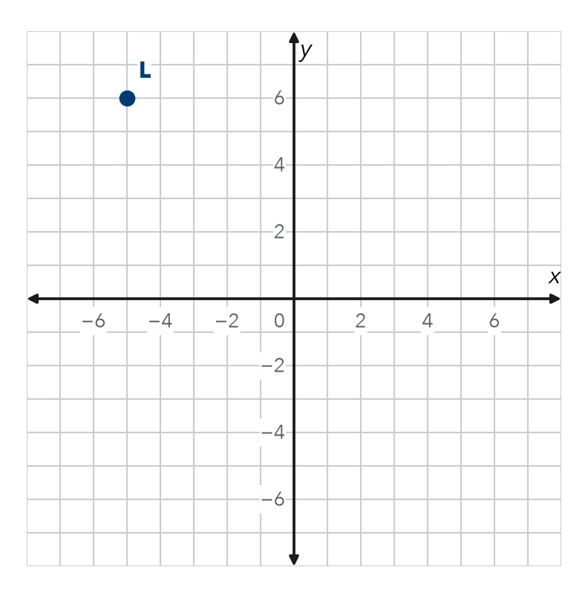

3. Two Kites. Maya’s kite flies over (−7, 2). Omar’s kite is its reflection across the y-axis. Where is Omar’s kite? How far apart are the kites?  Hint 7 units to the mirror, then 7 more.  Kite, distance | 4. Stage Lights. A light hangs over (−6, 9). A second light is its reflection across the x-axis. Where is it? How far apart are the lights?  Light 2, distance

5. Which Mirror? Point P is at (−4, 7) and point Q is at (4, 7). Across which axis are they reflections? How do the coordinates show it?
Hint Which coordinate changed sign?

6. Ana’s Image. Ana says reflecting (4, −5) across the y-axis gives (4, 5). What did she mix up? Write the correct image.
Hint Across the y-axis, y stays the same.

Show your work.
Image

7. Double Flip. Theo’s marker at (−6, −3) reflects across the x-axis. Then that image reflects across the y-axis.
a. First image:
b. Final image:
c. Quadrant of the final image:

8. Design Symmetry. A designer puts a corner at A(5, 2) and wants matching corners in the other three quadrants.
a. Reflect A across the y-axis.
b. Reflect A across the x-axis.
c. Name the fourth corner. How did you find it?

FIND THE ERROR explain the mistake, then fix it

9. Mateo’s Work. To reflect (−7, 2) across the x-axis, Mateo flipped both signs and wrote (7, −2). Explain his mistake. Then write the correct image.

TEST PRACTICE choose the best answer

10. Reflecting (5, 3) across the x-axis gives —
A (−5, 3) | B (5, −3) | C (−5, −3) | D (3, 5)

11. Reflecting (−2, 8) across the y-axis gives —
A (2, 8) | B (−2, −8) | C (2, −8) | D (8, −2)

SELF-CHECK CODE find your answer · copy its letter into that problem’s box · spell a math word
x-axis  Z | (4, 5)  Q | (6, 3)  R | (−4, −5)  T | (−5, −6)  Y | (−5, −2)  Y | y-axis  E | 18  M | (6, −2)  S | (7, 2)  M

#1a | #2a | #3 | #4 | #5 | #6 | #7b | #8c

CHECK YOURSELF | □ I can do this on my own | □ I need a little help | □ I have a question about #

