Name Date Period
Lesson 7-5 · Session 1 · Prerequisite Practice A · Skill 1 of 2
Plot Points in Quadrant I
Builds on Grade 5 · 5.G.A.1
TODAY’S LESSON | You will plot places like the Gate at (6, 3) and the Pond at (−4, 8).
YOU NEED TO | Plot a point like (4, 3): right 4, then up 3. You will use it in Practice Form A, problems 2 and 7.
STEPS TO FOLLOW use these same steps on every problem
1 | Start at the origin, (0, 0).
2 | Move right the first number (x).
3 | Move up the second number (y). Mark the point.
WATCH ME the steps in action
Plot the point (4, 3).  Step 1 Start at (0, 0).  Step 2 Move right 4.  Step 3 Move up 3. Mark the point.  Answer the point (4, 3) | 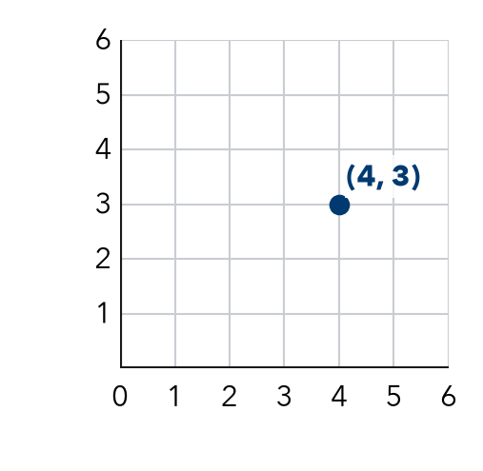

TRY IT WITH HELP fill in each step
1. Plot the point (2, 5).
Step 1 Start at .
Step 2 Move right .
Step 3 Move up . Mark the point.

2. Plot the point (6, 0).
Step 1 Start at .
Step 2 Move right .
Step 3 Move up . Mark the point.

YOUR TURN use the steps on your own

3. Start at the origin. Write the ordered pair for each set of moves.
a. right 2, up 6 | b. right 5, up 0 | c. right 0, up 4
d. right 7, up 1 | e. right 1, up 7 | f. right 4, up 4

Lesson 7-5 · Session 1 · Prerequisite Practice A · Skill 2 of 2
Locate Decimals Between Whole Numbers
Builds on Grade 4 · 4.NF.C.6
TODAY’S LESSON | You will plot points like (2.5, 3) and (−3.5, 2.5).
YOU NEED TO | Find where a decimal like 2.5 sits between whole numbers. You will use it in Practice Form A, problems 6 and 8.
STEPS TO FOLLOW use these same steps on every problem
1 | The number before the point is the whole number.
2 | The next whole number is one more.
3 | .25 is a quarter, .5 is halfway, .75 is three quarters.
WATCH ME the steps in action
Where is 2.75 on a number line?  Step 1 The whole number is 2.  Step 2 The next whole number is 3.  Step 3 .75 is three quarters of the way.  Answer between 2 and 3, close to 3 | 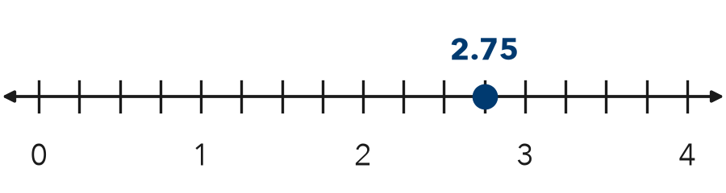

TRY IT WITH HELP fill in each step
4. Where is 3.5 on a number line?
Step 1 The whole number is .
Step 2 The next whole number is .
Step 3 .5 means of the way.

5. Where is 4.25 on a number line?
Step 1 The whole number is .
Step 2 The next whole number is .
Step 3 .25 means of the way.

YOUR TURN use the steps on your own

6. Write the two whole numbers each decimal is between.
a. 6.25 | b. 0.75 | c. 4.5
d. 1.25 | e. 9.75 | f. 2.5

READY CHECK a problem like the one in today’s lesson

7. A point has x = 4.5. Between which whole numbers is its x?
A between 4 and 5 | B between 3 and 4 | C at 45 | D between 5 and 6

CHECK YOURSELF | □ I can do this on my own | □ I need a little help | □ I have a question about #

