Name Date Period
Lesson 7-5 · Session 1 · Prerequisite Practice B · Skill 1 of 2
Locate Negative Decimals
Builds on Lesson 7-2 Session 1 · 6.NS.C.6c
TODAY’S LESSON | You will plot (−3.5, 2.5). First go 3.5 units left of the origin.
YOU NEED TO | Find a negative decimal like −3.5: halfway between −4 and −3. You will use it in Practice Form A, problem 6.
STEPS TO FOLLOW use these same steps on every problem
1 | Find the two integers the number sits between.
2 | Split that gap into equal parts.
3 | Count the parts away from 0. Mark the point.
WATCH ME the steps in action
Plot −2.5.  Step 1 −2.5 is between −2 and −3.  Step 2 Split −2 to −3 into 2 equal parts.  Step 3 Count 1 part left of −2. Mark it.  Answer halfway between −3 and −2 | 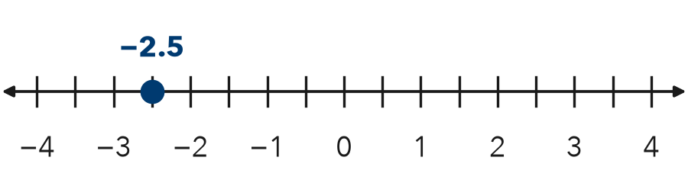

TRY IT WITH HELP fill in each step
1. Plot −1.5.
Step 1 −1.5 is between and .
Step 2 Split the gap into equal parts.
Step 3 Count part left of −1. Mark it.

2. Plot −0.5.
Step 1 −0.5 is between and .
Step 2 Split the gap into equal parts.
Step 3 Count part left of 0. Mark it.

YOUR TURN use the steps on your own

3. Write the two integers each number is between.
a. −3.5 | b. −6.25 | c. −0.75
d. −1.5 | e. −4.5 | f. −2.25

Lesson 7-5 · Session 1 · Prerequisite Practice B · Skill 2 of 2
Use Signs to Show Direction
Builds on Lesson 7-1 Session 2 · 6.NS.C.5
TODAY’S LESSON | You will turn “6 units left, 11 units above” into (−6, 11).
YOU NEED TO | Write a number for a move: left or down is −, right or up is +. You will use it in Practice Form A, problem 3.
STEPS TO FOLLOW use these same steps on every problem
1 | Read the direction word.
2 | Right or up is +. Left or down is −.
3 | Write the number with its sign.
WATCH ME the steps in action
A point is 4 units left of 0. Write its number.
Step 1 The direction is left.
Step 2 Left is −.
Step 3 Write −4.
Answer −4
TRY IT WITH HELP fill in each step
4. A point is 7 units down from 0. Write its number.
Step 1 The direction is .
Step 2 Down is .
Step 3 Write .

5. A point is 2.5 units up from 0. Write its number.
Step 1 The direction is .
Step 2 Up is .
Step 3 Write .

YOUR TURN use the steps on your own

6. Write a number for each move from 0.
a. 5 units right | b. 3 units left
c. 8 units down | d. 1.5 units up
e. 6.5 units left | f. 9 units up

READY CHECK a problem like the one in today’s lesson

7. A point is 4 units left and 9 units up from the origin. Which ordered pair names it?
A (4, 9) | B (−4, 9) | C (9, −4) | D (−4, −9)

CHECK YOURSELF | □ I can do this on my own | □ I need a little help | □ I have a question about #

