Name Date Period
Lesson 7-5 · Session 2 · Prerequisite Practice A · Skill 1 of 2
Find Mirror Images on a Grid
Builds on Grade 4 · 4.G.A.3
TODAY’S LESSON | You will reflect (−6, 3) across the y-axis.
YOU NEED TO | Find a mirror image: the same distance on the other side of the line. You will use it in Practice Form A, problems 3 and 4.
STEPS TO FOLLOW use these same steps on every problem
1 | Count how far the point is from the mirror line.
2 | Go the same distance on the other side.
3 | Keep the other coordinate the same.
WATCH ME the steps in action
The mirror line goes straight up through 4. Find the image of A(2, 3).  Step 1 A is 2 units left of the line.  Step 2 Go 2 units right of the line: x = 6.  Step 3 y stays 3. The image is (6, 3).  Answer (6, 3) | 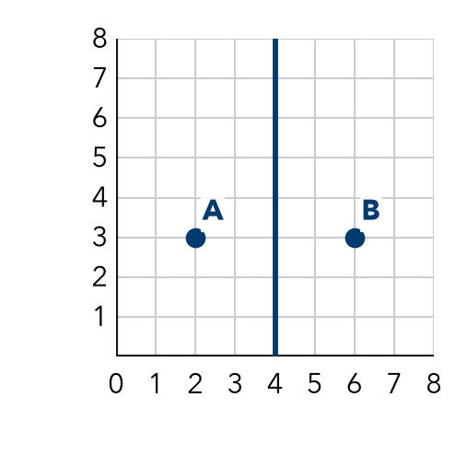

TRY IT WITH HELP fill in each step
1. The mirror line goes straight up through 4. Find the image of (3, 2).
Step 1 (3, 2) is unit left of the line.
Step 2 Go 1 unit right of the line: x = .
Step 3 y stays 2. The image is .

2. The mirror line goes straight up through 4. Find the image of (1, 6).
Step 1 (1, 6) is units left of the line.
Step 2 Go 3 units right of the line: x = .
Step 3 y stays 6. The image is .

YOUR TURN use the steps on your own

3. The mirror line goes straight up through 4. Find the image of each point.
a. (2, 5) | b. (0, 3) | c. (4, 7)
d. (3.5, 1) | e. (6, 2) | f. (8, 4)

Lesson 7-5 · Session 2 · Prerequisite Practice A · Skill 2 of 2
Name the x- and y-Coordinates
Builds on Grade 5 · 5.G.A.1
TODAY’S LESSON | You will see that (2, −7) and (2, 7) differ only in y.
YOU NEED TO | Name the x- and y-coordinates of a point, like (3, −5): x = 3, y = −5. You will use it in Practice Form A, problems 5 and 6.
STEPS TO FOLLOW use these same steps on every problem
1 | The first number is x (left or right).
2 | The second number is y (up or down).
3 | Compare two points one coordinate at a time.
WATCH ME the steps in action
Which coordinate is different: (4, 7) or (4, −7)?
Step 1 x: 4 and 4.
Step 2 y: 7 and −7.
Step 3 x is the same. y is different.
Answer y
TRY IT WITH HELP fill in each step
4. Which coordinate is different: (−3, 6) or (3, 6)?
Step 1 x: and .
Step 2 y: and .
Step 3 Different:

5. Which coordinate is different: (5, −2) or (−5, 2)?
Step 1 x: and .
Step 2 y: and .
Step 3 Different:

YOUR TURN use the steps on your own

6. Which coordinate is different? Write x, y, or both.
a. (−9, −4) and (−9, 4) | b. (2.5, 1) and (−2.5, 1)
c. (8, 0) and (−8, 0) | d. (1, 3) and (−1, −3)
e. (0, 5) and (0, −5) | f. (−6, 2) and (6, 2)

READY CHECK a problem like the one in today’s lesson

7. Point M is (3, −4) and point N is (3, 4). Which coordinate is different?
A x only | B y only | C both x and y | D neither

CHECK YOURSELF | □ I can do this on my own | □ I need a little help | □ I have a question about #

