Name Date Period
Lesson 7-5 · Session 2 · Prerequisite Practice B · Skill 1 of 2
Find Opposites of Rational Numbers
Builds on Lesson 7-2 Session 2 · 6.NS.C.6a
TODAY’S LESSON | You will reflect points. Each reflection changes one coordinate to its opposite.
YOU NEED TO | Find the opposite of a number, like −5.5 and 5.5. You will use it in Practice Form A, problems 1 and 7.
STEPS TO FOLLOW use these same steps on every problem
1 | Find the number’s distance from 0.
2 | Switch sides of 0: left becomes right, right becomes left.
3 | Write the number on the new side. −( ) means the opposite of.
WATCH ME the steps in action
Find the opposite of −5.5.  Step 1 −5.5 is 5.5 units from 0.  Step 2 −5.5 is left of 0. Switch to the right.  Step 3 The opposite is 5.5.  Answer 5.5 | 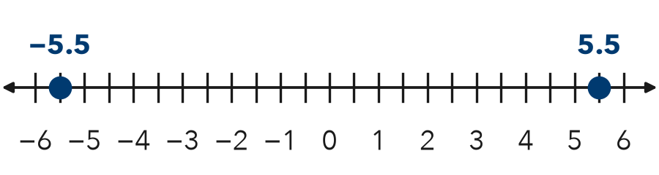

TRY IT WITH HELP fill in each step
1. Find the opposite of 3.25.
Step 1 3.25 is units from 0.
Step 2 3.25 is right of 0. Switch to the .
Step 3 The opposite is .

2. Find −(−8).
Step 1 −8 is units from 0.
Step 2 −8 is left of 0. Switch to the .
Step 3 −(−8) =

YOUR TURN use the steps on your own

3. Write the opposite of each number.
a. 9 | b. −4 | c. −11
d. 0 | e. −0.75 | f. −7.5

Lesson 7-5 · Session 2 · Prerequisite Practice B · Skill 2 of 2
Name a Point’s Quadrant
Builds on Lesson 7-5 Session 1 · 6.NS.C.6b
TODAY’S LESSON | You will name the quadrant where each reflected point lands.
YOU NEED TO | Name a quadrant from the signs, like (5, −2) is in Quadrant IV. You will use it in Practice Form A, problems 2 and 7.
STEPS TO FOLLOW use these same steps on every problem
1 | Look at the x sign: + is right, − is left.
2 | Look at the y sign: + is up, − is down.
3 | Name the quadrant: I up-right, II up-left, III down-left, IV down-right.
WATCH ME the steps in action
Which quadrant holds (5, −2)?
Step 1 x = 5 is +, so right.
Step 2 y = −2 is −, so down.
Step 3 Down and right is Quadrant IV.
Answer Quadrant IV
TRY IT WITH HELP fill in each step
4. Which quadrant holds (−2, 6)?
Step 1 x is −, so .
Step 2 y is +, so .
Step 3 Quadrant

5. Which quadrant holds (−7, −1)?
Step 1 x is −, so .
Step 2 y is −, so .
Step 3 Quadrant

YOUR TURN use the steps on your own

6. Name the quadrant.
a. (3, 8) | b. (4, −9) | c. (−0.5, 3)
d. (1.5, −2.5) | e. (−6, −6) | f. (−3, 4)

READY CHECK a problem like the one in today’s lesson

7. (4, 7) reflects across the x-axis to (4, −7). Which quadrant is (4, −7) in?
A Quadrant I | B Quadrant II | C Quadrant III | D Quadrant IV

CHECK YOURSELF | □ I can do this on my own | □ I need a little help | □ I have a question about #

