Name Date Period
Lesson 7-6 · Session 1 · Practice · Form A
Distance Between Points on a Grid
Learning target — I can find the distance between two points that share a coordinate. · 6.NS.C.8

REMEMBER  • Same y-coordinate: the points are side to side. Use the x-coordinates.  • Same x-coordinate: the points are up and down. Use the y-coordinates.  • Opposite signs: add the absolute values. Same sign: subtract them. (5, −2) to (5, −9) is 9 − 2 = 7. | WORKED EXAMPLE  Each unit is 1 meter. Find the distance from P(−9, 4) to Q(3, 4), and from P to R(−9, 11).  Step 1 P and Q share y = 4, so use x. −9 and 3 have opposite signs: 9 + 3 = 12 m.  Step 2 P and R share x = −9, so use y. 4 and 11 are both positive: 11 − 4 = 7 m.  Answer PQ = 12 m and PR = 7 m
WORDS distance (distancia) · absolute value (valor absoluto) · coordinate plane (plano de coordenadas)
PRACTICE show your work · label units

1. Find the distance between each pair of points.
a. (3, 14) and (3, 4) | b. (−11, 2) and (6, 2)
c. (−13, 9) and (−13, −6) | d. (−6, 4) and (5, 4)

2. Town Map Walk. Each unit is 1 kilometer. Library (−8, 5), Pool (7, 5), Clinic (−8, −6).  a. Plot and label the three places.  b. Library to Pool km  c. Library to Clinic km | 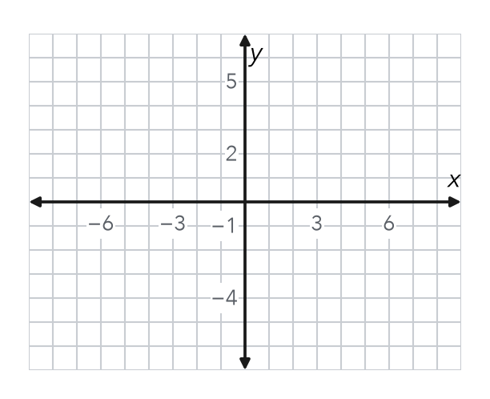

3. Drone Flight. A drone flies straight from (−5, 13) to (−5, −4). Each unit is 1 meter. How far does it fly?  Hint Same x, so use y. 13 and −4 have opposite signs.  Answer m | 4. One Quadrant. Find the distance from (−16, −7) to (−16, −20).  Hint Both y-values are negative, so subtract.  Answer units
  Show your work.
  Show your work.

5. Missing Point. Point G is at (10, −3). Point H is 15 units directly to the left of G. Name point H.  Hint Moving left changes only x: 10 − 15.  H = | 6. Window Washer. A window washer moves from (21, 18) to (21, 7). Each unit is 1 foot. How far does the washer move?  Hint Are 18 and 7 on the same side of 0?  Answer ft
  Show your work.
  Show your work.

7. Bus Route. A bus runs straight from (−17, −4) to (12, −4). Each unit is 1 block. How far does the bus go?

Show your work.
Answer blocks

8. City Grid. Each unit is 1 block. A library is at (−4, 6), a school at (5, 6) and a park at (5, −3). Plot the walk on the grid.  a. Library to school blocks  b. School to park blocks  c. Total walk blocks | 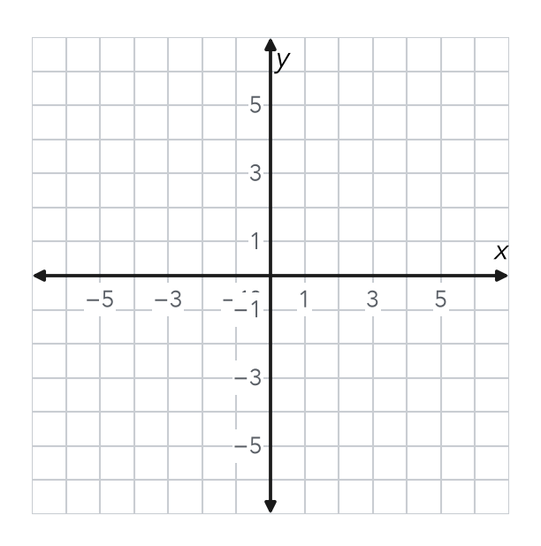

FIND THE ERROR explain the mistake, then fix it

9. Malik’s Work. To find the distance from (2, −9) to (2, 6), Malik wrote 9 − 6 = 3 units. Explain his mistake. Then find the correct distance.

TEST PRACTICE choose the best answer

10. The distance from (4, 2) to (4, 9) is —
A 2 units | B 7 units | C 11 units | D 13 units

11. The distance from (−3, 5) to (6, 5) is —
A 3 units | B 9 units | C 11 units | D −9 units

SELF-CHECK CODE find your answer · copy its letter into that problem’s box · spell a math word
(−5, −3)  N | 17  L | 27  Q | 25  J | 18  H | 13  E | 11  G | 5  X | 29  T | (25, −3)  Z

#3 | #4 | #5 | #6 | #7 | #8c

CHECK YOURSELF | □ I can do this on my own | □ I need a little help | □ I have a question about #

