Name Date Period
Lesson 7-6 · Session 2 · Practice · Form A
Comparing Distances on the Plane
Learning target — I can decide whether to add or subtract to find a distance, then compare two distances. · 6.NS.C.8

REMEMBER  • Find each distance first. Then compare the two numbers.  • Changing coordinates with opposite signs: add. Same sign: subtract.  • With a scale, change both distances to real units before you compare. A distance is never negative. | WORKED EXAMPLE  Jo walks from (−3, 10) to (−3, 2). Sam walks from (6, −8) to (−7, −8). Each unit is 1 block. Who walks farther?  Step 1 Jo: same x, both positive, so 10 − 2 = 8 blocks.  Step 2 Sam: same y, opposite signs, so 6 + 7 = 13 blocks.  Answer Sam walks farther, by 13 − 8 = 5 blocks.
WORDS distance (distancia) · quadrant (cuadrante) · compare (comparar)
PRACTICE show your work · label units

1. Add or subtract? Find each distance.
a. (5, −3) to (5, −15) | b. (5, −3) to (5, 10)
c. (−4, 1) to (6, 1) | d. (3, −8) to (3, −2)

2. Campus Map. The map shows a gym (G), a field (F) and an office (O). Each grid unit stands for 10 meters.  a. Gym to Field m  b. Gym to Office m  c. Which trip is longer? By how many meters? | 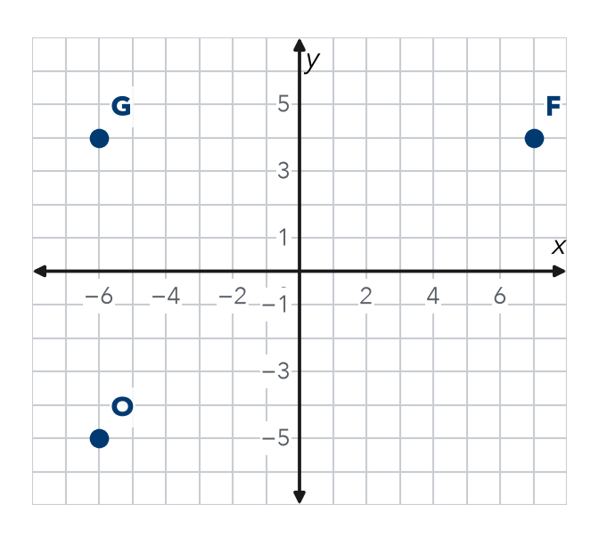

3. Two Riders. From (−9, 5), Tariq rides to (−9, −8) and Jada rides to (6, 5). Each unit is 1 block. Who rides farther, and by how much?
Hint Each ride keeps one coordinate. Check the signs of the other one.

Show your work.
By

4. Partner Point. Point T is at (−4, 16). Point U is 22 units directly below T. Name point U.  Hint Moving down changes only y: 16 − 22.  U = | 5. Place the Stop. Point N is at (13, −5). Point M is 20 units directly to the left of N. Name point M.  Hint Moving left changes only x: 13 − 20.  M =
  Show your work.
  Show your work.

6. Two Hikes. Kendra hikes from (−11, 12) to (−11, 3). Owen hikes from (−2, −15) to (10, −15). Each unit is 1 km. Who hikes farther, and by how much?

Show your work.
By

7. Two Walks. From (4.25, 5.75), Ana walks to (4.25, −3.25) and Ben walks to (4.25, 9.75). Who walks farther, and by how much?
Hint Decimals work the same way. Check the signs of the y-values.

Show your work.
By

8. Delivery Routes. A depot is at (0, 0). Stop 1 is at (0, 12), Stop 2 is at (0, −9) and Stop 3 is at (0, 4).
a. Find the distance from the depot to each stop.
b. Order the stops from closest to farthest.
c. Find the distance from Stop 1 to Stop 2. units

FIND THE ERROR explain the mistake, then fix it

9. Ines’s Work. To find the distance from (−8, 3) to (4, 3), Ines wrote 8 − 4 = 4 units. Explain her mistake. Then find the correct distance.

TEST PRACTICE choose the best answer

10. Two coordinates on the same side of zero call for —
A addition | B subtraction | C multiplication | D division

11. A distance can never be —
A zero | B a decimal | C negative | D greater than 10

SELF-CHECK CODE find your answer · copy its letter into that problem’s box · spell a math word
2  L | 1  J | 1.5  X | (33, −5)  Z | 3  G | 21  R | (−4, 38)  Q | (−4, −6)  O | 5  E | (−7, −5)  N

#3 | #4 | #5 | #6 | #7 | #8c

CHECK YOURSELF | □ I can do this on my own | □ I need a little help | □ I have a question about #

