Name Date Period
Lesson 7-6 · Homework Packet · Sheet 1 of 2
Distance Between Points on a Grid
Maryland Standard 6.NS.C.8 · Learning target — I can find the distance between two points that share a coordinate.

REMEMBER  • Same x-coordinate: the points are on a vertical line. Use the y-coordinates.  • Same y-coordinate: the points are on a horizontal line. Use the x-coordinates.  • Opposite signs: add the absolute values. Same signs: subtract them. | WORKED EXAMPLE  Find the distance from (3, −4) to (3, 5).  Step 1 Same x, so use the y-coordinates −4 and 5.  Step 2 Opposite signs, so add: 4 + 5 = 9.  Answer 9 units
PRACTICE show your work · label units

1. Use the grid. Find each distance.  a. A to B units  b. B to C units  c. A to D units | 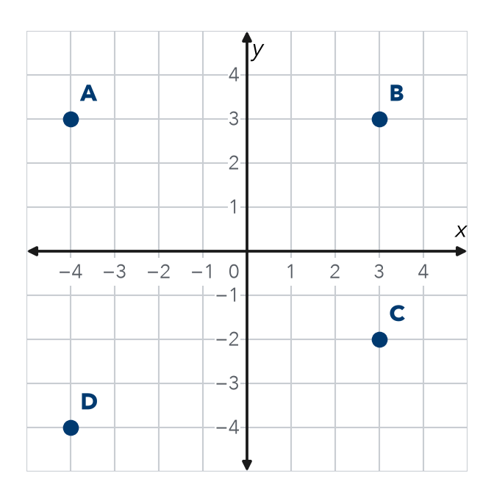

2. Find the distance between each pair of points.
a. (5, 6) and (5, −2) | b. (−7, 1) and (−2, 1)
c. (−3, −4) and (6, −4) | d. (0, −8) and (0, 3)
e. (−9, −2) and (−9, −7) | f. (2.5, 3) and (−4, 3)
g. (−1, −6) and (−1, 4) | h. (−8, 5) and (−3.5, 5)

3. City Blocks. Kim walks straight from (−6, −3) to (−6, 5). Each unit is 1 block. How far does she walk?
Answer blocks

4. Missing Point. Point P is at (2, −3). Point Q is 6 units to the left of P. Name point Q.
Answer

5. Find the Error. Eli says the distance from (1, −6) to (1, −2) is 8 because 6 + 2 = 8. Explain his mistake and find the correct distance.

CHECK YOURSELF | □ I can do this on my own | □ I need a little help | □ I have a question about #
AT HOME With someone at home, count the blocks between two places on one street.
Name Date Period
Lesson 7-6 · Homework Packet · Sheet 2 of 2
Comparing Distances on the Plane
Maryland Standard 6.NS.C.8 · Learning target — I can decide whether to add or subtract to find a distance, then compare two distances.

REMEMBER  • Find each distance first. Then compare.  • Different signs: add. Same sign: subtract.  • A distance is never negative. | WORKED EXAMPLE  Which is longer: (−2, 4) to (5, 4), or (1, −3) to (1, 5)?  Step 1 First: same y, use x: 2 + 5 = 7 units.  Step 2 Second: same x, use y: 3 + 5 = 8 units. 8 > 7.  Answer the second one
PRACTICE show your work · label units

1. Neighborhood. Each unit is 1 block. Which is closer to Home: the Library or the Park?  a. H to L blocks  b. H to P blocks  c. Which is closer? By how many blocks? | 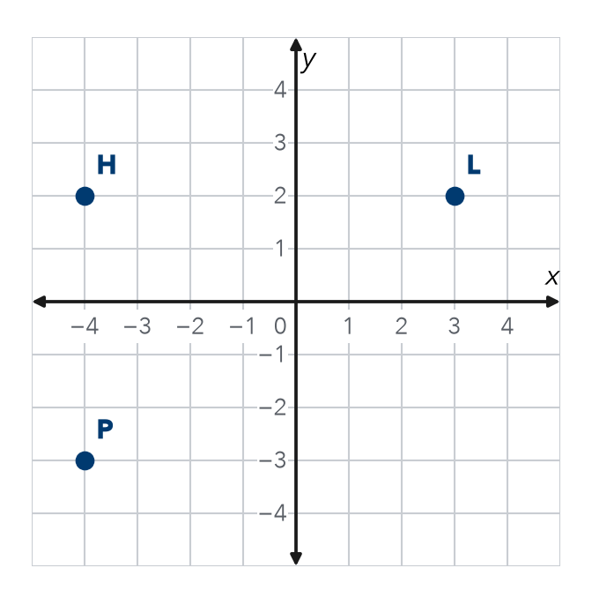

2. Find each distance.
a. (−8, 1) to (−3, 1) | b. (4, −6) to (4, 7)
c. (−6, −7) to (−6, −1) | d. (−2.5, 3) to (4.5, 3)

3. Runners. Ana runs from (−5, −1) to (6, −1). Jay runs from (2, 4) to (2, −6). Who runs farther, and by how many units?
Answer

4. Reasoning. For (−3, 7) to (−3, −2), do you add or subtract? Explain, then find the distance.

TEST PRACTICE choose the best answer
5. Segment JK runs from (−4, 2) to (6, 2). Segment MN runs from (1, −3) to (1, 5). Which is longer?
A JK, by 2 units | B MN, by 2 units | C neither | D JK, by 8 units

6. Point A is at (−2, −5). Point B is at (−2, 3). What is the distance from A to B?
A 2 units | B 3 units | C 8 units | D −8 units

CHECK YOURSELF | □ I can do this on my own | □ I need a little help | □ I have a question about #
AT HOME With someone at home, pick two places on one street. Which is closer to your home? By how many blocks?

