Name |  | Date |  | Period
LESSON 7-6 · SESSION 1 · GUIDED PRACTICE
Distance Between Points on a Grid
TODAY’S GOAL I can find the distance between two points on a grid line.

THE IDEA
If two points have the same y-number, they are side to side. Use the x-numbers. If they have the same x-number, they are up and down. Use the y-numbers.
Tip: Opposite sides of an axis: add the absolute values. Same side: subtract them. Example: (5, −2) to (5, −9) is 9 − 2 = 7.
Tip: To find a missing point, move from a point. 6 units left of (4, 1) is (4 − 6, 1) = (−2, 1).

EXAMPLE | Read each step.
Example: Each unit is 1 meter. Find the distance from P(−9, 4) to Q(3, 4), and from P to R(−9, 11).
1 | P and Q have the same y, so use the x-numbers.
2 | Subtract: 3 − (−9) = 12. So PQ = 12 m.
3 | P and R have the same x, so use the y-numbers.
4 | Subtract: 11 − 4 = 7. So PR = 7 m.
5 | State the answer: PQ is 12 meters and PR is 7 meters.
Check: Did I use only the number that changes?

WORDS TO KNOW | Read the meaning; find the word in a problem.
distance  Spanish: distancia | How far apart two points are. | zero or a positive length
absolute value  Spanish: valor absoluto | How many units a number is from 0, ignoring its sign. | |−7| = 7
horizontal distance  Spanish: distancia horizontal | How far apart two points are, side to side. | uses the x-coordinates
vertical distance  Spanish: distancia vertical | How far apart two points are, up and down. | uses the y-coordinates
coordinate plane  Spanish: plano de coordenadas | A flat grid with a horizontal number line and a vertical one. | x-axis across, y-axis up

TRY IT TOGETHER | Use the example above to complete each part.
1. Town Map Walk
On a town map each unit is one kilometer: Library (−8, 5), Pool (7, 5), Clinic (−8, −6), and Depot (7, −6).
a. Plot. Plot and label all four town places on the coordinate plane below.
b. Horizontal. Library to Pool: ______ km Which coordinates did you use? __________
c. Vertical. Library to Clinic: ______ km Did you add or subtract the distances? ______

d. Reason. Which coordinates change in each trip? Explain why both trips cross zero. _________  Sentence Frame: "I know this because..." | 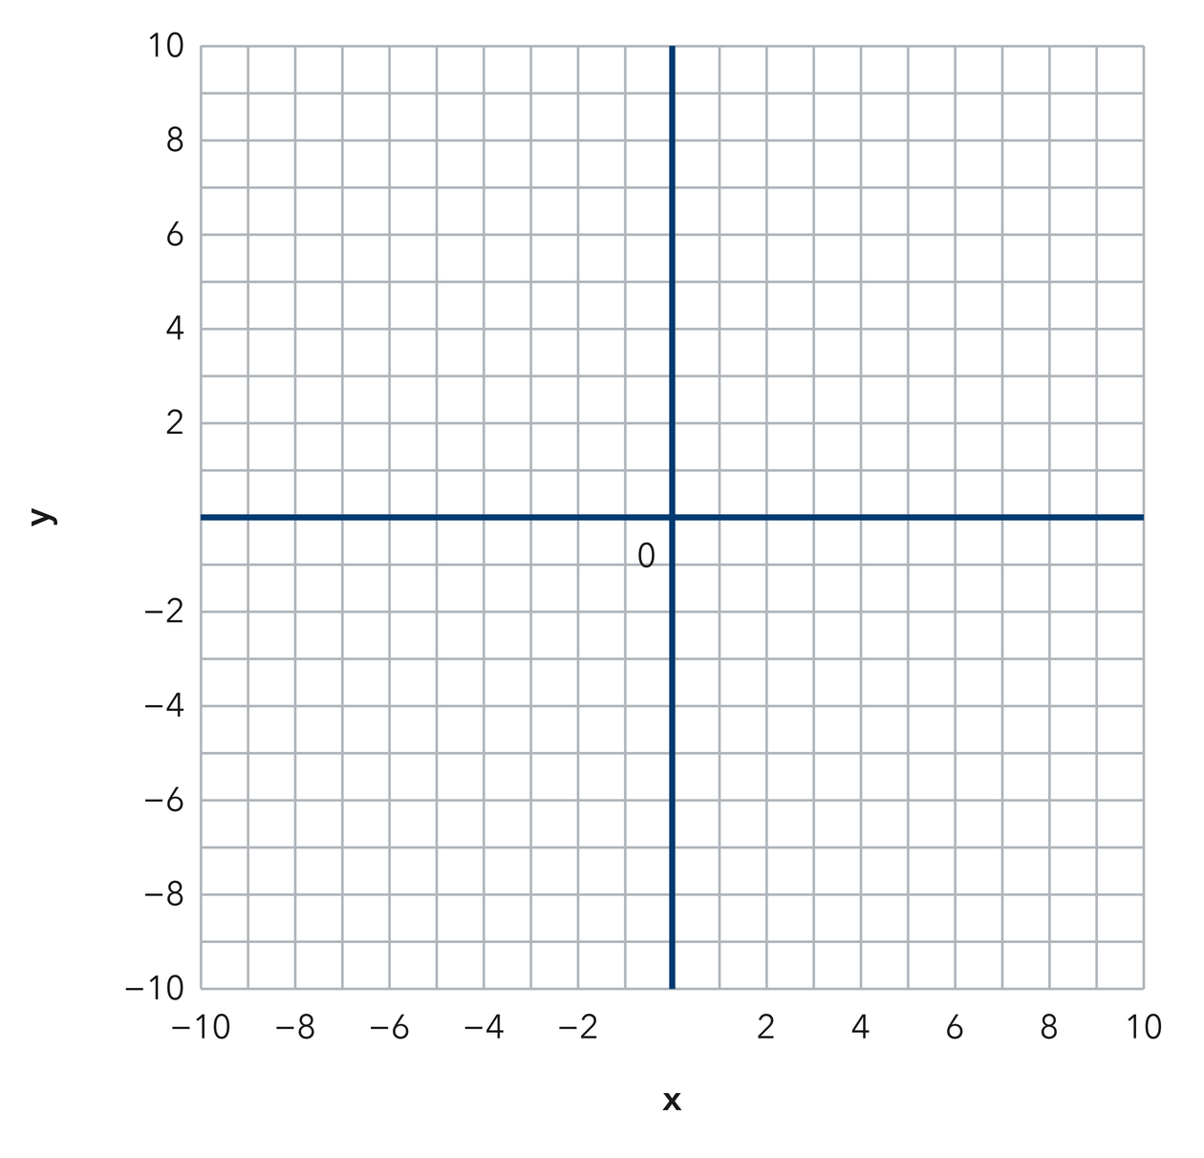​

TURN AND TALK
How can the coordinates alone tell you whether a trip runs across or up and down?

PRACTICE WITH A PARTNER | Take turns solving and explaining. Check each other’s work.
2. Two Buoys. Two buoys float at (3, 14) and (3, 4) on a lake grid where each unit is one meter.  a. Which coordinate do the two buoys share? __________  b. Distance between the buoys __________ | 3. Two Towers. Two radio towers stand at (−11, 2) and (6, 2) on a map grid.  a. Absolute value of each x-coordinate __________  b. Distance between the towers __________
  PARTNER TALK
  Why do two points on the same side of an axis call for subtraction instead?
  PARTNER TALK
  How does crossing the y-axis change the way you combine the two distances?

4. Two Flagpoles. Two flagpoles stand at (−13, 9) and (−13, −6) on a campus grid where each unit is one meter.
a. Which coordinate do the two poles share? __________
b. Distance between the poles __________

PARTNER TALK
Why does a trip that crosses the x-axis join the two distances instead of taking one away?
Sentence Frame: "I know this because..."

PRACTICE ON YOUR OWN | Show your steps. Label quantities. Use a hint if you need one.
5. Drone Flight. A drone flies straight from (−5, 13) to (−5, −4) on a grid where each unit is one meter.  Find the distance the drone travels and explain why you used the y-coordinates.  Sentence Frame: "I know this because..."  Hint Draw a visual model (like a tape diagram or double number line) to show this relationship.  Answer distance flown, in meters | 6. One Quadrant. Find the distance from the point (−16, −7) to the point (−16, −20) on a coordinate grid.  Hint Draw a visual model (like a tape diagram or double number line) to show this relationship.  Answer distance, in units

7. Missing Point. Point G sits at (10, −3). Point H sits 15 units directly to the left of point G.  Write the coordinates of point H and explain how the distance gave you its x-coordinate.  Sentence Frame: "I know this because..."  Hint Draw a visual model (like a tape diagram or double number line) to show this relationship.  Answer coordinates of point H | 8. Bus Route. A bus runs straight from (−17, −4) to (12, −4) on a city grid where each unit is one block.  Find the distance the bus travels, then explain why you used the x-coordinates.  Sentence Frame: "I know this because..."  Hint Draw a visual model (like a tape diagram or double number line) to show this relationship.  Answer distance traveled, in blocks

9. Window Washer. A window washer moves from (21, 18) to (21, 7) on a building grid where each unit is one foot.  Find the distance the washer moves, then explain why you subtracted the two absolute values.  Sentence Frame: "I know this because..."  Hint Draw a visual model (like a tape diagram or double number line) to show this relationship.  Answer distance moved, in feet | 10. Vertical Line. On a map where each unit is one kilometer, find the distance from (3, 8) to (3, −2).  Hint Draw a visual model (like a tape diagram or double number line) to show this relationship.  Answer kilometres

11. Horizontal Line. Find the distance from (−6, 4) to (5, 4).  Hint Draw a visual model (like a tape diagram or double number line) to show this relationship.  Answer units | Coordinate plane. Plot both points and draw the segment between them.​
  Show your work.

12. Same Side. Find the distance from (2, −9) to (2, −3).  a. Which coordinate do you use? __________  b. Find the distance. __________  Hint Draw a visual model (like a tape diagram or double number line) to show this relationship.  Answer: label your responses a and b | c. Coordinate plane. Plot both points and draw the segment between them.​
  Show your work.

FIND AND FIX THE MISTAKE | Explain what went wrong, then solve it correctly.
13. Read the student’s work. Identify the incorrect step, explain why it is incorrect, and show a correct solution.
Sentence Frame: "I know this because..."

MALIK’S WORK
To find the distance from (2, −9) to (2, 6), Malik subtracted and wrote 3 units, saying nine minus six is three.
a. Explain the mistake. Check the signs of the two y-coordinates. Does this trip cross the x-axis? | b. Show correct work  Correct answer (with units, if needed)
  Write the correct steps and label the answer. Check that it fits the problem.

PUT THE IDEAS TOGETHER | Solve each part. Explain how the steps connect.
Sentence Frame: "I know this because..."
14. City Grid. On a map with one unit per block, a library sits at (−4, 6), a school at (5, 6), and a park at (5, −3).  a. Find the distance from the library to the school.  b. Find the distance from the school to the park.  c. Find the total walking distance from the library to the park by way of the school.  Answer both distances and the total | d. Coordinate plane. Plot the library, the school and the park, then draw the walking route.​
  Show your work.

CHOOSE THE BEST ANSWER | Solve first, then mark one answer for each question.
15. The distance from (4, 2) to (4, 9) is — | 16. Two points with the same x-value lie on a —
  □ A. 5 | □ B. 11 | □ C. 7 | □ D. 13
  □ A. circle | □ B. horizontal line. | □ C. diagonal | □ D. vertical line.

17. The distance from (−3, 5) to (6, 5) is — | 18. The distance from (1, −4) to (1, −10) is —
  □ A. 9 | □ B. 3 | □ C. 11 | □ D. 30
  □ A. 14 | □ B. 6 | □ C. −6 | □ D. 40

REVIEW EARLIER SKILLS | Show the steps you remember; check your result.
19. From Lesson 7-5 Session 2. Reflect (4, 3) across the x-axis.  Answer (include labels or units) | 20. From Lesson 7-4 Session 2. Order −2, −11, and 3 from least to greatest.  Answer (include labels or units)

21. From Lesson 6-7 Session 2. Find the LCM of 6 and 14.  Answer (include labels or units) | 22. From Lesson 5-5 Session 1. A prism is 8 cm by 5 cm by 2 cm. Find its volume.  Answer (include labels or units)

SHOW WHAT YOU LEARNED | Solve on your own, then check your answer.
23. Trail Markers. Two trail markers sit at (−14, 8) and (19, 8) on a park grid where each unit is one meter.
a. Distance between the two markers __________
b. Did you add or subtract the absolute values? __________
Hint Draw a visual model (like a tape diagram or double number line) to show this relationship.

Answer (include labels or units)

□ 4 — Can teach it | □ 3 — Got it | □ 2 — Need hint | □ 1 — Need help
Mark one confidence box. Star a problem you can explain. If you need help, write its number: _____.

