Lesson 7-7 · Session 1

Polygons and Perimeter on the Plane
Version 2 / Regular
Name ______________________________ Date ______________ Period ______
Maryland Standard 6.G.A.3 · Learning target — I can find the perimeter and area of a polygon drawn on the coordinate plane.
Show a model, calculation, or explanation. Answer every part and label units when needed.
Exercises 1–12 earn 1 point for a correct response and 1 for supporting work. Spiral Review and Test Practice earn 1 point each.
Learn from a model
REMEMBER  • You can plot a polygon’s vertices on a coordinate plane, then find its side lengths using the distance between points.  • Perimeter = the sum of all the side lengths.  • Watch out — a side that crosses zero needs its two absolute values added, not subtracted.  • Check it — sketch the polygon and label each side before you add or multiply. | WORKED EXAMPLE  Finding the Perimeter of a Rectangle from Its Vertices A rectangle has vertices at (−8.5, 7.5), (5.5, 7.5), (5.5, −3.5), and (−8.5, −3.5). Find its perimeter.  Step 1 Plot the four vertices and connect them in order to draw the rectangle.  Step 2 Top side: the y-coordinates match, so use the x-values: |−8.5| + |5.5| = 14  Step 3 Left side: the x-coordinates match, so use the y-values: |7.5| + |−3.5| = 11  Step 4 Perimeter adds all four sides: 14 + 11 + 14 + 11 = 50  Answer The rectangle measures 14 units by 11 units, so its perimeter is 50 units.

Practice
1. A rectangle has vertices (0,0), (0,4), (6,4), (6,0). Find the length of each side, then the perimeter.
Answer ______________________________
SHOW YOUR THINKING


2. A right triangle has vertices (0,0), (0,5), (3,0). Find its two leg lengths using the grid.
Answer ______________________________
DRAW YOUR GRAPH / LABEL BOTH AXES AND THE SCALE
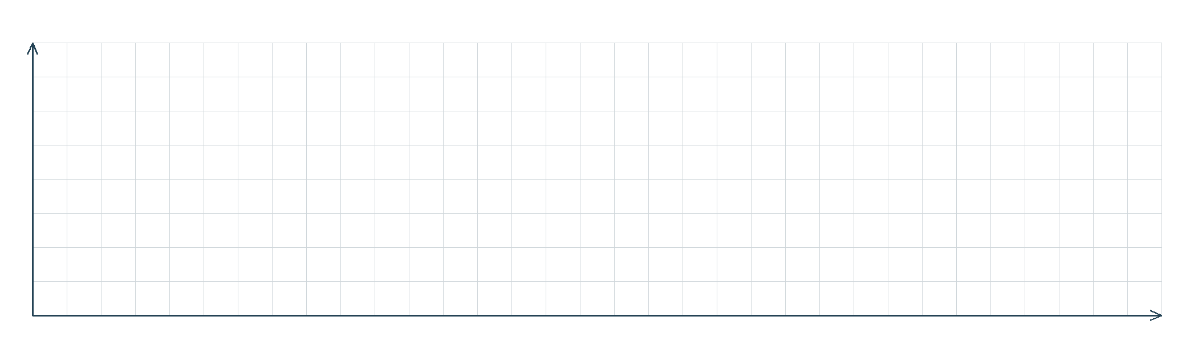

3. Explain how you find a horizontal or vertical side length using coordinates.
Sentence Frame: "I know this because..."
Answer ______________________________
EXPLAIN WITH MATHEMATICAL EVIDENCE


4. Write each answer on the line.
a. Distance between (−4, 3) and (7, 3): ______
b. Distance between (2, 9) and (2, −5): ______
c. Perimeter of a rectangle 8 units by 5 units: ______
d. Perimeter of a square with side 9 units: ______
e. Area of a rectangle 6 units by 7 units: ______
Answer ______________________________
SHOW YOUR THINKING


5. Sandbox. A sandbox has corners at (−5, 2), (7, 2), (7, −6), and (−5, −6). Each unit is one foot. Find both side lengths.
Answer ______________________________
SHOW YOUR THINKING

6. Poster Border. A poster has corners at (−3, 10), (9, 10), (9, −4), and (−3, −4). Each unit is one inch. Find the perimeter of the poster.
Answer ______________________________
SHOW YOUR THINKING

7. Fourth Corner. Three corners of a rectangle sit at (−8, 6), (4, 6), and (4, −5). Find the fourth corner, then find the perimeter in grid units.
Answer ______________________________
SHOW YOUR THINKING

8. For a side joining (−9, 2) and (6, 2), Bri wrote the length as 3 units, because nine minus six is three. Explain the mistake, then show the correct length.
Answer ______________________________
EXPLAIN WITH MATHEMATICAL EVIDENCE

9. A rectangle has vertices at (−4, 3), (8, 3), (8, −5), and (−4, −5). Find its perimeter.
Answer ______________________________ units
SHOW YOUR THINKING

10. For the same rectangle, find the area.
Answer ______________________________ square units
SHOW YOUR THINKING

11. Find the Sides. A rectangle has vertices at (2, 9), (11, 9), (11, 1), and (2, 1). Find both side lengths.
Answer ______________________________ both sides
SHOW YOUR THINKING

12. Find the Mistake. For a side from (−5, 2) to (4, 2), Jo wrote 1 unit. Explain the mistake.
Answer ______________________________ the mistake and the length
EXPLAIN WITH MATHEMATICAL EVIDENCE

Spiral review
13. From Lesson 7-6 Session 1. Find the distance from (6, −3) to (6, 5).
Answer ______________________________
SHOW YOUR THINKING

14. From Lesson 6-6 Session 1. Simplify 8k + 1 + 2k.
Answer ______________________________
SHOW YOUR THINKING

15. From Lesson 4-4 Session 1. Find 40% of 175.
Answer ______________________________
SHOW YOUR THINKING

Test practice
16. A rectangle with sides 11 and 6 has a perimeter of —
□ A. 66 | □ B. 34
□ C. 17 | □ D. 22

17. A rectangle with sides 11 and 6 has an area of —
□ A. 17 | □ B. 34
□ C. 66 | □ D. 132

18. The distance from (0, −4) to (0, 6) is —
□ A. 24 | □ B. 2
□ C. −10 | □ D. 10

Check and revise
CHECK YOUR MATHEMATICS  Use the scale and count every side once.  Every part answered / Work shown / Units labeled when needed | HOW DID IT GO?  I can do this:  Independently / With a hint / With help  Question to revisit: ______
One correction or question I want to discuss: __________________________________
Check signs, scale, and labels. Use a number line or coordinate grid to verify one response.

