Name Date Period
Lesson 8-1 · Session 2 · Prerequisite Practice A · Skill 1 of 2
Round to Estimate
Builds on Grade 4 · 4.NBT.A.3
TODAY’S LESSON | A class donated 75 cans and had 22 left. Estimate first: 80 + 20 = 100.
YOU NEED TO | Round to the nearest ten to estimate, like 75 + 22 is about 100. You will use it in Practice Form A, problem 6.
STEPS TO FOLLOW use these same steps on every problem
1 | Look at the ones digit.
2 | 5 or more: round up. Less than 5: round down.
3 | Add or subtract the rounded numbers.
WATCH ME the steps in action
Estimate 58 + 26.
Step 1 The ones digits are 8 and 6.
Step 2 58 rounds to 60. 26 rounds to 30.
Step 3 60 + 30 = 90.
Answer about 90
TRY IT WITH HELP fill in each step
1. Estimate 44 − 26.
Step 1 The ones digits are and .
Step 2 44 rounds to . 26 rounds to .
Step 3 40 − 30 =

2. Estimate 90 − 58.
Step 1 The ones digits are and .
Step 2 90 stays 90. 58 rounds to .
Step 3 90 − 60 =

YOUR TURN use the steps on your own

3. Estimate. Round each number to the nearest ten first.
a. 75 + 22 | b. 61 + 28
c. 83 − 47 | d. 39 + 54

Lesson 8-1 · Session 2 · Prerequisite Practice A · Skill 2 of 2
Model Parts and Wholes
Builds on Grade 2 · 2.OA.A.1
TODAY’S LESSON | A bus left with 44 students; 26 stayed on. 44 is the whole.
YOU NEED TO | Find a missing part: whole − known part = missing part. You will use it in Practice Form A, problems 4 and 5.
STEPS TO FOLLOW use these same steps on every problem
1 | Find the whole: the total amount.
2 | Find the known part.
3 | Subtract: whole − known part = missing part.
WATCH ME the steps in action
A full box has 50 crayons. It has 32. How many are missing?  Step 1 The whole is 50.  Step 2 The known part is 32.  Step 3 50 − 32 = 18.  Answer 18 crayons | 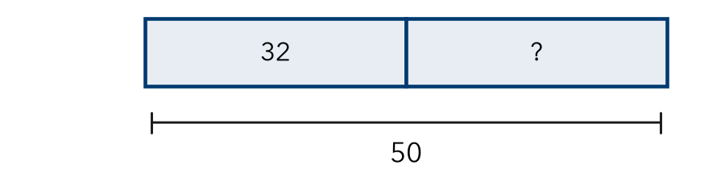

TRY IT WITH HELP fill in each step
4. A bus had 30 kids. Some got off. 18 are still on. How many got off?
Step 1 The whole is .
Step 2 The known part is .
Step 3 30 − 18 =

5. A book has 64 pages. Lia read 40. How many pages are left?
Step 1 The whole is .
Step 2 The known part is .
Step 3 64 − 40 =

YOUR TURN use the steps on your own

6. Find the missing part.
a. whole 40, part 25 | b. whole 75, part 50
c. whole 100, part 63 | d. whole 52, part 17

READY CHECK a problem like the one in today’s lesson

7. 36 riders, then 21 stay on. Which equation finds g, who got off?
A 36 + 21 = g | B 36 − g = 21 | C g − 36 = 21 | D 21 − g = 36

CHECK YOURSELF | □ I can do this on my own | □ I need a little help | □ I have a question about #

