Name Date Period
Lesson 8-3 · Session 1 · Practice · Form A
Multiplication Equations
Learning target — I can solve a multiplication equation by dividing both sides by the same number. · 6.EE.B.7

REMEMBER  • The coefficient is the number next to the variable. 5b means 5 × b.  • Division undoes multiplication. Divide both sides by the coefficient.  • Check by multiplying: coefficient × your answer = the total. | WORKED EXAMPLE  5 boxes each hold the same number of pencils, 45 in all. Solve 5b = 45.  Step 1 Divide both sides by 5: 5b ÷ 5 = 45 ÷ 5.  Step 2 Simplify: b = 9.  Step 3 Check: 5 × 9 = 45.  Answer Each box holds 9 pencils.
WORDS coefficient (coeficiente) · inverse operation (operación inversa) · Division Property of Equality (propiedad de división de la igualdad)
PRACTICE show your work · label units

1. Solve each equation.
a. 12k = 60 | b. 9m = 117 | c. 11w = 88
d. 4y = 10 | e. 15t = 90 | f. 2r = 7

2. Soccer Cleats. A team spent $175 on 5 pairs of cleats. Each pair cost the same, p dollars.
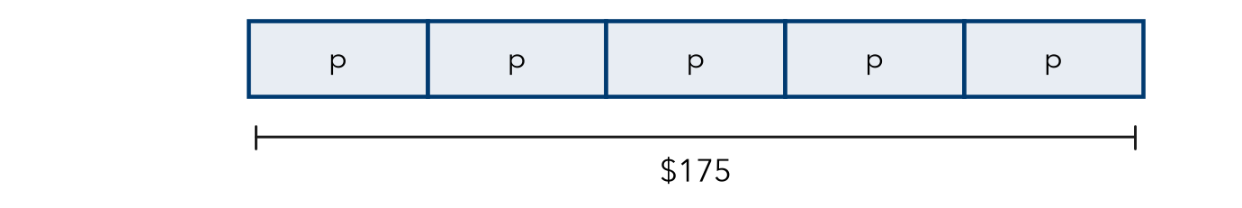
a. Write a multiplication equation.
b. Solve it.
c. Check by multiplying.

3. Bookshelf Rows. A bookshelf holds the same number of books on each of its 7 shelves. It holds 133 books in all. Write and solve an equation for b, the books on one shelf.
Hint Shelves × books on one shelf = all books.

Show your work.
Answer books

4. Egg Cartons. A farm fills 15 cartons with e eggs each, 270 eggs in all. Solve 15e = 270.  Hint Divide both sides by 15.  e = | 5. Training Miles. A runner ran m miles each day for 14 days, 154 miles in all. Solve 14m = 154.  m =
  Show your work.
  Show your work.

6. Car Wash. A car wash charges the same price for every car. Washing 24 cars brought in $336. Write and solve an equation for the price of one wash.
Hint The number of cars is the coefficient.

Show your work.
Price

7. Field Day Water. A crew fills 18 identical coolers. Together they hold 216 cups of water. Write and solve an equation for the cups in one cooler. Check it.
Hint Check: 18 × your answer should be 216.

Show your work.
Answer cups

8. Concert Rows. A hall has r rows with 24 seats in each row. It has 648 seats in all.
a. Write and solve an equation for the number of rows.
b. Ten rows are removed for a stage. How many seats are left?
c. How can you check part a without dividing again?

FIND THE ERROR explain the mistake, then fix it

9. Nadia’s Work. To solve 5x = 65, Nadia multiplied both sides by 5. She wrote x = 325. Explain her mistake. Then solve correctly.

TEST PRACTICE choose the best answer

10. Solve 8n = 96.
A n = 88 | B n = 768 | C n = 12 | D n = 104

11. In 4y = 28, the number 4 is the —
A variable | B coefficient | C solution | D total

SELF-CHECK CODE find your answer · copy its letter into that problem’s box · spell a math word
35  P | 18  O | 19  R | 27  T | 11  D | 12  C | 140  Z | $14  U | $312  X | 875  Q

#2b | #3 | #4 | #5 | #6 | #7 | #8a

CHECK YOURSELF | □ I can do this on my own | □ I need a little help | □ I have a question about #

