Name Date Period
Lesson 8-3 · Session 1 · Practice · Form B
Multiplication Equations
Learning target — I can solve a multiplication equation by dividing both sides by the same number. · 6.EE.B.7

REMEMBER  • The coefficient is the number next to the variable. 5b means 5 × b.  • Division undoes multiplication. Divide both sides by the coefficient.  • Check by multiplying: coefficient × your answer = the total. | WORKED EXAMPLE  5 boxes each hold the same number of pencils, 45 in all. Solve 5b = 45.  Step 1 Divide both sides by 5: 5b ÷ 5 = 45 ÷ 5.  Step 2 Simplify: b = 9.  Step 3 Check: 5 × 9 = 45.  Answer Each box holds 9 pencils.
WORDS coefficient (coeficiente) · inverse operation (operación inversa) · Division Property of Equality (propiedad de división de la igualdad)
PRACTICE show your work · label units

1. Solve each equation.
a. 13k = 78 | b. 8m = 136 | c. 12w = 84
d. 4y = 14 | e. 16t = 64 | f. 2r = 9

2. Soccer Cleats. A team spent $258 on 6 pairs of cleats. Each pair cost the same, p dollars.
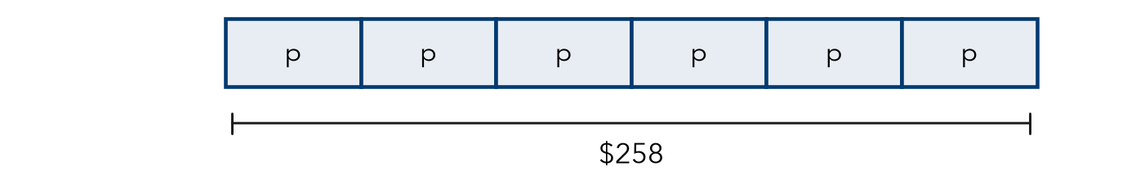
a. Write a multiplication equation.
b. Solve it.
c. Check by multiplying.

3. Bookshelf Rows. A bookshelf holds the same number of books on each of its 8 shelves. It holds 168 books in all. Write and solve an equation for b, the books on one shelf.
Hint Shelves × books on one shelf = all books.

Show your work.
Answer books

4. Egg Cartons. A farm fills 12 cartons with e eggs each, 264 eggs in all. Solve 12e = 264.  Hint Divide both sides by 12.  e = | 5. Training Miles. A runner ran m miles each day for 16 days, 208 miles in all. Solve 16m = 208.  m =
  Show your work.
  Show your work.

6. Car Wash. A car wash charges the same price for every car. Washing 28 cars brought in $420. Write and solve an equation for the price of one wash.
Hint The number of cars is the coefficient.

Show your work.
Price

7. Field Day Water. A crew fills 16 identical coolers. Together they hold 224 cups of water. Write and solve an equation for the cups in one cooler. Check it.
Hint Check: 16 × your answer should be 224.

Show your work.
Answer cups

8. Concert Rows. A hall has r rows with 26 seats in each row. It has 754 seats in all.
a. Write and solve an equation for the number of rows.
b. Ten rows are removed for a stage. How many seats are left?
c. How can you check part a without dividing again?

FIND THE ERROR explain the mistake, then fix it

9. Omar’s Work. To solve 6x = 78, Omar multiplied both sides by 6. He wrote x = 468. Explain his mistake. Then solve correctly.

TEST PRACTICE choose the best answer

10. Solve 7n = 84.
A n = 77 | B n = 12 | C n = 588 | D n = 91

11. To solve a multiplication equation, you —
A multiply both sides by the coefficient | B subtract the coefficient
C divide both sides by the coefficient | D add the coefficient

SELF-CHECK CODE find your answer · copy its letter into that problem’s box · spell a math word
21  I | 13  I | 29  S | 43  D | 14  E | $392  X | 22  V | $15  D | 192  Z | 1,548  Q

#2b | #3 | #4 | #5 | #6 | #7 | #8a

CHECK YOURSELF | □ I can do this on my own | □ I need a little help | □ I have a question about #

