Name Date Period
Lesson 8-4 · Session 2 · Practice · Form B
Representing Inequalities
Learning target — I can represent an inequality with a set of solutions and describe them. · 6.EE.B.8

REMEMBER  • Closed (filled) circle: the boundary counts (≤, ≥). Open circle: it does not (<, >).  • Arrow left for less than. Arrow right for greater than.  • Check the story: people and tickets come only in whole numbers. | WORKED EXAMPLE  An elevator allows no more than 8 people. Show the solutions for p.  Step 1 Write the rule: p ≤ 8.  Step 2 “No more than” includes 8, so draw a closed circle at 8 and an arrow left.  Step 3 People come in whole numbers: 0, 1, 2, … , 8.  Answer p ≤ 8, whole numbers 0 to 8
WORDS number line (recta numérica) · open circle (círculo abierto) · closed circle (círculo cerrado)
PRACTICE show your work · label units

1. Write the inequality for each graph. Use x.
a. open circle at 2, arrow left | b. closed circle at −3, arrow right
c. closed circle at 5, arrow left | d. open circle at −1, arrow right

2. Meeting Room. A meeting room may hold at most 90 people at one time.
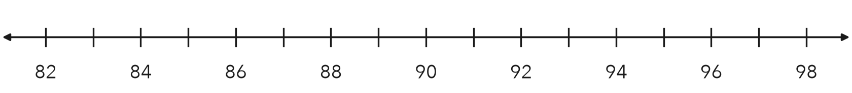
a. Write an inequality for n, the number of people.
b. Graph it on the number line.

3. Fish Tank. The graph shows the safe water temperatures, t, for a fish tank. Write the inequality. Is 80 degrees a solution?
Hint Look at the circle at 80. Is it open or closed?
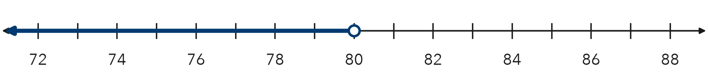
Answer

4. Locker Bag. A bag must be shorter than 24 inches to fit in a locker. Write an inequality for h. Name two solutions and one non-solution.  Answer | 5. Lab Station. A lab station may hold at most 6 students. Write an inequality for s. Is 6 a solution?  Hint “At most” includes the boundary.  Answer
  Show your work.
  Show your work.

6. Parade Float. A float must be shorter than 13 feet to pass under a bridge.
Hint “Shorter than” leaves the boundary out.
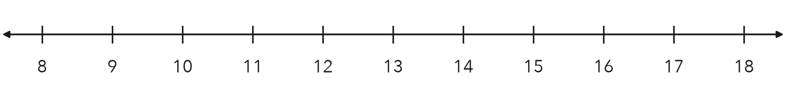
a. Write an inequality for h.
b. Graph it on the number line.

7. Name Solutions. For n > 4, name three solutions and one number that is not a solution.

Show your work.
Answer

8. Delivery Limit. A van’s load, w, must be at least 40 pounds and at most 800 pounds.
a. Write both inequalities.
b. Name three loads that fit both rules.
c. Why is 800 pounds allowed but 801 pounds is not?

FIND THE ERROR explain the mistake, then fix it

9. Theo’s Work. A study hall may seat at most 32 students. Theo wrote s < 32. Explain his mistake. Write the correct inequality.

TEST PRACTICE choose the best answer

10. Which value is a solution of n ≤ 9?
A 9 | B 9.5 | C 10 | D 12

11. Which value is NOT a solution of x ≤ 7?
A 7 | B 6.5 | C 0 | D 7.5

SELF-CHECK CODE find your answer · copy its letter into that problem’s box · spell a math word
n < 90  Q | t ≤ 80  Z | s < 6  X | w ≥ 40  S | h < 13  W | w > 40  J | s ≤ 6  O | h < 24  R | n ≤ 90  A | t < 80  R

#2a | #3 | #4 | #5 | #6a | #8a

CHECK YOURSELF | □ I can do this on my own | □ I need a little help | □ I have a question about #

