EXIT TICKET · LESSON 8-4 · SESSION 1 Name
Writing Inequalities

1. Write an inequality for each phrase. Use x.
a. at most 40 | b. more than 6

2. A class wins a prize when it collects more than 300 cans. Write an inequality for c. Is 300 a solution?

Show your work.
Answer

3. Which phrase means ≥?
A at most | B less than | C at least | D more than

HOW DID IT GO? □ I got it □ Almost □ I need help
cut here
EXIT TICKET · LESSON 8-4 · SESSION 1 Name
Writing Inequalities

1. Write an inequality for each phrase. Use x.
a. at most 40 | b. more than 6

2. A class wins a prize when it collects more than 300 cans. Write an inequality for c. Is 300 a solution?

Show your work.
Answer

3. Which phrase means ≥?
A at most | B less than | C at least | D more than

HOW DID IT GO? □ I got it □ Almost □ I need help
EXIT TICKET · LESSON 8-4 · SESSION 2 Name
Representing Inequalities

1. Write the inequality shown. Use x.
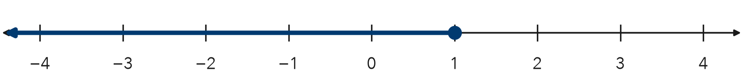
Inequality

2. Is each number a solution of x ≥ −2? Write yes or no.
a. −2 | b. −3

3. Which graph shows x > 3?
A open circle at 3, arrow right | B closed circle at 3, arrow right
C open circle at 3, arrow left | D closed circle at 3, arrow left

HOW DID IT GO? □ I got it □ Almost □ I need help
cut here
EXIT TICKET · LESSON 8-4 · SESSION 2 Name
Representing Inequalities

1. Write the inequality shown. Use x.
Inequality

2. Is each number a solution of x ≥ −2? Write yes or no.
a. −2 | b. −3

3. Which graph shows x > 3?
A open circle at 3, arrow right | B closed circle at 3, arrow right
C open circle at 3, arrow left | D closed circle at 3, arrow left

HOW DID IT GO? □ I got it □ Almost □ I need help

