Name Date Period
Lesson 8-4 · Session 1 · Guided Notes
Writing Inequalities
Learning target — I can write an inequality that describes a constraint in a real situation. · 6.EE.B.8
WORDS TO KNOW fill in the missing words
WORD | WHAT IT MEANS | EXAMPLE
inequality  desigualdad | A math sentence that using <, >, ≤ or ≥. | x ≥ 18
at least  al menos | That number (≥). | at least 5: x ≥ 5
at most  a lo sumo | That number or (≤). | at most 8: x ≤ 8
more than  más que | than the number, not equal to it (>). | more than 5: x > 5
KEY IDEA complete each sentence
• First decide whether the boundary number is .
• Allowed: use ≤ or . Not allowed: use < or .
WORKED EXAMPLE fill in the blanks as we solve
To make the team, a swimmer must swim more than 20 laps. Write an inequality for L, the laps.
Step 1 Key words: “ .”
Step 2 Is 20 allowed? , so use >.
Step 3 Inequality: L 20.
Answer L > 20, so 20 laps is a solution.
YOU TRY use the example as a model

1. Write an inequality for each phrase. Use x.
a. at least 13 | b. fewer than 9

2. A coupon works on orders of $50 or less. Write an inequality for d, the order amount. Does a $50 order work?

Show your work.
Answer

SUM IT UP in your own words
To choose an inequality symbol, I because .
Name Date Period
Lesson 8-4 · Session 2 · Guided Notes
Representing Inequalities
Learning target — I can represent an inequality with a set of solutions and describe them. · 6.EE.B.8
WORDS TO KNOW fill in the missing words
WORD | WHAT IT MEANS | EXAMPLE
open circle  círculo abierto | The boundary is a solution (< or >). | x > 3: open circle at 3
closed circle  círculo cerrado | The boundary a solution (≤ or ≥). | x ≤ 3: closed circle at 3
solutions of an inequality  soluciones de una desigualdad | the numbers that make it true. | x > 3: 3.5, 4, 10, …
KEY IDEA complete each sentence
• Draw a circle at the number.
• For < or ≤, the arrow points . For > or ≥, it points .
WORKED EXAMPLE fill in the blanks as we solve
Graph x < 3.
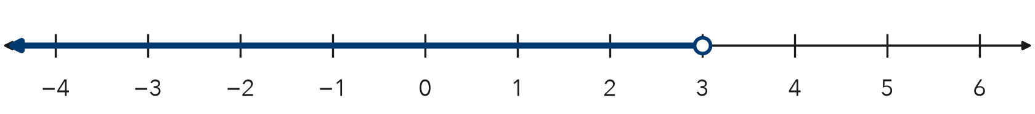
Step 1 The boundary is .
Step 2 < does not include 3, so draw an circle.
Step 3 Draw the arrow to the .
Answer Sample solutions: 2, 0, −1.5
YOU TRY use the example as a model

1. Write the inequality shown. Use x.
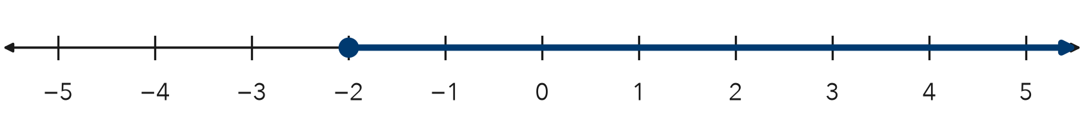
Inequality

2. Is each number a solution of n > 7? Write yes or no.
a. 7 | b. 7.5

SUM IT UP in your own words
To graph an inequality, I because .

