Name Date Period
Lesson 8-5 · Session 1 · Practice · Form A
Graphing Inequalities
Learning target — I can graph an inequality on a number line using an open or a closed dot. · 6.EE.B.8

REMEMBER  • An open dot means the boundary is NOT a solution (< or >). A closed dot means it is (≤ or ≥).  • Point the arrow toward the numbers that work: > and ≥ point right; < and ≤ point left.  • At least means ≥. At most means ≤. Under means <. | WORKED EXAMPLE  Graph x < 6 on a number line.  Step 1 The boundary number is 6.  Step 2 < does not include 6, so draw an open dot at 6.  Step 3 Less than 6 means the arrow points left. Test: 5 < 6 is true.  Answer open dot at 6, arrow pointing left
WORDS boundary point (punto límite) · closed circle (círculo cerrado) · open circle (círculo abierto)
PRACTICE show your work · label units

1. Describe each graph: open or closed dot, and the arrow direction.
a. n > 6 | b. k ≤ 2
c. x ≥ −3 | d. p < 8

2. Donation Box. A food pantry accepts a donation box only when it weighs at least 15 pounds. Let w be the weight in pounds.
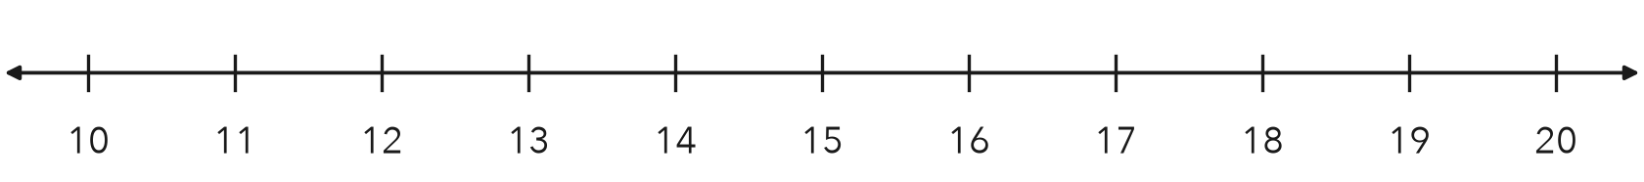
a. Write the inequality.
b. Graph it on the number line.
c. Name one value that works and one that does not.

3. Freezer Setting. A freezer keeps food frozen when the temperature stays at most 8 degrees Fahrenheit. Write an inequality using t. Then graph it.
Hint “At most” means the boundary is allowed, so fill the dot.
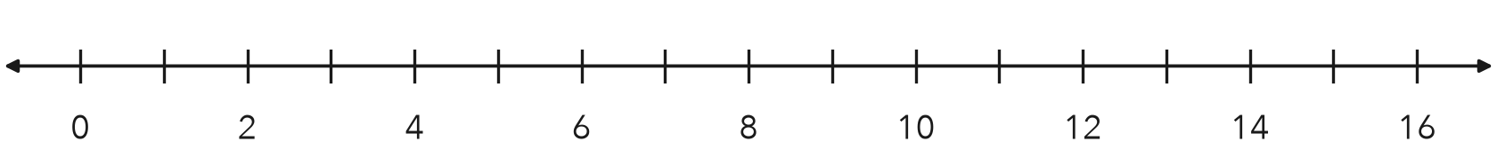
Inequality

4. Practice Cancelled. The county cancels outdoor practice when the temperature drops to 20 degrees or lower. Write an inequality using t and describe its graph.  Hint “Or lower” means 20 itself counts.  Inequality | 5. Reading Goal. Students meet the reading goal by finishing at least 18 books. Write an inequality using b and describe its graph.  Hint “At least” means 18 books meets the goal.  Inequality
  Show your work.
  Show your work.

6. Read a Graph. Use the graph below.
Hint An open dot leaves the boundary out; a closed dot keeps it.
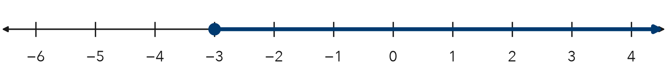
a. Write the inequality, using x.
b. Is −3 a solution? Explain.

7. Recycling Points. A class earns a party when it collects at least 250 recycling points. Let p be the points.
Hint Any total of 250 or more earns the party.
a. Write the inequality.
b. Name two totals under your arrow.

8. Two Signs. A pool sign says the water must be at least 4 feet deep for diving. A slide sign says riders must weigh under 200 pounds.
a. Write an inequality for the first sign, using d.
b. Write an inequality for the second sign, using w.
c. Explain why one graph uses a closed dot and the other an open dot.

Show your work.

FIND THE ERROR explain the mistake, then fix it

9. Ines’s Work. Ines graphed n ≥ 30. She drew a closed dot at 30 and then drew her arrow pointing to the left. Explain her mistake and describe the correct graph.

TEST PRACTICE choose the best answer

10. The graph of n ≥ 5 has —
A an open dot at 5, arrow left | B a closed dot at 5, arrow right
C an open dot at 5, arrow right | D a closed dot at 5, arrow left

11. An open dot at the boundary means the boundary value is —
A a solution | B not a solution | C negative | D zero

SELF-CHECK CODE find your answer · copy its letter into that problem’s box · spell a math word
t ≤ 20  R | x > −3  X | w ≥ 15  A | w ≤ 200  J | w < 200  S | t ≤ 8  R | p ≥ 250  W | w > 15  Q | x ≥ −3  O | t ≥ 8  Z

#2a | #3 | #4 | #6a | #7 | #8b

CHECK YOURSELF | □ I can do this on my own | □ I need a little help | □ I have a question about #

