Name Date Period
Lesson 8-5 · Session 2 · Practice · Form B
Testing Solutions to Inequalities
Learning target — I can test values against an inequality and graph the solution set. · 6.EE.B.8

REMEMBER  • To test a value, substitute it for the variable. A true statement means it is a solution.  • Test the boundary: true means a closed dot (≤, ≥); false means an open dot (<, >).  • More than means >. Fewer than and below mean <. At most means ≤. | WORKED EXAMPLE  Test 8, 9 and 10 in x < 9.  Step 1 8 < 9 is true, so 8 is a solution.  Step 2 9 < 9 is false, so use an open dot at 9.  Step 3 10 < 9 is false, so 10 is not a solution.  Answer 8 works; open dot at 9, arrow left
WORDS substitute (sustituir) · solution (solución) · true statement (enunciado verdadero)
PRACTICE show your work · label units

1. Is the value a solution? Write yes or no.
a. n ≥ 15; n = 18 | b. y < 4; y = 4 | c. t > 9; t = 9.5
d. k ≤ −1; k = 0 | e. m ≥ 6; m = 6 | f. x > 2; x = −3

2. Zip Line. A zip line lets a rider go only when the rider weighs more than 70 pounds. Let w be the weight in pounds.
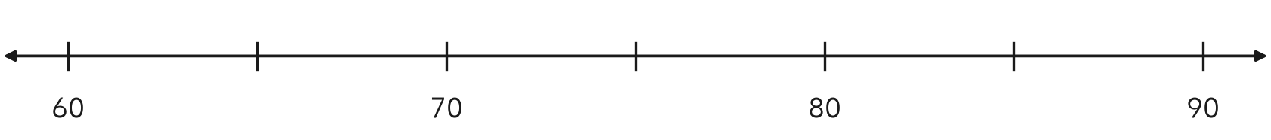
a. Write the inequality.
b. Substitute 85. Is it a solution?
c. Substitute 70. Is it a solution?
d. Graph the inequality.

3. Snack Bar. A snack bar opens a second window when more than 30 people are waiting. Write an inequality using n. Test 30 and 41.
Hint Substitute each number. A true statement means a solution.

Show your work.
Inequality

4. Fish Tank. Fish stay healthy only while the water stays below 28 °C. Write an inequality using c. Test 28 and 24.  Hint “Below” leaves the boundary out.  Inequality | 5. Teen Center. A teen center is open to people older than 12. Write an inequality using a. Is 12 a solution?  Hint Is the boundary older than itself?  Inequality
  Show your work.
  Show your work.

6. Test and Graph. For x ≥ 4, test x = 4 and x = 3. Then graph the inequality.
Hint The boundary test tells you the dot.
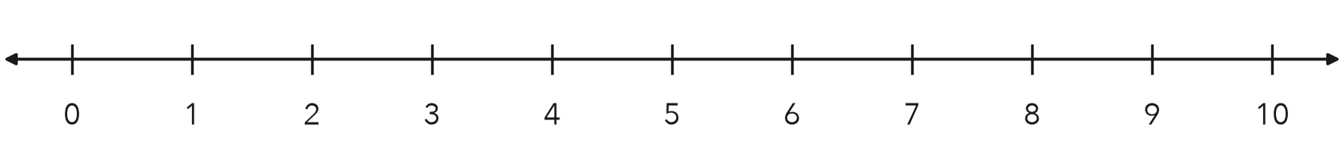
Solutions

7. Drone Range. A drone keeps its signal while it is less than 400 meters from the pilot. Write an inequality using d. Test 400, 350 and 410.

Show your work.
Inequality

8. Backpack Rule. A hiking club allows a backpack that weighs at most 30 pounds. Three packs weigh 30, 32 and 24 pounds.
a. Write the inequality, using w.
b. Which packs are allowed?
c. Describe the graph. What does the dot tell you about a 30-pound pack?

Show your work.

FIND THE ERROR explain the mistake, then fix it

9. Kiara’s Work. Kiara graphed y < 15 with a closed dot at 15. She told her group that 15 is one of the solutions. Explain her mistake and fix the graph.

TEST PRACTICE choose the best answer

10. Which value is a solution of k ≥ 7?
A 6 | B 6.9 | C 7 | D −7

11. To decide whether to use an open or a closed dot, test —
A the boundary value | B a value far from the boundary
C zero | D a negative value

SELF-CHECK CODE find your answer · copy its letter into that problem’s box · spell a math word
n > 30  H | d ≤ 400  X | w ≤ 30  S | w ≥ 70  Q | a > 12  C | a ≥ 12  J | c < 28  E | w > 70  C | c ≤ 28  Z | d < 400  K

#2a | #3 | #4 | #5 | #7 | #8a

CHECK YOURSELF | □ I can do this on my own | □ I need a little help | □ I have a question about #

