Name Date Period
Lesson 8-5 · Homework Packet · Level 1 · Sheet 1 of 2
Graphing Inequalities
Maryland Standard 6.EE.B.8 · Learning target — I can graph an inequality on a number line using an open or a closed dot.

REMEMBER  • Use an open dot for < or >. Use a closed dot for ≤ or ≥.  • Draw the arrow toward the solutions. The dot depends on the symbol, not on the sign of the number.  • Test a number under your arrow. It should make the inequality true. | WORKED EXAMPLE  Graph y > −2.  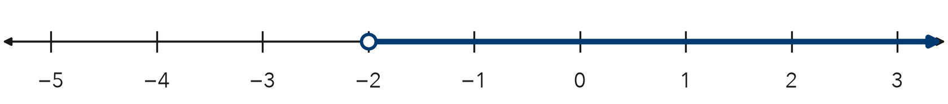  Step 1 > does not include −2, so draw an open dot at −2.  Step 2 Solutions are greater, so the arrow points right.  Answer Open dot at −2, arrow right

WORD BANK  open dot — the number is NOT a solution (< or >)  closed dot — the number IS a solution (≤ or ≥) | at least — that number or more (≥)  arrow — points to all the numbers that work
PRACTICE use the number lines · show your work

1. For each graph, tell the dot (open or closed) and the arrow direction (left or right).
Step 1 Look at the symbol: < or > means open; ≤ or ≥ means closed.
Step 2 Greater (> or ≥) points right. Less (< or ≤) points left.
a. x ≥ 9 | b. n < −4
c. p ≤ 0 | d. k > 2.5
e. w ≥ −6 | f. r < 7
g. b > −1.5 | h. c ≤ 12

2. Graph a ≤ −1 on the number line. Then name one solution.
Step 1 Find −1 on the number line.
Step 2 ≤ includes −1, so choose the dot.
Step 3 Shade toward the numbers that are less.
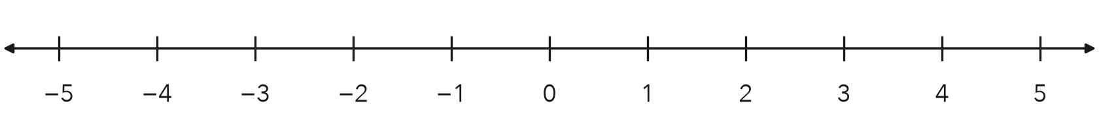
One solution

3. Hiking Trail. Hikers must be at least 10 years old. Write an inequality for a, a hiker’s age. Then graph it.
Step 1 “At least 10” means 10 or more.
Step 2 Draw the dot at 10, then the arrow.
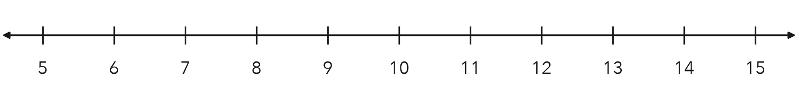
Inequality

4. Read the Graph. Write the inequality shown, using m. Then describe a real situation it could show.
Frame The graph shows m 6. A real situation is .
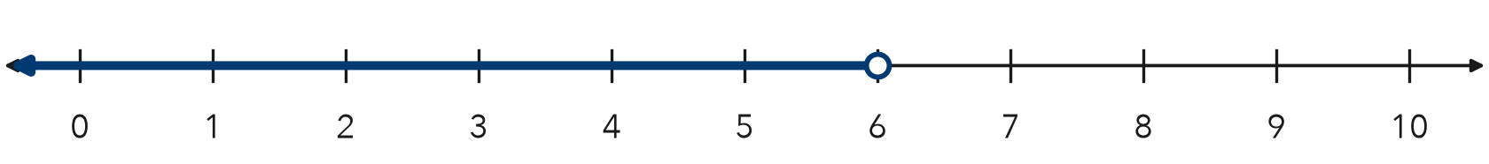

CHECK YOURSELF | □ I can do this on my own | □ I need a little help | □ I have a question about #
AT HOME Ask someone at home for a rule with a limit (bedtime, screen time, a speed limit). Write it as an inequality and graph it.
Name Date Period
Lesson 8-5 · Homework Packet · Level 1 · Sheet 2 of 2
Testing Solutions to Inequalities
Maryland Standard 6.EE.B.8 · Learning target — I can test values against an inequality and graph the solution set.

REMEMBER  • Substitute the value. A true statement means it is a solution.  • An inequality usually has many solutions.  • The boundary is a solution for ≤ and ≥ only. | WORKED EXAMPLE  Which of 6, 8, and 11 are solutions of x ≥ 8?  Step 1 Test 6: 6 ≥ 8 is false. Test 8: 8 ≥ 8 is true.  Step 2 Test 11: 11 ≥ 8 is true.  Answer 8 and 11 are solutions; 6 is not.

WORD BANK  substitute — put the number in place of the letter  solution — a number that makes it true | boundary — the number in the inequality  true — the comparison is correct
PRACTICE show your work · label units

1. Substitute each value. Write yes if it is a solution or no if it is not.
Step 1 Put the value in place of x.
Step 2 Read the comparison. True means yes; false means no.
Inequality | x = 4 | x = 7 | x = 10
x > 7
x ≤ 7
x ≥ 4

2. Is the value a solution? Write yes or no.
a. x < 9; x = 9 | b. m ≥ −1; m = 0 | c. t ≤ 2.5; t = 3

3. Bowling. A bowling team wins a trophy if it scores more than 450 points. Write an inequality for the score s. Test 450, 445, and 472.
Step 1 “More than” means >.
Step 2 Put each score in place of s. Is it true?
Inequality and winning scores

4. Test −3, 0, and 2 in y ≤ −1. Then graph y ≤ −1 on the number line.
Step 1 Put −3, 0, and 2 in place of y, one at a time.
Step 2 ≤ includes −1, so choose the dot. Then draw the arrow.
Solutions from the list

5. Find the Error. Bianca says n < 12 has 12 solutions: 11, 10, 9, and so on down to 0. Explain what she is missing.
Frame Bianca is missing . For example, is also a solution.

TEST PRACTICE choose the best answer

6. Which value is not a solution of k ≥ −2?
A −3 | B −2 | C 0 | D 5

7. Which value is a solution of n > 15?
A 12 | B 14.9 | C 15 | D 15.5

CHECK YOURSELF | □ I can do this on my own | □ I need a little help | □ I have a question about #

