Name Date Period
Lesson 9-2 · Session 1 · Practice · Form A
From Table to Graph
Learning target — I can turn a table of values into points and plot them on a graph. · 6.EE.C.9

REMEMBER  • Each row of a table gives an ordered pair (x, y): the input first, then the output.  • To plot (x, y), start at (0, 0). Go right x, then up y.  • Points from a constant rate line up in a straight line. A starting fee moves the line up off (0, 0). | WORKED EXAMPLE  A table for y = 4x has x = 1, 2, 3. Plot the points.  Step 1 Write the pairs: (1, 4), (2, 8), (3, 12).  Step 2 Plot (1, 4): right 1, then up 4. Plot the others the same way.  Step 3 Check: the points line up.  Answer three points in a straight line
WORDS ordered pair (par ordenado) · coordinates (coordenadas) · axis (eje)
PRACTICE show your work · label units

1. Write each table row as an ordered pair (x, y).
a. x = 3, y = 6 | b. x = 5, y = 45
c. x = 0, y = 7 | d. x = 8, y = 1

2. Dog-Walking Pay. Priya earns $9 for every dog she walks. Complete the table. Then plot the points on the grid. | 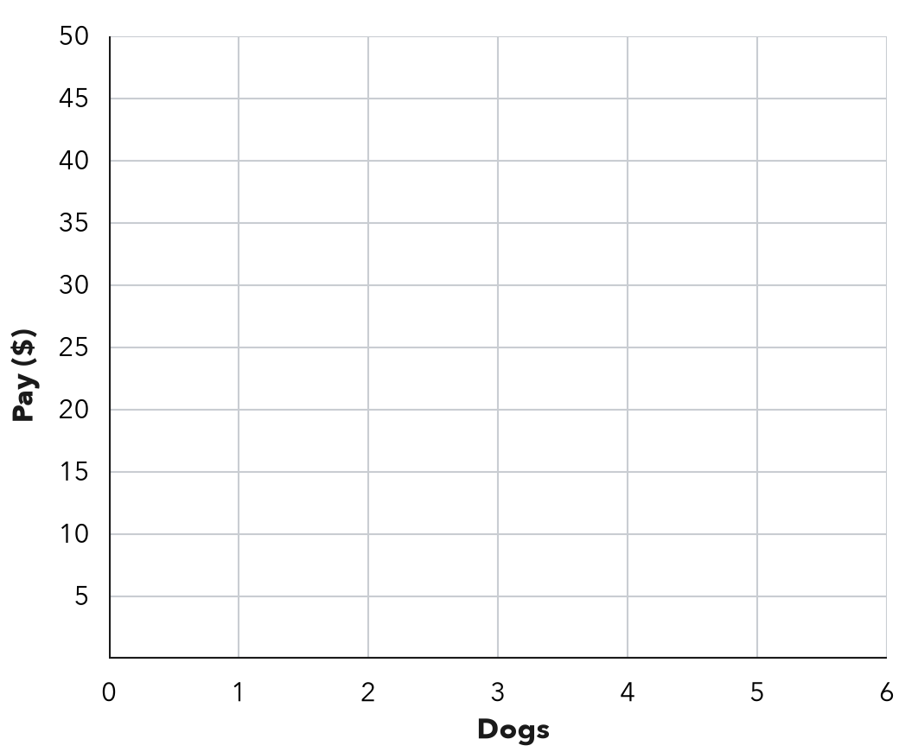
  Dogs (x) | 1 | 2 | 3 | 5
  Pay in $ (y)

3. Ski Lift. A ski lift rises 50 feet every second. Write the ordered pair for 6 seconds. What does it mean?  Hint Seconds come first; multiply by 50 for the feet.  Pair | 4. Reading Log. Sofia’s table shows x: 1, 2, 3, 4 nights and y: 25, 50, 75, 100 minutes read. For the third night she plotted (75, 3). What did she do wrong? Give the correct point.  Hint Which quantity is x in the table?  Point

5. Craft Ribbon. Ribbon costs $3 for every yard. Complete the table. Then plot the points on the grid.  Hint Each row of the table is one point. | 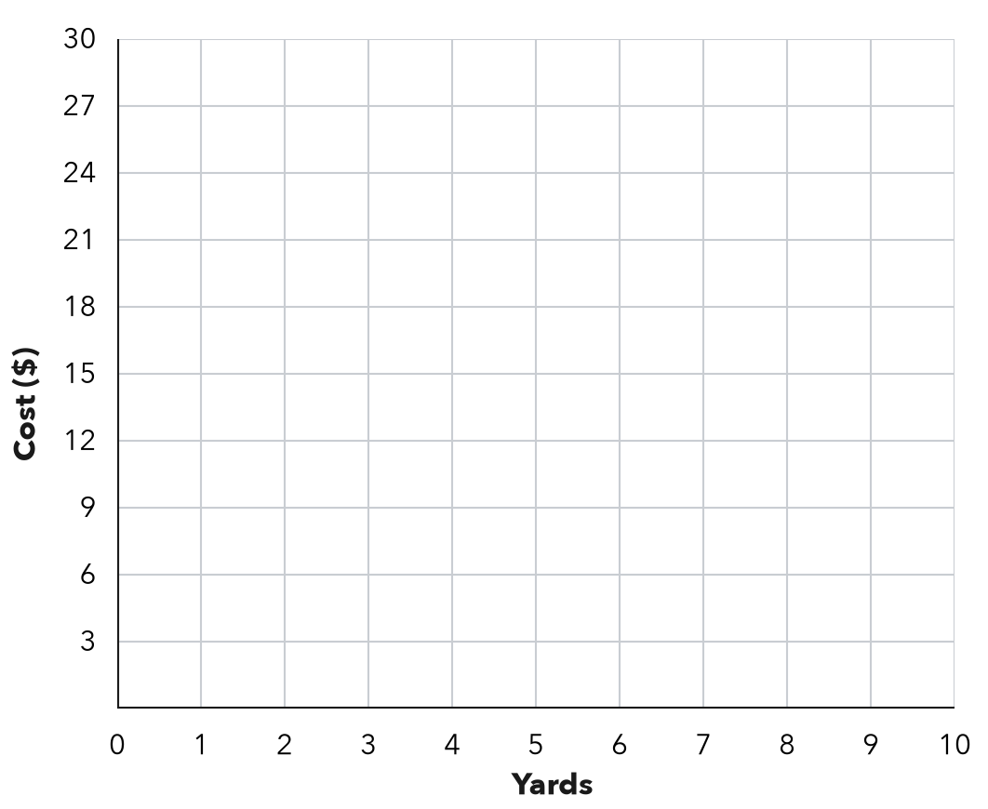
  Yards (x) | 2 | 5 | 8
  Cost ($) (y)

6. Corn Rows. A garden plants 18 corn seeds in every row. Write the ordered pair for 5 rows. Then tell what it means.
Hint Multiply 5 by 18.
Pair

7. From Pairs to a Pattern. A table gives the pairs (1, 5), (2, 10), (3, 15).
Hint Compare each y with its x.
a. Describe the rule.
b. What shape do the points make?
c. Write the pair for x = 7.

8. With a Fee. A service charges $4 plus $2 for each item. List the pairs for 1, 2 and 3 items. Plot them. Where does the line meet the y-axis?  y-axis point | 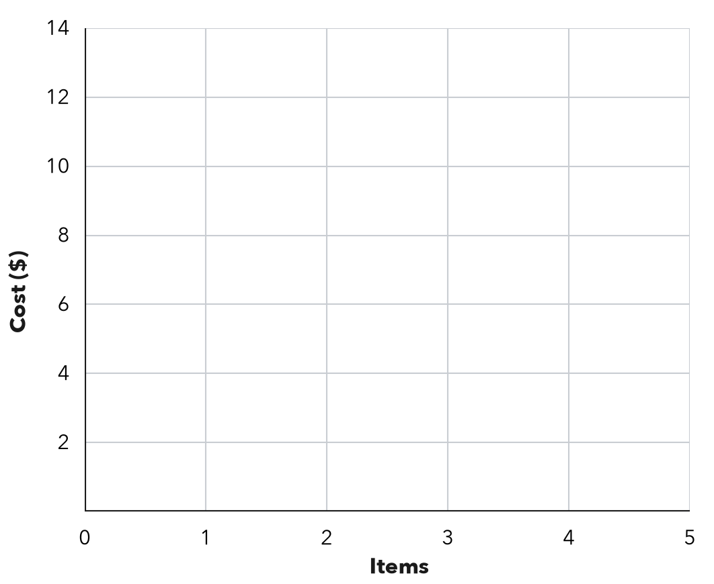

FIND THE ERROR explain the mistake, then fix it

9. Jonah’s Work. A parking garage charges $5 per hour. Jonah plotted the points (15, 3) and (25, 5). Explain his mistake and give the correct points.

TEST PRACTICE choose the best answer

10. A table row with x = 4 and y = 20 becomes the ordered pair —
A (20, 4) | B (4, 20) | C (4, 24) | D (24, 4)

11. At $9 per ticket, 3 tickets give the ordered pair —
A (9, 3) | B (3, 12) | C (3, 27) | D (27, 3)

SELF-CHECK CODE find your answer · copy its letter into that problem’s box · spell a math word
(6, 300)  G | (3, 75)  R | (0, 4)  H | (7, 35)  P | (0, 0)  Z | (90, 5)  X | (75, 3)  Q | (300, 6)  J | (5, 90)  A

#3 | #4 | #6 | #7c | #8

CHECK YOURSELF | □ I can do this on my own | □ I need a little help | □ I have a question about #

