Name Date Period
Lesson 9-2 · Session 2 · Practice · Form A
Analyzing a Graph
Learning target — I can read a relationship off a graph and describe the rate it shows. · 6.EE.C.9

REMEMBER  • The rate of change is how much y goes up when x goes up by 1: change in y ÷ change in x.  • If the line starts at (0, 0), divide y by x for one point: (4, 20) gives 20 ÷ 4 = 5.  • With the same scales, a steeper line has a greater rate. | WORKED EXAMPLE  A graph of hours (x) and dollars (y) passes through (2, 6) and (5, 15). Find the rate.  Step 1 Change in y: 15 − 6 = 9 dollars.  Step 2 Change in x: 5 − 2 = 3 hours.  Step 3 Divide: 9 ÷ 3 = 3.  Answer $3 per hour
WORDS rate of change (tasa de cambio) · unit rate (tasa unitaria) · steeper (más empinada)
PRACTICE show your work · label units

1. Find the rate of change of a line through the two points.
a. (1, 7) and (3, 21) | b. (2, 10) and (6, 30)
c. (4, 12) and (5, 15) | d. (2, 18) and (5, 45)

2. Scooter Rental. The graph shows the cost of renting a scooter.  a. What does (4, 28) mean?  b. Cost for 1 minute:  c. Cost for 3 minutes: | 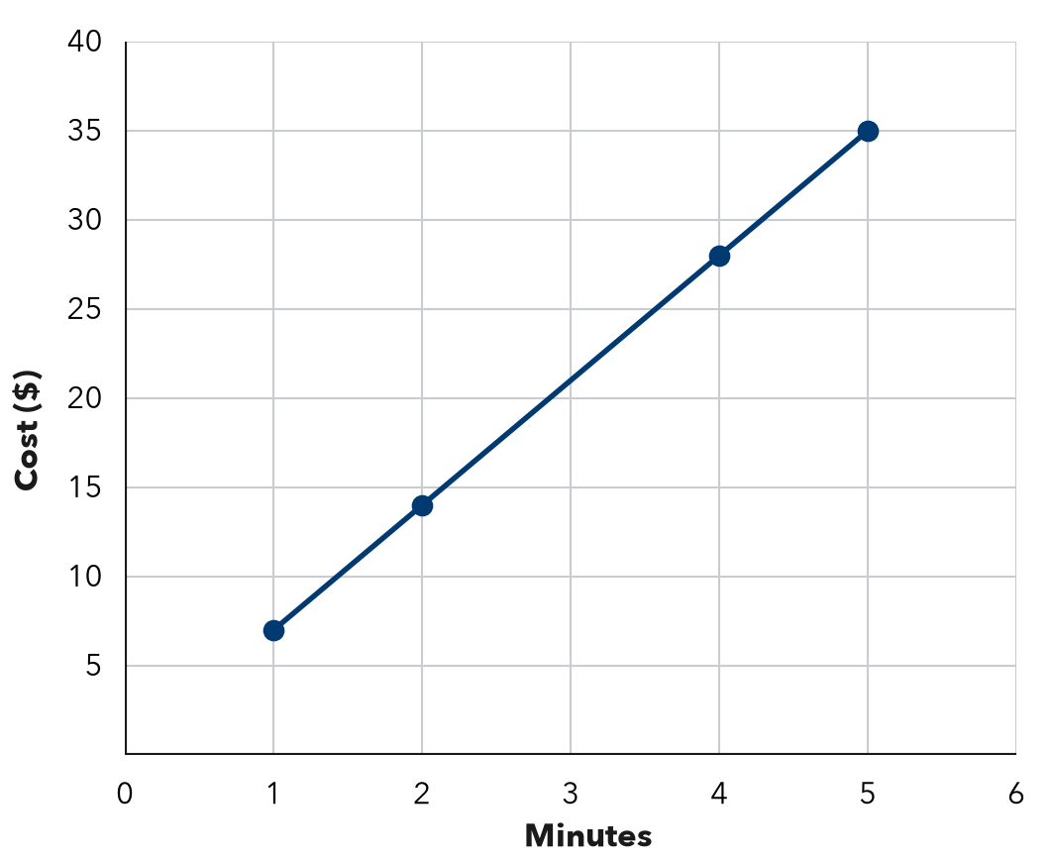

3. Hiking Trail. A graph of hours (x) and miles (y) passes through (1, 2), (3, 6), (5, 10).  a. Miles each hour:  b. Miles after 8 hours: | 4. Phone Storage. A graph of songs (x) and megabytes (y) passes through (2, 8), (5, 20), (10, 40).  Hint Divide y by x.  a. Megabytes for one song:  b. What does (5, 20) mean?

5. Sunflower Growth. A graph of weeks (x) and height in inches (y) passes through (2, 14), (4, 28), (6, 42).
Hint Two weeks apart: divide the jump by 2.
a. Find the rate of change.
b. Find the height at 9 weeks.

6. Two Pay Graphs. Job A’s pay graph passes through (1, 6) and (3, 18). Job B’s passes through (1, 9) and (3, 27). Which line is steeper? What does that mean?  Hint Find the pay for one hour on each line.  Steeper | 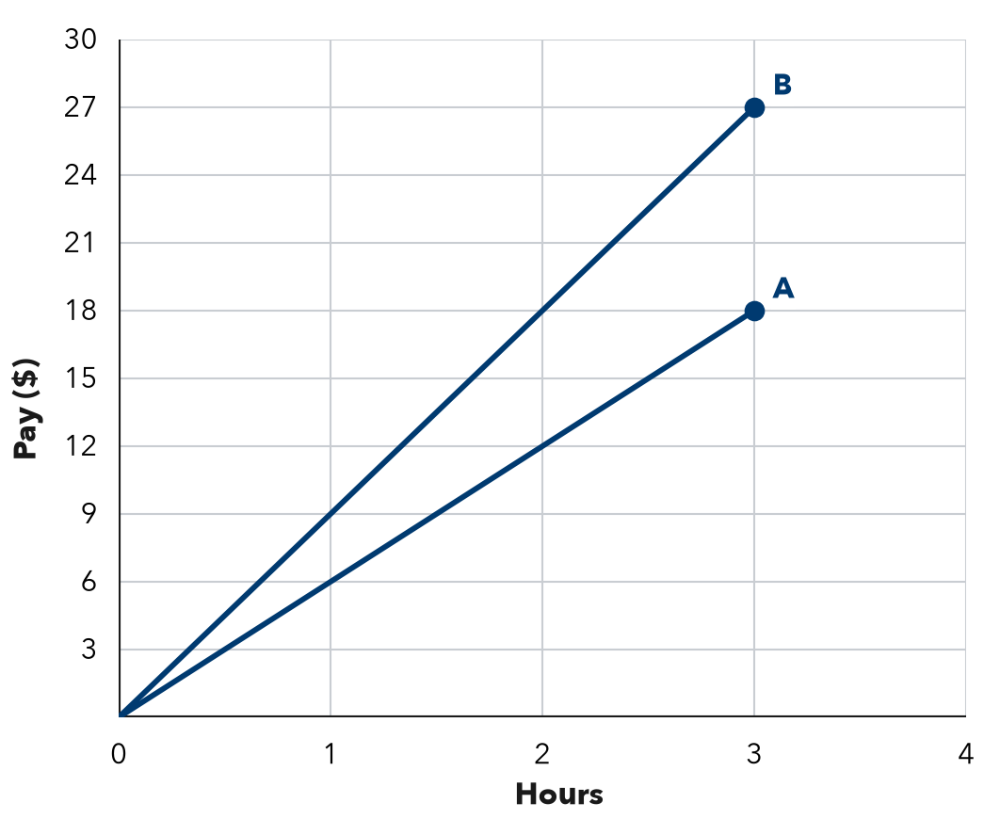
  Show your work.

7. Water Tank. A graph of hours (x) and gallons (y) passes through (2, 50), (4, 100), (7, 175).
Hint Find the amount for 1 hour first.
a. Find the unit rate.
b. Write the ordered pair for 10 hours.

8. Lawn Signs. A fundraiser graph shows lawn signs sold (x) and dollars raised (y). It passes through (3, 45) and (7, 105). Yusuf says (3, 45) means the group raises $45 each hour. Explain the mistake. How much is raised for each sign?

Show your work.
$ per sign

FIND THE ERROR explain the mistake, then fix it

9. Bianca’s Work. A walking graph shows minutes (x) and steps (y). It passes through (2, 100) and (4, 200). Bianca said the walker takes 100 steps each minute. Explain her mistake and find the rate.

TEST PRACTICE choose the best answer

10. A graph through (1, 8) and (2, 16) shows a rate of —
A 8 per unit | B 16 per unit | C 2 per unit | D 24 per unit

11. With the same scales, a steeper line shows —
A a smaller rate | B a greater rate | C a starting fee | D a rate of 0

SELF-CHECK CODE find your answer · copy its letter into that problem’s box · spell a math word
(10, 250)  E | 28  Z | 126  Q | 15  S | 45  J | 21  R | (250, 10)  X | 63  T | 16  A

#2c | #3b | #5b | #7b | #8

CHECK YOURSELF | □ I can do this on my own | □ I need a little help | □ I have a question about #

