Name Date Period
Lesson 9-2 · Homework Packet · Level 1 · Sheet 1 of 2
From Table to Graph
Maryland Standard 6.EE.C.9 · Learning target — I can turn a table of values into points and plot them on a graph.

REMEMBER  • Each row of a table becomes an ordered pair (x, y).  • To plot (x, y), start at (0, 0). Move right x, then up y.  • Points from a constant rate line up in a straight line. | WORKED EXAMPLE  Movie tickets cost $8 each. Write ordered pairs for 1, 2, and 3 tickets.  Step 1 Tickets is x. Cost is y. Multiply each x by 8.  Step 2 8 × 1 = 8, 8 × 2 = 16, 8 × 3 = 24  Answer (1, 8), (2, 16), (3, 24)

WORD BANK  ordered pair — (x, y): x first, then y  x-coordinate — how far right | y-coordinate — how far up  plot — mark a point on a graph
PRACTICE show your work · label units

1. Write each table row as an ordered pair (x, y).
Step 1 Write the x value first.
Step 2 Write the y value second, inside ( ).
a. x = 4, y = 12 | b. x = 0, y = 0
c. x = 6, y = 30 | d. x = 9, y = 2

2. Smoothies. Smoothies cost $4 each. Complete the table. Then plot the points on the grid and connect them.  Step 1 Multiply each number of smoothies by $4.  Step 2 Plot each pair: go right x, then up y. | 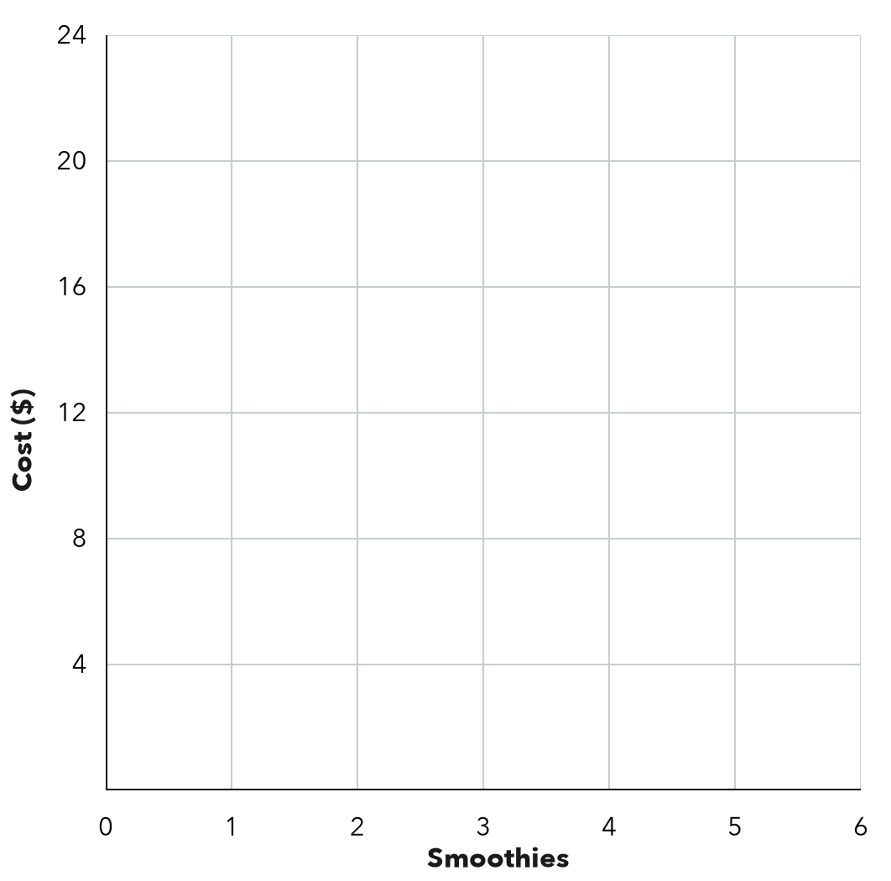
  Smoothies (x) | 1 | 2 | 3 | 5
  Cost in $ (y)

3. Hiking. The graph shows how far Kofi hikes.  a. Write the ordered pair for 5 hours.  b. What does (3, 6) mean?  c. Miles per hour: | 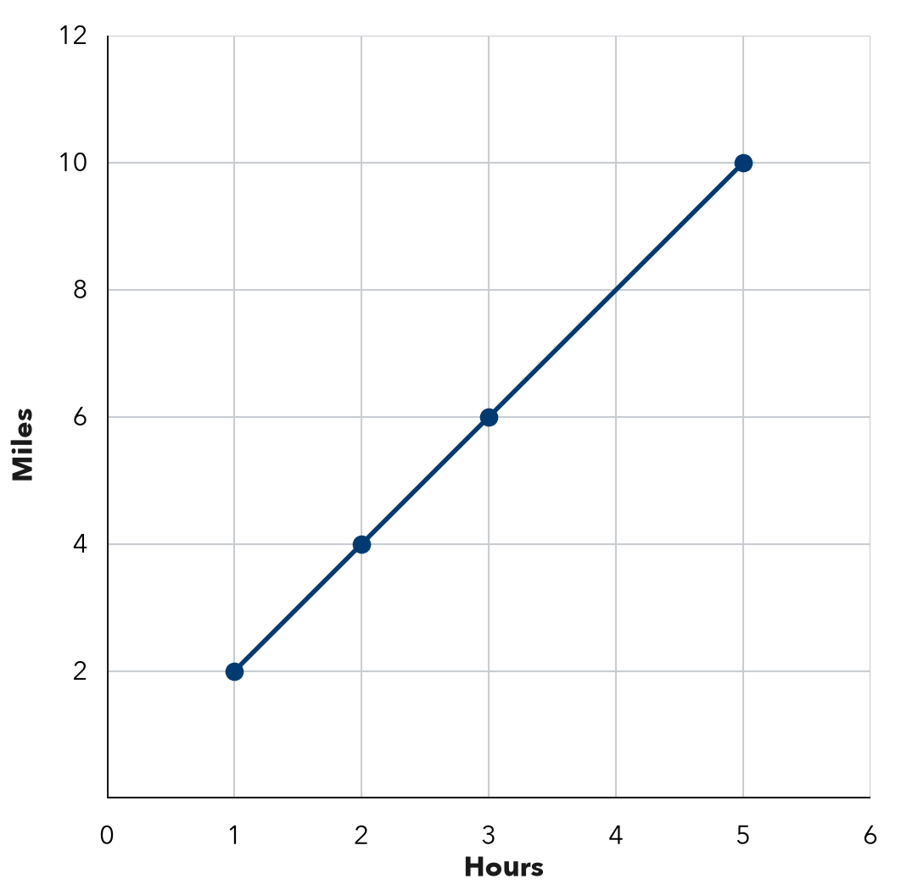

4. Bike Rental. A bike costs $6 for each hour. Write the ordered pairs (hours, cost) for 1, 3, and 4 hours. Then tell what (0, 0) means.
Step 1 Multiply each number of hours by 6.
Step 2 Write (hours, cost).
Ordered pairs

5. Find the Error. Teo’s table shows x (hours): 2, 4 and y (dollars): 10, 20. He plotted (10, 2) and (20, 4). Explain his mistake. Which points should he plot?
Frame Teo’s mistake is . He should plot and .

CHECK YOURSELF | □ I can do this on my own | □ I need a little help | □ I have a question about #
AT HOME Show someone at home how to plot (3, 5): right 3, then up 5.
Name Date Period
Lesson 9-2 · Homework Packet · Level 1 · Sheet 2 of 2
Analyzing a Graph
Maryland Standard 6.EE.C.9 · Learning target — I can read a relationship off a graph and describe the rate it shows.

REMEMBER  • For a line through (0, 0), the unit rate is y ÷ x. The point (3, 12) means 3 of x go with 12 of y.  • With the same scales, a steeper line has a greater rate. | WORKED EXAMPLE  A line through (0, 0) passes through (2, 10). Find the unit rate and y when x = 7.  Step 1 Unit rate: 10 ÷ 2 = 5  Step 2 y = 5 × 7 = 35  Answer 5 per unit; y = 35

WORD BANK  unit rate — the amount for 1 of x  steeper — rises faster | origin — the point (0, 0)  proportional — a straight line through (0, 0)
PRACTICE show your work · label units

1. Filling a Pool. The graph shows the water in a pool.  Step 1 Find (4, 60) on the graph. Read the labels on both axes.  Step 2 For 1 minute, divide the gallons by the minutes.  a. What does (4, 60) mean?  b. Gallons per minute:  c. Gallons after 9 minutes: | 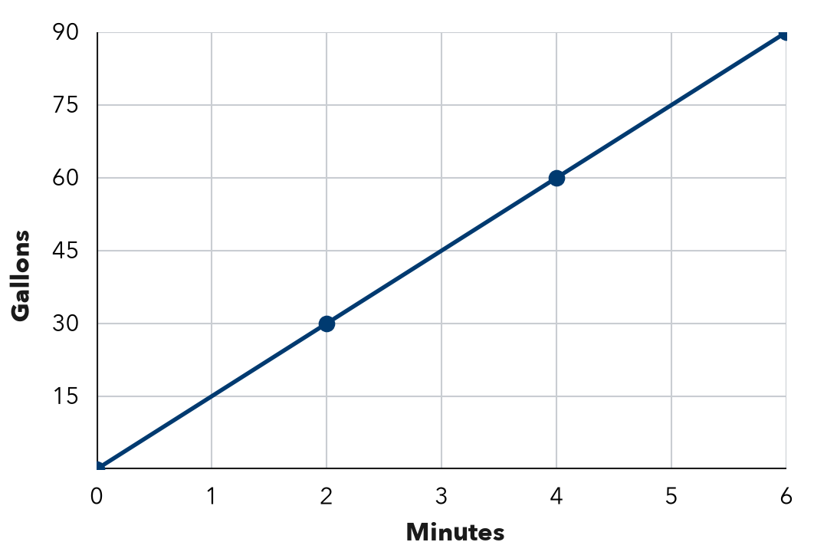

2. Each line passes through (0, 0) and the given point. Find the unit rate.
Step 1 Divide y by x.
a. (3, 21) | b. (5, 40) | c. (8, 96)

3. Reading. A line through (0, 0) shows that Ana reads 18 pages in 3 hours. Find her unit rate. How many pages does she read in 7 hours?
Step 1 Divide the pages by the hours to find pages in 1 hour.
Step 2 Multiply that by 7.
Answer

4. Two Jobs. The graph shows pay for two jobs. Find each pay rate. Which line is steeper, and what does it mean?  Answer | 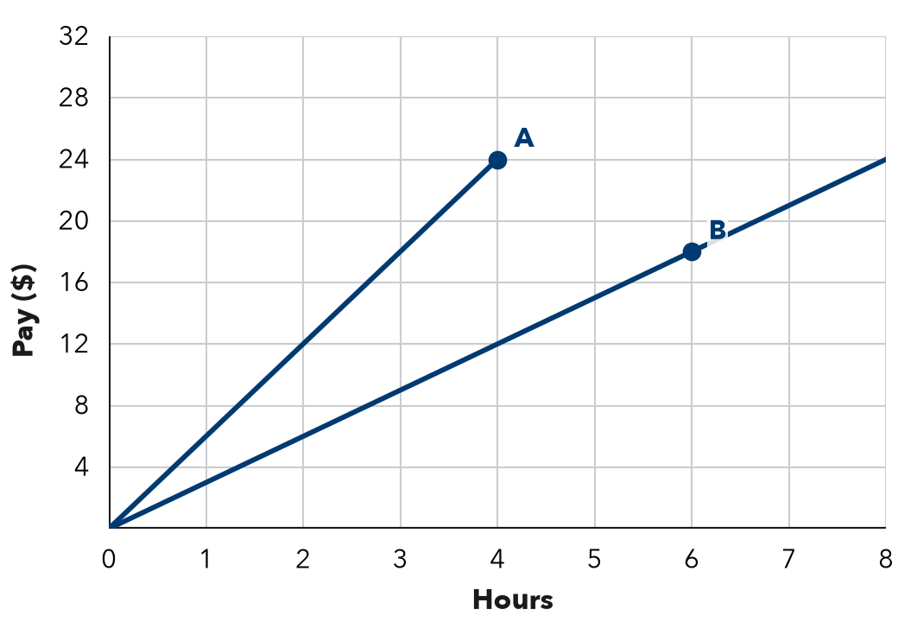

5. Savings. Jada’s savings graph passes through (0, 10), (1, 15), and (2, 20). She says it is proportional. Is she right? What does (0, 10) mean?
Frame Jada is because a proportional graph . (0, 10) means .

TEST PRACTICE choose the best answer

6. A line through the origin passes through (5, 35). What is the unit rate?
A 5 | B 30 | C 7 | D 175

7. Line P passes through (1, 4). Line Q passes through (1, 9). Both start at (0, 0). Which is true?
A P is steeper. | B Q is steeper; greater rate.
C They have the same rate. | D Q is steeper; smaller rate.

CHECK YOURSELF | □ I can do this on my own | □ I need a little help | □ I have a question about #

