Name Date Period
Lesson 9-2 · Session 2 · Prerequisite Practice A · Skill 1 of 2
Read Coordinates from a Graph
Builds on Grade 5 · 5.G.A.2
TODAY’S LESSON | You will read (4, 28) on a scooter graph: 4 minutes cost $28.
YOU NEED TO | Read a point on a graph whose y-axis counts by 5s or 10s. You will use it in Practice Form A, problems 2 and 6.
STEPS TO FOLLOW use these same steps on every problem
1 | Go down from the point to the x-axis. Read the number.
2 | Go left from the point to the y-axis. Read the number.
3 | Write the pair: (x, y).
WATCH ME the steps in action
Name point A.  Step 1 Down to the x-axis: 3.  Step 2 Left to the y-axis: 30.  Step 3 (3, 30)  Answer A = (3, 30) | 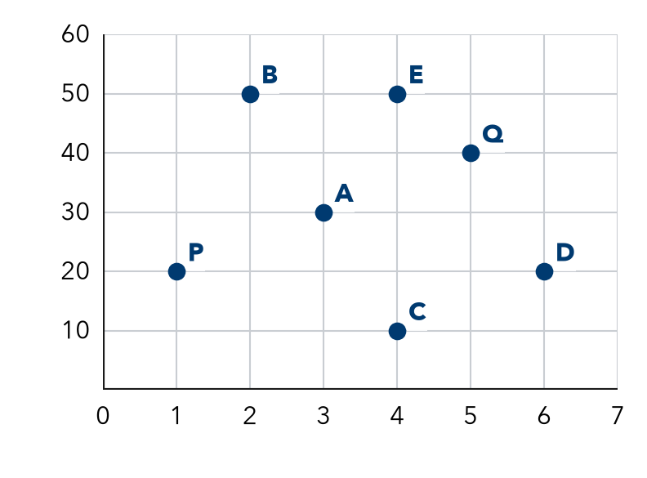

TRY IT WITH HELP fill in each step
1. Use the Watch Me graph. Name point P.
Step 1 Down to the x-axis: .
Step 2 Left to the y-axis: .
Step 3 P =

2. Use the Watch Me graph. Name point Q.
Step 1 Down to the x-axis: .
Step 2 Left to the y-axis: .
Step 3 Q =

YOUR TURN use the steps on your own

3. Use the Watch Me graph. Write the pair for each point.
a. B: | b. C: | c. D: | d. E:

Lesson 9-2 · Session 2 · Prerequisite Practice A · Skill 2 of 2
Divide Whole Numbers
Builds on Grade 5 · 5.NBT.B.6
TODAY’S LESSON | You will find the cost for 1 minute: $28 ÷ 4 minutes.
YOU NEED TO | Divide like 175 ÷ 7 by breaking the number into friendly parts. You will use it in Practice Form A, problems 2, 5, and 7.
STEPS TO FOLLOW use these same steps on every problem
1 | Break the number into parts the divisor goes into easily.
2 | Divide each part.
3 | Add the answers.
WATCH ME the steps in action
175 ÷ 7
Step 1 175 = 140 + 35
Step 2 140 ÷ 7 = 20. 35 ÷ 7 = 5.
Step 3 20 + 5 = 25
Answer 25
TRY IT WITH HELP fill in each step
4. 156 ÷ 4
Step 1 156 = 120 +
Step 2 120 ÷ 4 = . 36 ÷ 4 = .
Step 3 30 + 9 =

5. 216 ÷ 6
Step 1 216 = 180 +
Step 2 180 ÷ 6 = . 36 ÷ 6 = .
Step 3 30 + 6 =

YOUR TURN use the steps on your own

6. Divide. Use the same three steps.
a. 84 ÷ 4 = | b. 75 ÷ 5 = | c. 96 ÷ 8 =
d. 336 ÷ 8 = | e. 405 ÷ 9 = | f. 252 ÷ 7 =

READY CHECK a problem like the one in today’s lesson

7. A line passes through (6, 54). What is y when x = 1?
A 48 | B 9 | C 60 | D 324

CHECK YOURSELF | □ I can do this on my own | □ I need a little help | □ I have a question about #

