Name Date Period
Lesson 9-3 · Homework Packet · Sheet 1 of 2
Equations from Tables
Maryland Standard 6.EE.C.9 · Learning target — I can write an equation that matches a table of values.

REMEMBER  • An equation like y = 5x is a rule that works for every row.  • Same y ÷ x in every row: y = (that number) × x. Same y − x: y = x + (that number).  • Check your equation with two rows. | WORKED EXAMPLE  Write an equation for x: 2, 3, 5 and y: 12, 18, 30.  Step 1 12 ÷ 2 = 6, 18 ÷ 3 = 6, 30 ÷ 5 = 6  Step 2 Check: 6 × 5 = 30  Answer y = 6x
PRACTICE show your work · label units
1. Write an equation for each table.
a. x: 1, 2, 3 y: 7, 14, 21 y = | b. x: 1, 2, 3 y: 10, 11, 12 y =
c. x: 2, 4, 6 y: 10, 20, 30 y = | d. x: 5, 6, 7 y: 2, 3, 4 y =
e. x: 0, 4, 8 y: 6, 10, 14 y = | f. x: 1, 3, 5 y: 9, 27, 45 y =
g. x: 2, 3, 4 y: 16, 24, 32 y = | h. x: 10, 12, 14 y: 5, 7, 9 y =

2. Write the equation. Then complete the table.
x | 2 | 3 | 4 | 6 | 9
y | 22 | 33 | 44
Equation

3. Stretch. A table shows x: 2, 5, 9 and y: 0, 3, 7. Write an equation. Then find y when x = 20.
Answer

4. Tickets. The graph shows the cost of fair tickets. Write an equation for the graph. Then find the cost of 10 tickets.  Answer | 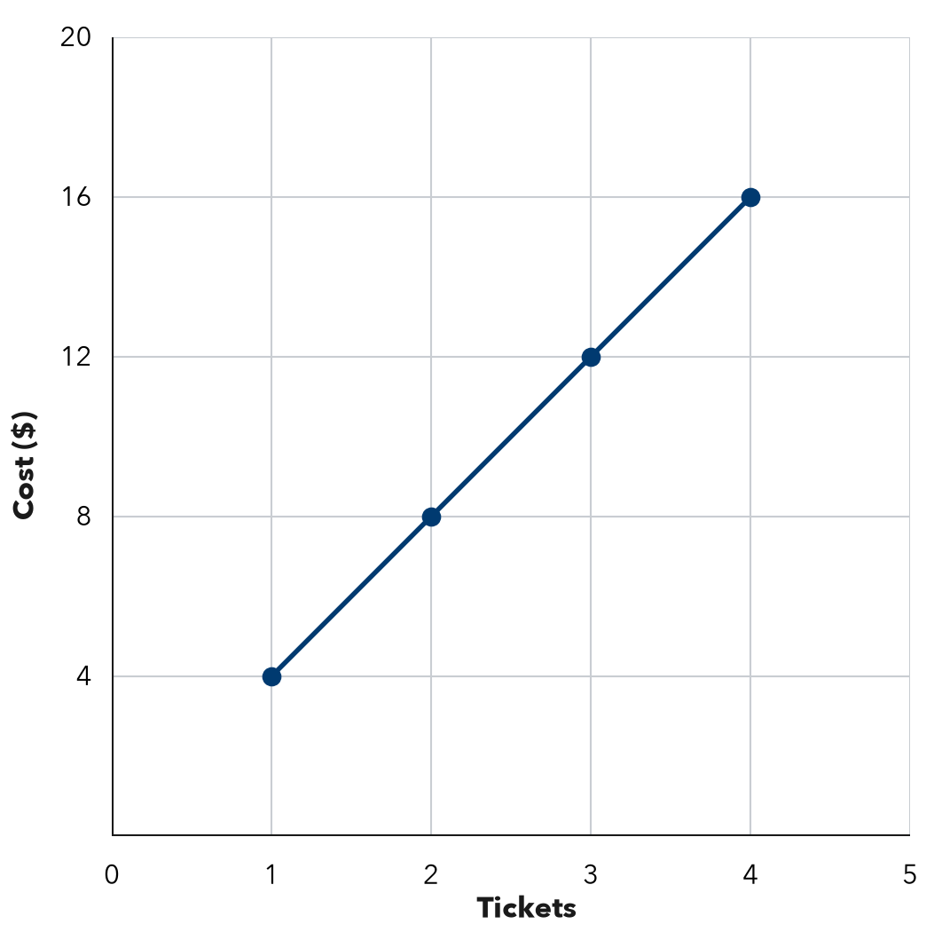

5. Find the Error. For x: 2, 4, 6 and y: 6, 8, 10, Owen wrote y = 3x because 3 × 2 = 6. Explain his mistake and write the correct equation.

CHECK YOURSELF | □ I can do this on my own | □ I need a little help | □ I have a question about #
AT HOME Make a 3-row table for a rule. Ask someone at home to find your equation.
Name Date Period
Lesson 9-3 · Homework Packet · Sheet 2 of 2
Equations from Situations
Maryland Standard 6.EE.C.9 · Learning target — I can write an equation from a described situation and identify its variables.

REMEMBER  • A rate (“each,” “per”) multiplies x. A starting amount or fee is added once.  • y = (rate) × x + (starting amount). Check it with one value from the story. | WORKED EXAMPLE  A gym charges $10 to enter plus $7 per hour. Write an equation for the cost y of x hours.  Step 1 Rate: 7 per hour, so 7x. Fee: add 10.  Step 2 Check 3 hours: 7 × 3 + 10 = 31  Answer y = 7x + 10
PRACTICE show your work · label units
1. Write an equation for each situation.
a. Each pack holds 12 pencils. Pencils y in x packs. y =
b. Jamal is 3 years older than his sister. Jamal’s age y when she is x. y =
c. A club costs $20 to join plus $15 a month. Cost y for x months. y =

2. Bowling. Shoes cost $4, plus $5 per game. Write an equation for the cost y of x games. Find the cost of 4 games.
Answer

3. Taxi. A taxi charges $3 to start plus $2 per mile. Write an equation for the cost y of x miles. Find the cost of 7 miles.
Answer

4. Car Wash. A class has $30 and earns $8 per car washed. Complete the table. Write an equation.
Cars (x) | 0 | 1 | 2 | 5
Total $ (y)
Equation

5. Find the Error. For “a $25 fee plus $10 an hour,” Nia wrote y = 35x. Explain her mistake and fix it.

TEST PRACTICE choose the best answer
6. A plumber charges a $40 fee plus $25 per hour. Which equation gives the cost c for h hours?
A c = 40h + 25 | B c = 25h + 40 | C c = 65h | D c = 25h

7. Which situation matches y = 3x + 12?
A 3 cans per box, 12 boxes | B Start with $3, earn $12 per hour
C Start with 12 gal, add 3 gal per min | D $12 for 3 people

CHECK YOURSELF | □ I can do this on my own | □ I need a little help | □ I have a question about #

