Name Date Period
Lesson 2-3 · Session 2 · Practice · Form A
Comparing Distributions
Learning target — I can compare two distributions using the median and the interquartile range together. · 6.SP.B.5d

REMEMBER  • Median = center: which group is typically higher or lower?  • IQR = spread: which group is more consistent (smaller IQR)?  • Use both to decide. Ask what is better here: a shorter wait or a higher score? | WORKED EXAMPLE  Line 1: median 8 min, IQR 7. Line 2: median 13 min, IQR 12.  Step 1 Center: 13 − 8 = 5, so Line 1 is typically 5 min shorter.  Step 2 Spread: 7 < 12, so Line 1 is steadier.  Answer Join Line 1: shorter and steadier
WORDS center (centro) · spread (dispersión) · distribution (distribución)
PRACTICE show your work · label units

1. Two Lunch Lines. Wait times (min). Line 1: 3, 5, 7, 8, 10, 12, 15. Line 2: 2, 4, 11, 13, 14, 16, 20.
Hint Lower median = shorter wait. Smaller IQR = steadier.
 | Median | Q1 | Q3 | IQR
Line 1
Line 2
Which to join

2. Two Carrot Plots. Plot A lengths (cm): 10, 12, 14, 15, 16, 17, 19. Plot B: 5, 11, 14, 15, 20, 23, 27.
a. Median A: | b. IQR A: | c. Median B: | d. IQR B:

3. Two Months. Month 1: median 120 sales, IQR 40. Month 2: median 135, IQR 12. | 4. Nikhil’s Claim. Set E: median 60, IQR 30. Set F: median 55, IQR 8. Nikhil says Set E wins in every way. Is Nikhil right?  Hint A higher median says nothing about spread.
  a. Typically higher:
  b. Steadier:
  □ Right | □ Not right

5. Two Water Coolers. The box plots show cups served per hour.  Hint Read the box edges for Q1 and Q3.  a. Median of 1:  b. IQR of 1:  c. Median of 2:  d. IQR of 2:  e. Compare them: | 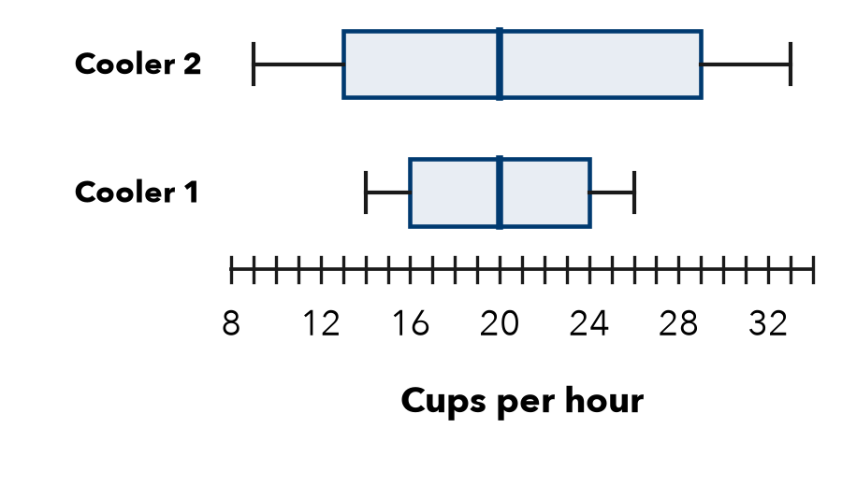

6. Coach’s Choice. Team 1: median 58 points, IQR 20. Team 2: median 52, IQR 5. The coach wants the team most likely to score close to its usual total.
□ Team 1 | □ Team 2
Why

7. Two Stores. Store P: median 46 sales, IQR 9. Store Q: median 52, IQR 21. Write a comparison that uses both measures.

8. Two Study Methods. Method 1 quiz scores: median 78, IQR 6. Method 2: median 83, IQR 24.
a. Higher typical score:
b. More dependable (use both IQRs):
c. Pick one method for the whole class. Argue using both measures.

Show your work.

FIND THE ERROR explain the mistake, then fix it

9. Kofi’s Work. Kofi wrote: “Group 1 has the larger median, so Group 1 must have the larger IQR too.” Explain the mistake.

TEST PRACTICE choose the best answer

10. To compare two skewed distributions fully, report the —
A median and IQR | B median only | C greatest values | D number of values

11. Set A: median 60, IQR 5. Set B: median 60, IQR 18. Set A is —
A higher | B more consistent | C more spread out | D lower

SELF-CHECK CODE find your answer · copy its letter into that problem’s box · spell a math word
Month 2  T | 12  N | 5  E | Month 1  Z | 16  R | Method 2  S | Line 2  Q | 8  E | 22  X | Line 1  C

#1 | #2b | #2d | #3a | #5b | #5d | #8a

CHECK YOURSELF | □ I can do this on my own | □ I need a little help | □ I have a question about #

