Name Date Period
Lesson 2-3 · Session 2 · Practice · Form B
Comparing Distributions
Learning target — I can compare two distributions using the median and the interquartile range together. · 6.SP.B.5d

REMEMBER  • Median = center: which group is typically higher or lower?  • IQR = spread: which group is more consistent (smaller IQR)?  • Use both to decide. Ask what is better here: a shorter wait or a higher score? | WORKED EXAMPLE  Line 1: median 8 min, IQR 7. Line 2: median 13 min, IQR 12.  Step 1 Center: 13 − 8 = 5, so Line 1 is typically 5 min shorter.  Step 2 Spread: 7 < 12, so Line 1 is steadier.  Answer Join Line 1: shorter and steadier
WORDS center (centro) · spread (dispersión) · distribution (distribución)
PRACTICE show your work · label units

1. Two Lunch Booths. Wait times (min). Booth 1: 4, 6, 8, 9, 11, 13, 16. Booth 2: 1, 3, 10, 14, 15, 17, 21.
Hint Lower median = shorter wait. Smaller IQR = steadier.
 | Median | Q1 | Q3 | IQR
Booth 1
Booth 2
Which to join

2. Two Bean Plots. Plot A lengths (cm): 8, 10, 12, 14, 15, 17, 18. Plot B: 4, 9, 13, 14, 19, 22, 26.
a. Median A: | b. IQR A: | c. Median B: | d. IQR B:

3. Two Months. Month 1: median 210 sales, IQR 15. Month 2: median 190, IQR 45. | 4. Rosa’s Claim. Set E: median 72, IQR 28. Set F: median 68, IQR 7. Rosa says Set E wins in every way. Is Rosa right?  Hint A higher median says nothing about spread.
  a. Typically higher:
  b. Steadier:
  □ Right | □ Not right

5. Two Fountains. The box plots show cups served per hour.  Hint Read the box edges for Q1 and Q3.  a. Median of 1:  b. IQR of 1:  c. Median of 2:  d. IQR of 2:  e. Compare them: | 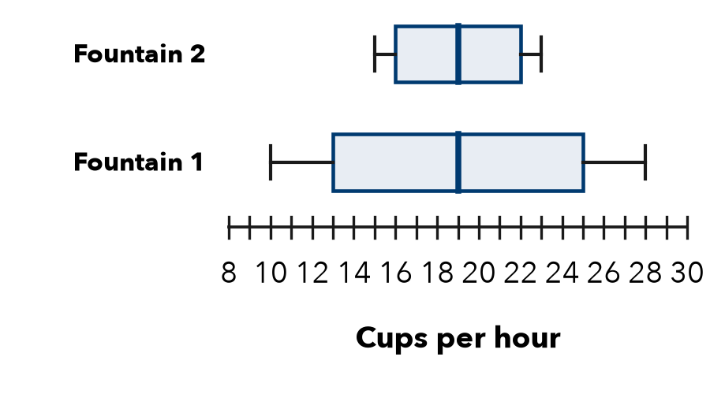

6. Coach’s Choice. Team 1: median 61 points, IQR 6. Team 2: median 66, IQR 25. The coach wants the team most likely to score close to its usual total.
□ Team 1 | □ Team 2
Why

7. Two Stores. Store R: median 38 sales, IQR 14. Store S: median 33, IQR 5. Write a comparison that uses both measures.

8. Two Study Methods. Method 1 quiz scores: median 85, IQR 20. Method 2: median 81, IQR 5.
a. Higher typical score:
b. More dependable (use both IQRs):
c. Pick one method for the whole class. Argue using both measures.

Show your work.

FIND THE ERROR explain the mistake, then fix it

9. Lucia’s Work. Lucia wrote: “Group 1 has the larger median, so Group 1 must have the larger IQR too.” Explain the mistake.

TEST PRACTICE choose the best answer

10. Medians of 48 and 55 differ by —
A 7 | B 103 | C 8 | D 55

11. Group 1: median 12 cm, IQR 3 cm. Group 2: median 12 cm, IQR 9 cm. Which is more consistent?
A Group 1 | B Group 2
C They are the same | D Cannot tell

SELF-CHECK CODE find your answer · copy its letter into that problem’s box · spell a math word
Month 1  I | Month 2  Z | 18  X | Method 1  S | 12  A | Booth 1  M | 13  D | 6  N | Booth 2  Q | 7  E

#1 | #2b | #2d | #3a | #5b | #5d | #8a

CHECK YOURSELF | □ I can do this on my own | □ I need a little help | □ I have a question about #

