Featured Lesson: Speak, Write, Improve

Our Class Garden
Name
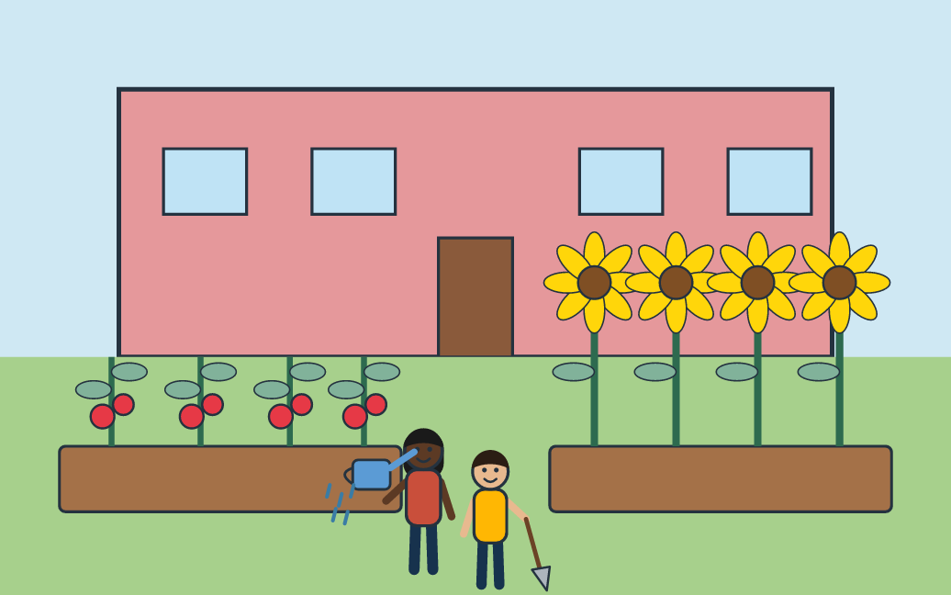
Your task: Look at the class garden. Explain how the children help the plants grow, and give a reason.
Sentence frame: The children help the plants by ___. This helps because ___. For example, ___.

What to do
- Open the link. Look at the class garden picture.
- Name two things you see and what the children are doing.
- Say your answer to a partner: The children help the plants by ___. This helps because ___. For example, ___.
- Write what you said in two or three sentences.
- Add one example that starts with “For example.”
- Read your new response to your partner.

My first response

My improved response

You need: A device with the student link, or the printed backup page; Paper or a document to write in; A partner (a microphone is not needed).
Time: About 10 minutes. Online activity: thelanguagepage.com/access-practice-lab/voice/ladder/class-garden?grades=4-5

Teacher page: Our Class Garden (Grades 4–5)
Use this page if the live activity will not load. Hand out page 1 and teach the same 10 minutes.
Objective: Students will explain how the children help the plants grow and support it with a reason and an example, first aloud and then in writing.

Five steps
- Notice 1 minute. Show the picture. Ask: “What do you see? What are the children doing?” Take two quick answers.
- Speak 2 minutes. Read the prompt. Partners take turns with the frame. For a model, the activity’s Step 3 · Tell more asks the same question and “Hear Tariq first” plays an answer.
- Write 3 minutes. Students turn what they said into two or three written sentences. Allow home-language notes first.
- Improve 2 minutes. Give one cue only: “Add an example that starts with For example.” Students add it and read the new version once.
- Share 2 minutes. Two or three students read the revised response and say what they added.

Example learner work
Example first response: The children help the plants. They give them water.
Example improved response: The children help the plants by watering them and digging the soil. This helps because plants need water and soft soil to grow. For example, the girl waters the tomatoes with a watering can.
The improved response adds a clear action, a reason and an example.
One feedback cue: Add an example that starts with “For example.”
Quick check: Ask students to point to their action, their “because,” and their “For example.” Count how many have all three.
Follow-up: Students explain how the children could care for the sunflowers with the same three parts, then try the Language Upgrade Lab: Plants.

Three support choices
More support
- Vocabulary: garden bed, tomatoes, sunflowers, watering can, shovel, soil, roots.
- Visual reference: the garden picture stays on screen.
- Oral rehearsal: say it twice with a partner before writing.
- Sentence frame: The children help the plants by ___. This helps because ___.
Some support
- Optional connectors: because, so, also, for example.
- Reason prompt: “Why does that help the plants?”
Greater independence
- Write a fuller explanation with two ways the children help.
- Choose a more exact word for “help” or “give.”
- Add what would happen without that care: “If ___, then ___.”
Students may plan in their home language before they say or write in English. Supports fade; the task stays the same. These are practical supports, not WIDA levels or alignments. If students will not record, use live partner talk. The activity needs no microphone.
All activities and handouts: thelanguagepage.com/access-practice-lab/start

