Featured Lesson: Look, Say, Draw

Our Garden
Name
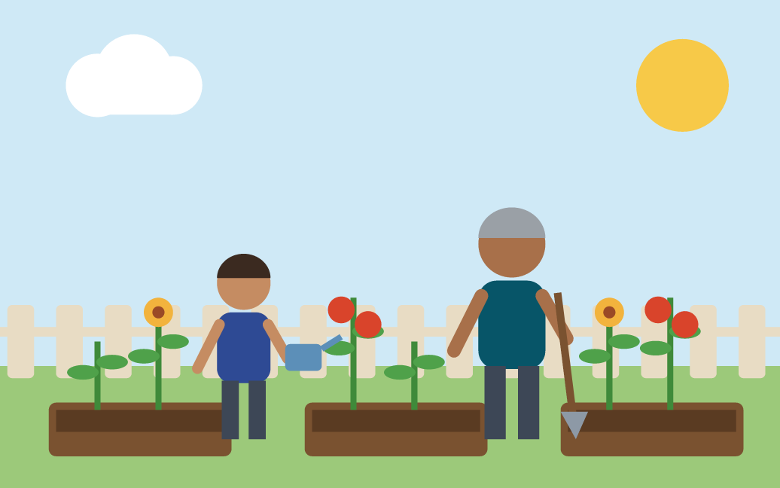
Your task: Look at the garden. What do you see? Say one thing.
Sentence frame: I see a ___.

What to do
- Look at the garden picture.
- Say one thing you see: “I see a ___.”
- Draw it on your paper.
- Copy the word.
- Add a color. Say your sentence again.
- Show a partner or a grown-up.

My drawing

My word

You need: The garden picture on a screen, or the printed backup page; Paper with crayons or a pencil; A partner or a grown-up (a microphone is not needed).
Time: About 10 minutes. Online activity: thelanguagepage.com/access-practice-lab/Speaking/A/gk-s-a-garden-see?grades=K

Teacher page: Our Garden (Kindergarten)
Use this page if the live activity will not load. Hand out page 1 and teach the same 10 minutes.
Objective: Children will name one thing in a garden picture aloud, then draw it and copy one word under the drawing.

Five steps
- Notice 1 minute. Show the garden picture. Point and ask: “What do you see?” Children point to one thing.
- Speak 2 minutes. Say the starter “I see a ___.” Children tell a partner one thing. For a model first, open the activity and press “Hear Lina, age 5 answer first.”
- Write 3 minutes. On paper, children draw the thing they named, then copy one word under the drawing. Write it on the board to copy.
- Improve 2 minutes. Give one cue only: “Add a color word.” Children color the drawing and say the sentence again with the color.
- Share 2 minutes. Two or three children hold up their drawing and say their sentence.

Example learner work
Example first response: I see a flower.
Example improved response: I see a yellow flower.
The improved sentence adds a color word. The flowers in the picture are yellow.
One feedback cue: Add a color word.
Quick check: Listen as each child says the sentence. Count how many named a thing and added a color word.
Follow-up: Children name a different thing in the garden with a color word, then try “Draw a Garden.”

Three support choices
More support
- Vocabulary with pointing: flower, plant, sun, fence, watering can, shovel.
- Point to the picture while you say each word.
- Say the starter together first: “I see a ___.”
- Draw only, and say the word aloud.
Some support
- Color word cards: red, yellow, green, blue.
- Copy the word from the board.
Greater independence
- Say two things: “I see a ___ and a ___.”
- Write the sentence starter on your own.
Children may name things in their home language first, then in English. Supports fade; the task stays the same. These are practical supports, not WIDA levels or alignments. Young writers use crayons and a pencil on paper. If children will not record, use partner talk. The activity needs no microphone.
All activities and handouts: thelanguagepage.com/access-practice-lab/start

