Family Math Studio Lesson 1.2 · 5.NF.B.4

Math is Exploring and Thinking
Find a fraction of a whole number: divide by the bottom, then multiply by the top.
Name Date

Tonight's spark
A school garden map shows 60 pea pods on the vines. A sign says 2/3 of them are ready to pick. How many pods are ready? Make a guess first: are more than half of the pods ready, or fewer?
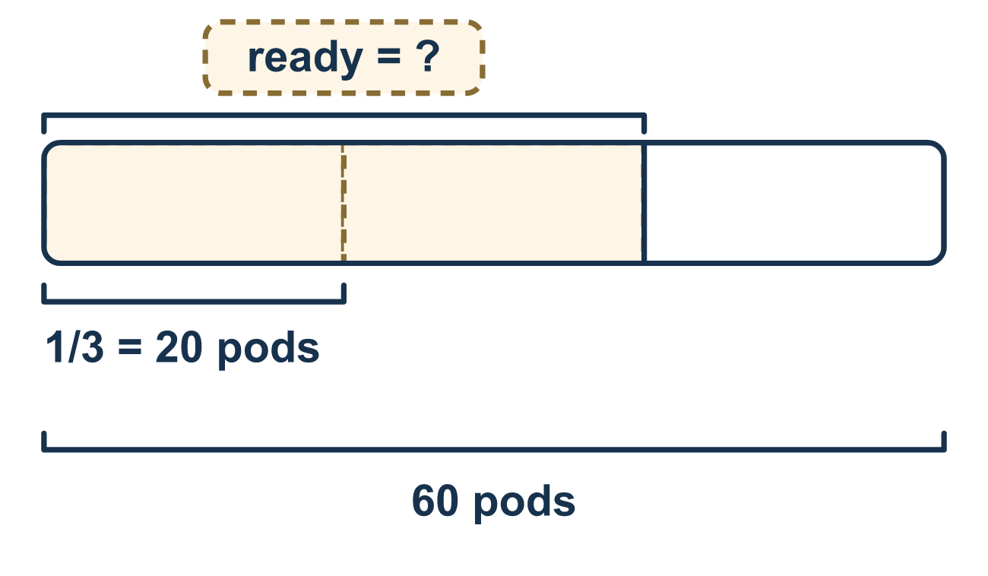
Our class model: divide, then multiply

Try it
Work it out on paper. Write one answer on each line.
- What is 1/2 of 10?
A. 5 B. 20 C. 12
My answer
- What is 1/3 of 12?
A. 36 B. 9 C. 4 D. 15
My answer
- To find 3/4 of 20, what do you do first?
A. Multiply 20 by 3 B. Divide 20 by 4 C. Divide 20 by 3 D. Add 20 and 4
My answer
- What is 2/3 of 30?
A. 10 B. 15 C. 60 D. 20
My answer
- A box has 20 crayons. 3/5 of them are used. How many crayons are used?
A. 4 B. 12 C. 60 D. 15
My answer
- A class has 35 students. 2/5 of them walk to school. How many students walk?
A. 14 B. 7 C. 70 D. 33
My answer

Talk about it
Can two thirds of the pods be more than all of the pods?

Home mission
A different situation: set out 12 beans, coins, or pasta pieces. Ask your student to make 3 equal piles. Then ask for 2/3 of the beans. How many is that?

If we get stuck, ask
- How many equal groups does the bottom number ask for?
- What is one of those groups worth?
- Does your answer make sense compared to the whole?

Do it on a screen

Scan or type the link. Same lesson, with hints. eduwonderlab.com/lessons/1-2/homework.html
How did it feel? (optional) ☐ Tricky ☐ Getting there ☐ Got it

Family Math Studio · For grown-ups Lesson 1.2 · 5.NF.B.4

Answers and talk notes
Math is Exploring and Thinking

What your student is learning
Tonight we make sense of a problem, plan a strategy, and use a fraction of a whole number to compare two amounts.

Answers
Ask your student to explain before you look.
- A. 5. Half of 10 means 10 split into 2 equal groups, so 10 ÷ 2 = 5.
- C. 4. Split 12 into 3 equal groups: 12 ÷ 3 = 4.
- B. Divide 20 by 4. Divide 20 by 4 first to find one equal part. Then multiply by 3 to take 3 parts.
- D. 20. 30 ÷ 3 = 10 is one third. Two thirds is 2 × 10 = 20.
- B. 12. 20 ÷ 5 = 4 is one fifth. Three fifths is 3 × 4 = 12 crayons.
- A. 14. 35 ÷ 5 = 7 is one fifth. Two fifths is 2 × 7 = 14 students.

Talk about it
Can two thirds of the pods be more than all of the pods?

When they are stuck, ask
- How many equal groups does the bottom number ask for?
- What is one of those groups worth?
- Does your answer make sense compared to the whole?

Try not to say
- Just multiply the two numbers together.
- Skip the check — the answer is fine.
- Fractions are too hard, use a calculator.

Home mission
A different situation: set out 12 beans, coins, or pasta pieces. Ask your student to make 3 equal piles. Then ask for 2/3 of the beans. How many is that?

