Family Math Studio Lesson 1.3 · Session 2 · 5.NBT.B.7

Math is In My World
Pick a tool, then change minutes into hours and minutes by dividing by 60.
Name Date

Tonight's spark
A route map shows a night bus. It leaves at midnight and rides for 500 minutes. What time does it arrive? Make a guess first: does it arrive before 8:00 a.m., or after?
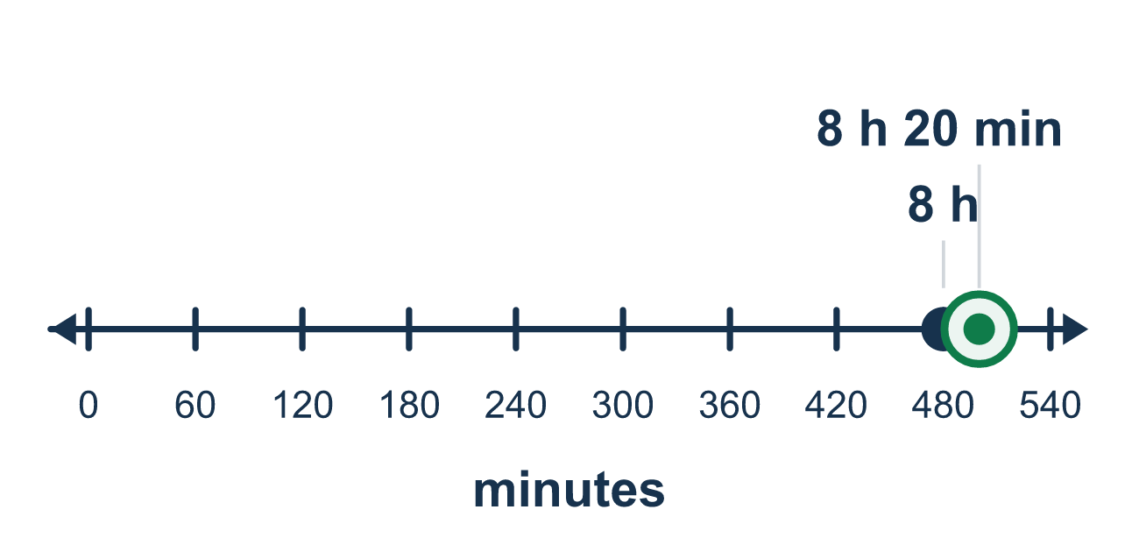
Our class model: the number line of 60-minute jumps

Try it
Work it out on paper. Write one answer on each line.
- How many minutes are in 1 hour?
A. 60 B. 100 C. 30 D. 12
My answer
- How many minutes are in 2 hours?
A. 200 B. 22 C. 120
My answer
- One ride takes 4.5 minutes. How many minutes do 10 rides take?
A. 0.45 B. 45 C. 14.5 D. 450
My answer
- A number line is marked every 60 minutes. How many jumps reach 240 minutes?
A. 24 B. 6 C. 3 D. 4
My answer
- What is 200 minutes in hours and minutes?
A. 3 hours 20 minutes B. 2 hours 20 minutes C. 3 hours 2 minutes D. 3.2 hours
My answer
- A party starts at midnight. What time is it 330 minutes later?
A. 3:30 a.m. B. 5:30 a.m. C. 6:30 a.m.
My answer

Talk about it
How many whole hours fit, and how many minutes are left over?

Home mission
A different situation: use a phone or clock. Start at midnight and ask what time it is 150 minutes later. Let your student count by 60s on their fingers, then say the leftover minutes.

If we get stuck, ask
- Which tool would show this best — a bar, a number line, or a table?
- How many minutes are in one hour? So what do we divide by?
- What does the leftover number mean in this problem?

Do it on a screen

Scan or type the link. Same lesson, with hints. eduwonderlab.com/lessons/1-3-part2/homework.html
How did it feel? (optional) ☐ Tricky ☐ Getting there ☐ Got it

Family Math Studio · For grown-ups Lesson 1.3 · Session 2 · 5.NBT.B.7

Answers and talk notes
Math is In My World

What your student is learning
Tonight we pick a math tool — a tape diagram, a number line, or a table — and use it to turn a big pile of minutes into hours and minutes.

Answers
Ask your student to explain before you look.
- A. 60. There are 60 minutes in 1 hour.
- C. 120. 2 hours is 60 + 60 = 120 minutes.
- B. 45. 4.5 × 10 = 45. Multiplying by 10 moves each digit one place left.
- D. 4. 240 ÷ 60 = 4, so 4 jumps of 60 reach 240 minutes.
- A. 3 hours 20 minutes. 3 hours is 180 minutes, and 200 − 180 = 20 left, so 3 hours 20 minutes.
- B. 5:30 a.m.. 330 ÷ 60 is 5 with 30 left over, so it is 5 hours and 30 minutes after midnight: 5:30 a.m.

Talk about it
How many whole hours fit, and how many minutes are left over?

When they are stuck, ask
- Which tool would show this best — a bar, a number line, or a table?
- How many minutes are in one hour? So what do we divide by?
- What does the leftover number mean in this problem?

Try not to say
- Just move the decimal point two places and you have the hours.
- You do not need a picture, just use the calculator.
- The remainder does not matter, round it away.

Home mission
A different situation: use a phone or clock. Start at midnight and ask what time it is 150 minutes later. Let your student count by 60s on their fingers, then say the leftover minutes.

